**Vehicle Management Platform Client**

User Manual

Version：V3.1

2024/6/2

# System login

Open https://[IP/domain]:port enter into login interface.

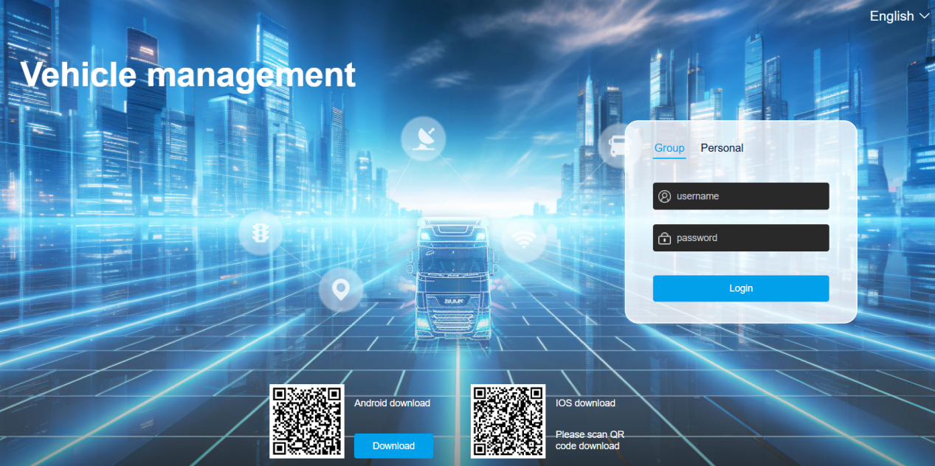

Enter your username, password, and drag the verification icon to log in on the login interface. At the bottom of the login interface, there are various client versions corresponding to the platform that can be downloaded：android APP, IOS APP. Click on the multilingual function in the upper right corner to switch between multiple languages.

# main functions of the platform

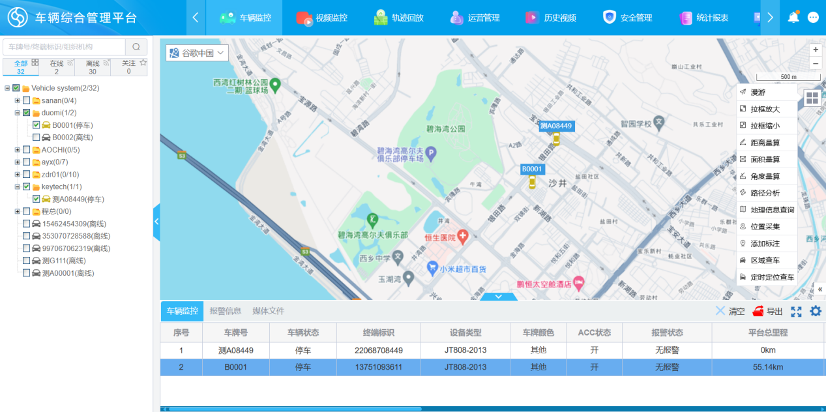

The layout of the platform UI interface is mainly divided into three parts, with the main menu buttons on top, corresponding to the main functions of the platform: vehicle monitoring, historical videos, operation management, statistical reports, and data analysis.

The left side of the following section mainly contains the operation objects, which may be the vehicle tree or the operation menu. On the right is the main content display area, which mainly realizes the results of some operations and further operation buttons, such as displaying video content. The following chapters will explain the main functions of the top main menu one by one.

# vehicle monitoring

Select Vehicle Monitoring from the main menu and enter the Vehicle Monitoring Center interface. The Vehicle Monitoring Center is the main information display center for devices and platforms, as well as the control center for devices.

## Vehicle Tree

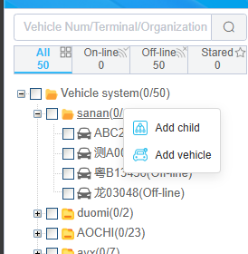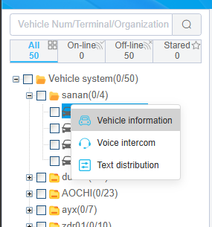

The left side of the monitoring center displays the current vehicles of the entire platform, which are equipped with monitoring equipment. Display according to organizational structure. Users can follow the license plate number, Search for information such as SIM card number and driver name to find a certain car on the tree. The display of vehicles on the tree varies in color, with gray indicating that the vehicle is offline, red indicating that the vehicle is in an alarm state, green indicating that the vehicle is in motion, and yellow indicating that it is in a stopped state. For vehicles that have been launched, there is a representation of the number and total number of launches under each institution and its sub institutions. The vehicle has two states: selected and unselected, and the selected vehicle will have data displayed on the monitoring center map.

Right click on the mechanism to directly add its sub mechanisms or directly affiliated vehicles.

Right click on the vehicle to view vehicle information, intercom, and text distribution.

## Map monitoring

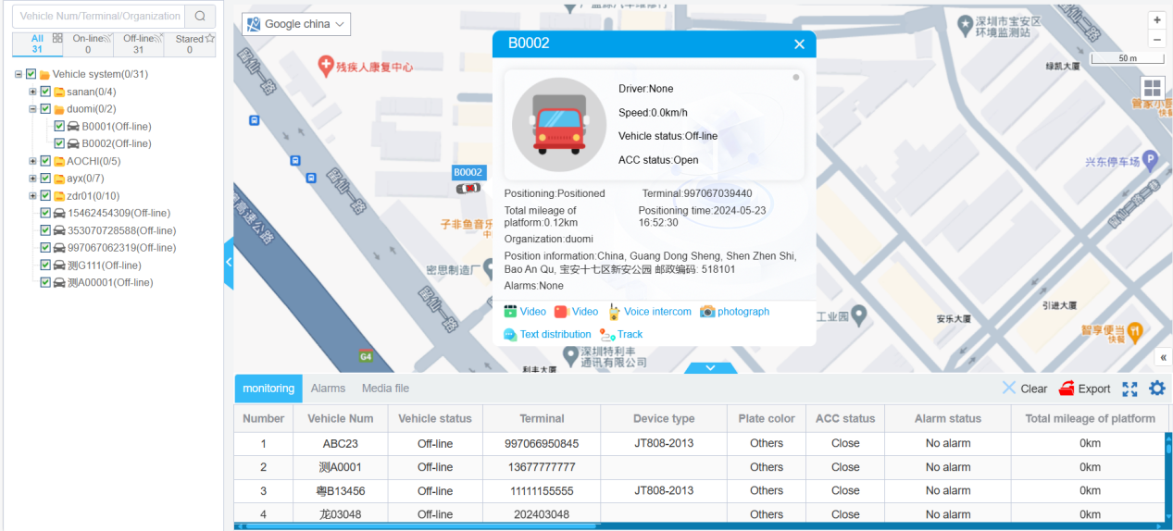

Select the monitoring menu from the main menu to enter map monitoring mode.

In map monitoring mode, users can select devices on the tree for monitoring. After selecting a vehicle, the location of the vehicle will be displayed on the map, and a detailed menu for monitoring will pop up, including the vehicle's status, location, time, speed, and alarm information. At the bottom of the pop-up message are some operation buttons. If the vehicle is equipped with a video device, it will display video, playback, intercom, photograph, Text distribution, and track.

### Map type

At present, the system supports Gaode, Baidu, OSM, and Google Maps. It is recommended to use Gaode and Baidu Maps in mainland China. For other regions, it is recommended to use Google or OSM maps.

### Map tools

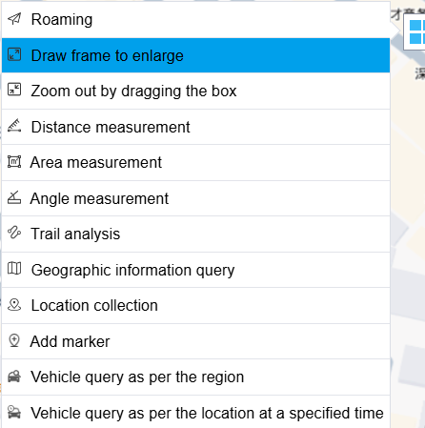

In the upper right corner of the map, there is a menu of map tools floating. It contains some electronic map tools, including zooming in, zooming out, calculating distance and area, as well as functions for checking vehicles in certain areas, locating vehicles at regular intervals, and quickly adding annotations

#### Regional vehicle query

Select an area on the map to view the vehicles in that area.

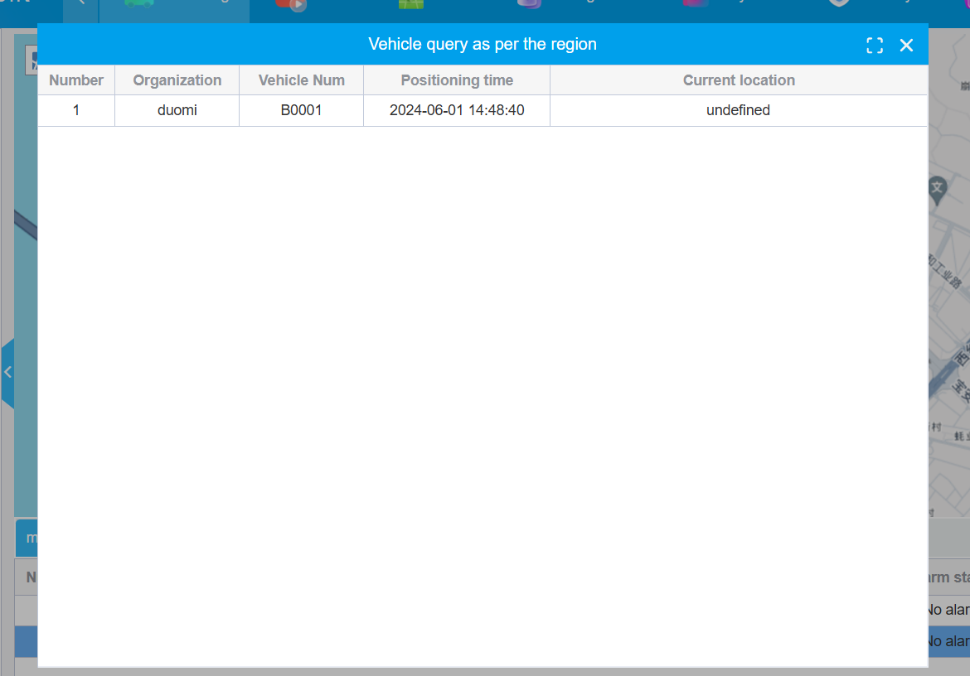

#### Check vehicles based on time and region

Timed positioning and vehicle inspection are mainly used to check which vehicles have passed through a specific area at a specific time, in order to track the trajectory of the vehicle.

Regular positioning and vehicle inspection are of great use in searching for lost items and monitoring the driving situation in the area.

The specific operation method is to enter the area and the mechanism of the vehicle to be searched (multiple choices are allowed), and click "Search" to find all vehicle information. Click "View" to view the trajectory of the car.

For example, to search for an electronic fence that passed through a certain area on November 2, 2021. You need to select the fence and time, and the system will search for all vehicles in or passing through this area.

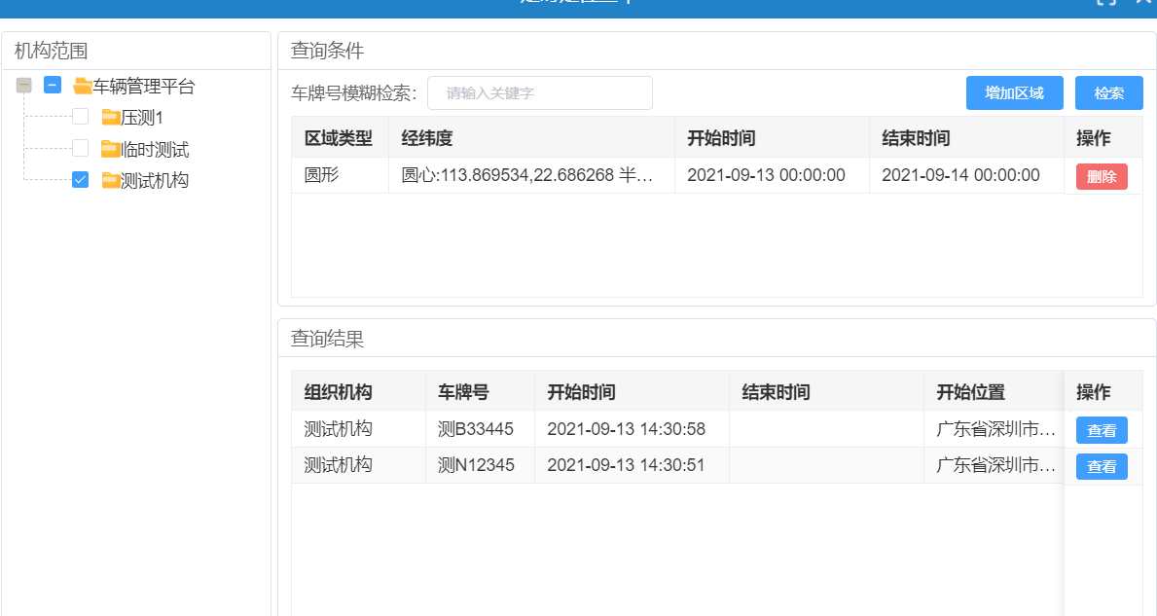

### Multi vehicle monitoring

At the bottom of the map monitoring, there is a vehicle monitoring column that monitors the status of multiple vehicles in a form. The options for the form can be customized。User clicksThe button can define the information it needs to monitor.

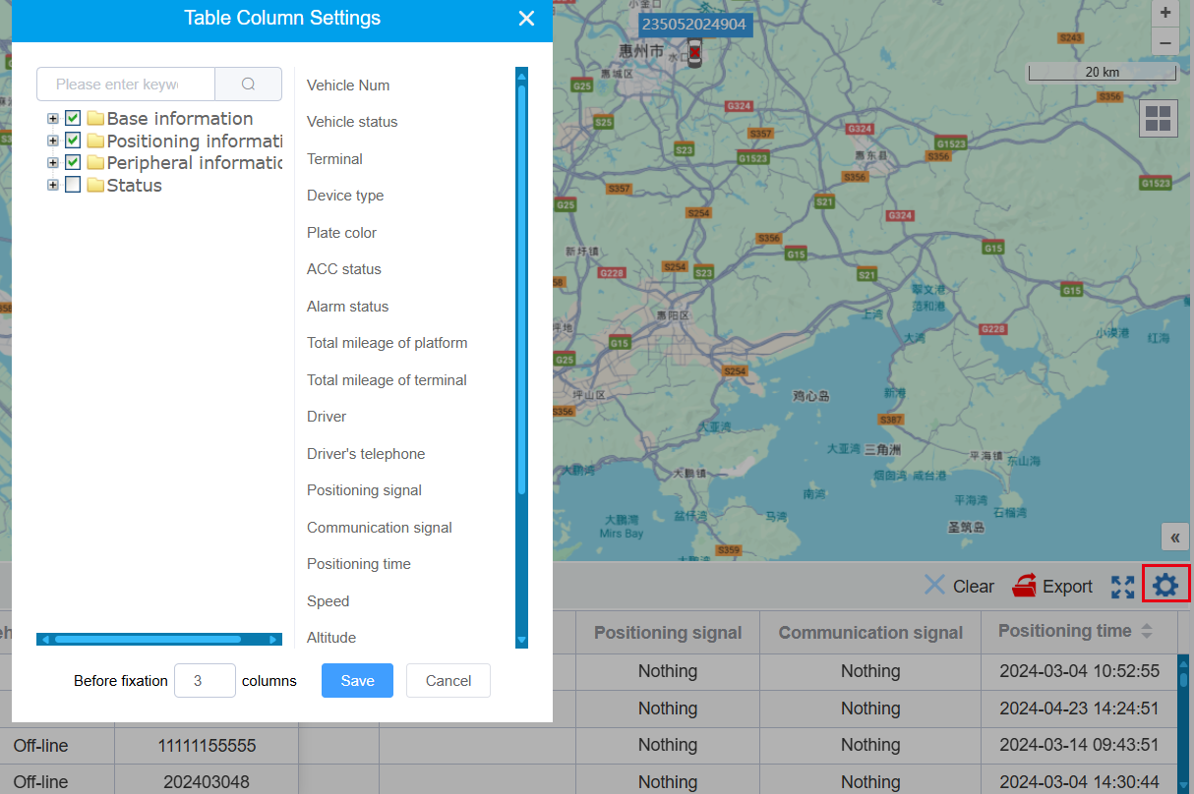

Select multiple vehicles on the map and display their information in the status bar. This information can be exported to an Excel spreadsheet by clicking the "Export" button.

The information in the monitoring column can be sorted by operating the up and down arrows of the positioning time.

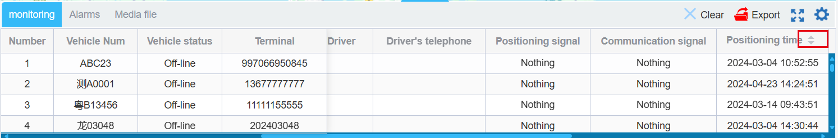

The second submenu of the monitoring bar displays the latest alarm information.

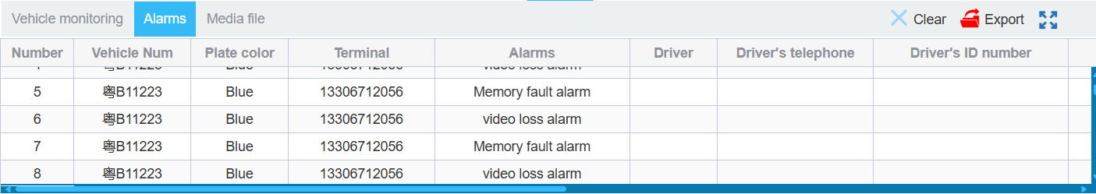

The third submenu of the monitoring bar is used to display the most recent media files.

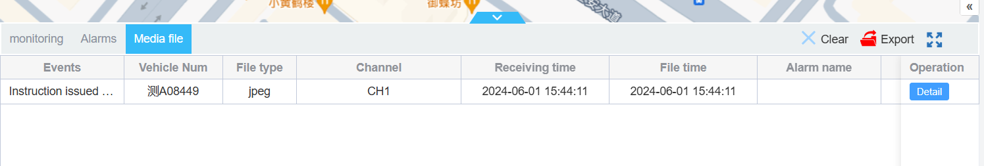

### Intercom

Click the intercom button on the monitoring bubble to enter the intercom mode for the user

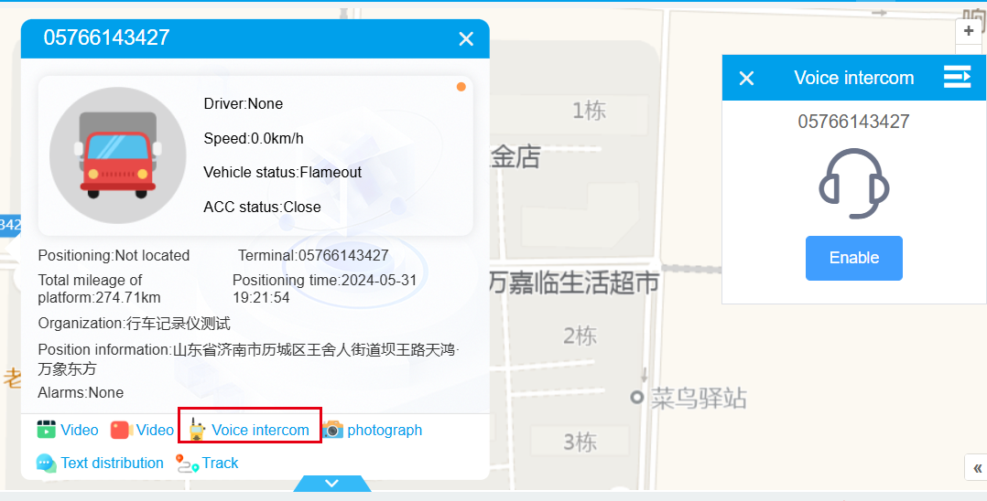

For vehicle equipment intercom, the following points need to be noted：

1. The device itself needs to support intercom。
2. . Users need to know the device's intercom channel. We can input intercom channels in the device type in the vehicle management system. For input on device types, please refer to 5.1.3 Device Type Management Instructions.
3. The web needs to run in secure mode, which means HTTPS access mode, because browsers can only run in this mode to access the computer's microphone. Regarding the access mode of HTTPS, a security certificate needs to be configured. Please contact us for specific configuration.

### Photography

The specific steps for operating the device to take photos are:

1. Click on the "photography" button

2. Select device channel

3. In the pop-up resolution parameter bar, select the photo resolution

4. Single machine sending button

Then the photo information can be displayed in the media section of the monitoring bar.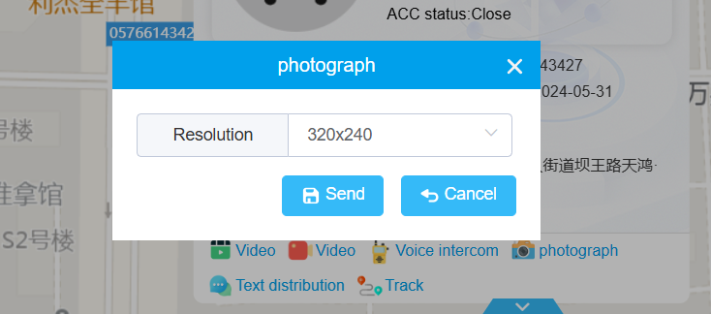

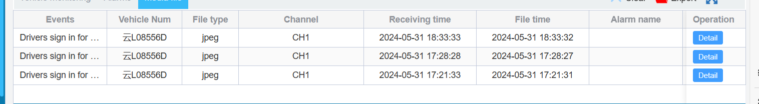

### text distribution

On the operation button under the vehicle monitoring bubble, select “text distribution” to enter the text distribution interface. Users can choose to play the message based on its characteristics, select the display time, input the message content, and send the message to the vehicle terminal. The device will display the content of the issued message, and if TTS playback is required, the issued content will be played and read on the device

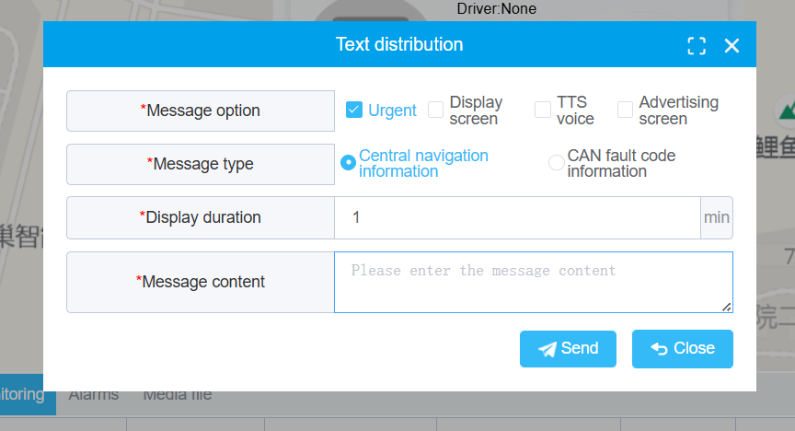

## Video monitoring

### Video splitting and control

Select video monitoring menu to enter the real-time monitoring screen. Users can switch to various split screen screens as needed, including 1, 2, 4, 9, 16, 25, and 36, with the vehicle area still selected on the left. The video results are displayed on the right side. In the split screen operation bar, there are also full screen, close all videos, and rotate operation buttons.

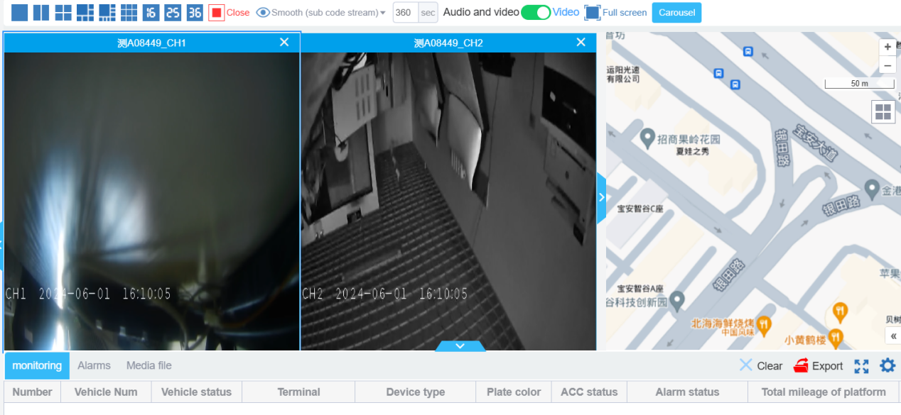

### Single channel video monitoring

Double clicking on a vehicle's channel or vehicle's icon in the vehicle tree can directly open the vehicle's video interface.

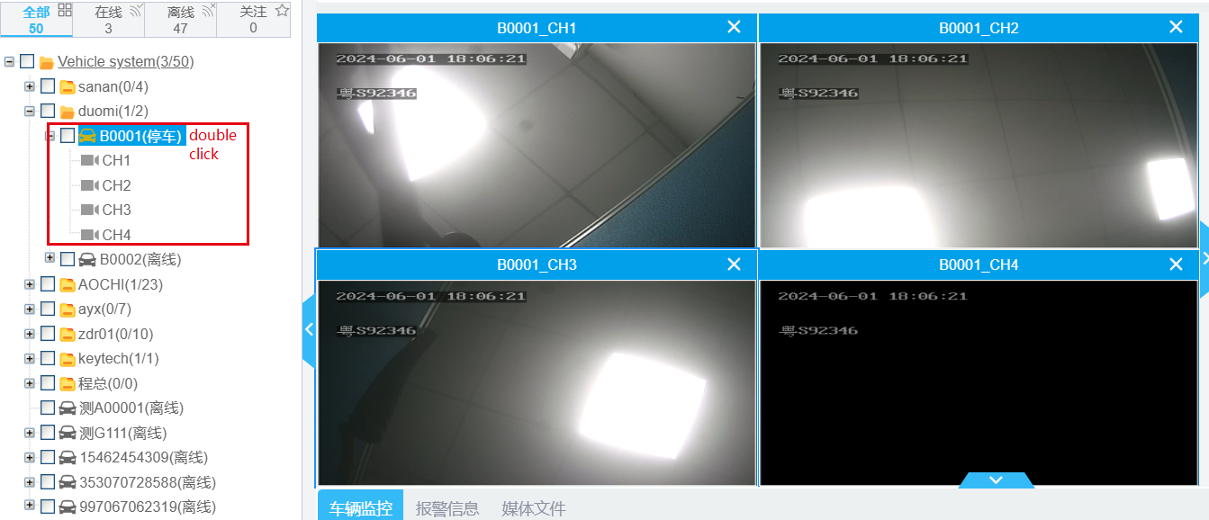

In a single channel video, the upper part is the video screen, and the lower part displays the vehicle license plate and sped and some button including stop, mute and turn on, volume adjustment, pause, screenshot, record, and full screen buttons.

### Video Carousel

After selecting the vehicle, click the carousel button and then click start carousel

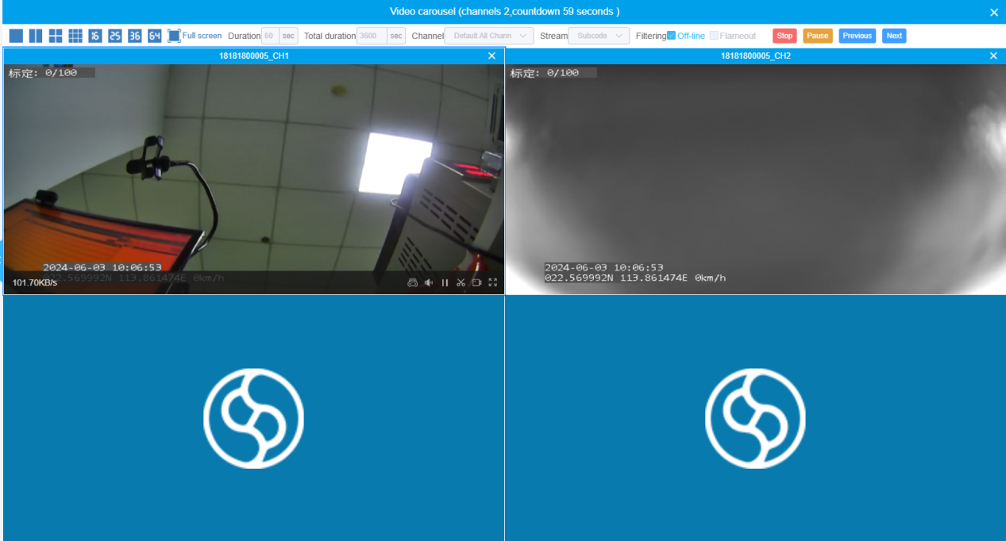

The video will start broadcasting based on the number of cameras on the selected vehicle. The default duration of the broadcast is 1 minute, with a total time of 1 hour. You can set it according to your actual needs.

After the broadcast time is up, by default, it will enter the next round of video drawing for live streaming. Users can click the previous or next page button to turn pages.

When the set rotation duration reaches, the platform will automatically proceed to the next page rotation.

Click the pause carousel button, and the video will remain on the currently playing camera without automatically being carouseled to the next page.

## Track

Click Track menu.

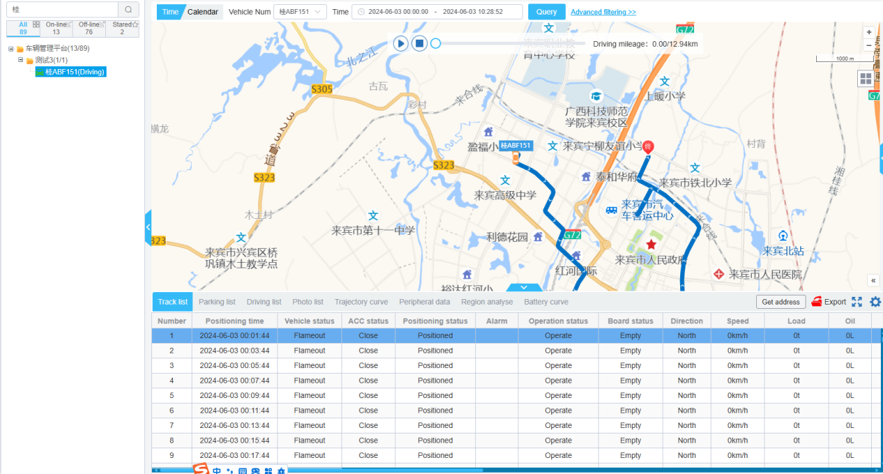

The step of trajectory playback is:

1. Click on the vehicle device in the vehicle tree, and after selecting the vehicle, the license plate number will be displayed;
2. Select the time range of the queried trajectory;
3. Clicking the query button will display trajectory information in the trajectory list;
4. Click the play button in the middle of the map to start playing the trajectory;
5. Click the stop button to stop the trajectory playback;
6. You can click and drag the playback progress bar to quickly jump to a certain playback node;

It should be noted that on the right side of the trajectory playback interface, there is an advanced option function that is usually hidden, **which can define the trajectories to be filtered, the speed of trajectory playback, and other parameters**. This function is usually hidden.Click on advanced filtering to open this interface.

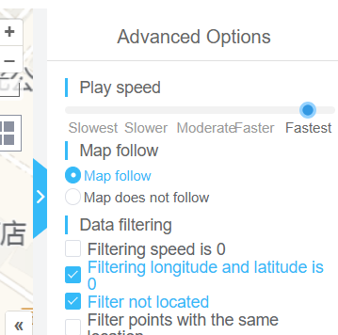

1. Clicking on the vehicle icon on the map will pop up corresponding trajectory point information.

During trajectory playback, the progress bar will move and the trajectory information of the driving vehicle will also be refreshed.

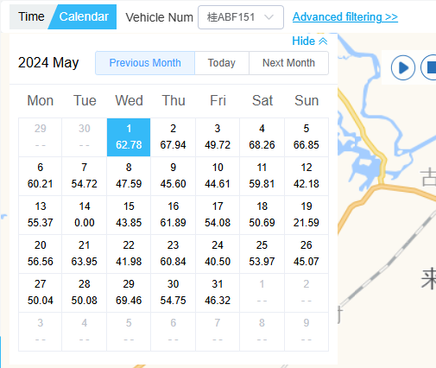

In calendar mode, you can see the daily vehicle mileage statistics for a month. Clicking to select a certain day will query the trajectory of the next day.

### Track list

The trajectory list will display the playback point position of the current vehicle in dark color. Clicking on a certain row will move the vehicle to the corresponding position of the clicked row.

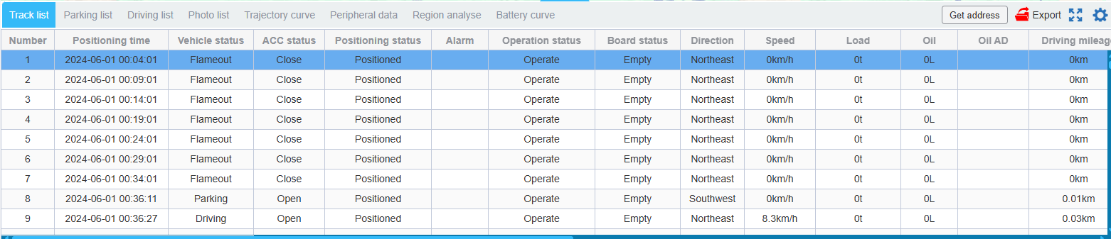

### Parking list

Switch to the parking list tab, the table will display the parking information calculated based on the parking conditions of the advanced options, and draw parking points on the map. Clicking on a parking point on the map will pop up relevant information, and clicking on a row can also move the vehicle.

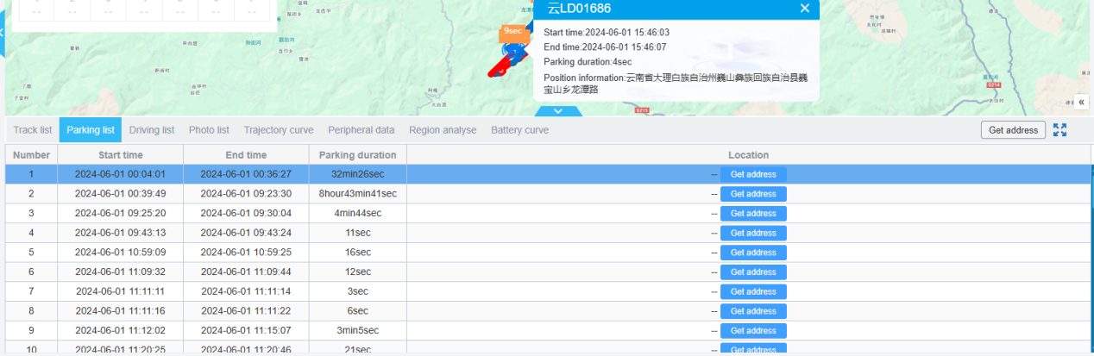

### Driving list

Switch to the driving list tab, and the table will display the driving information calculated based on advanced options. Clicking on the row can also move the vehicle.

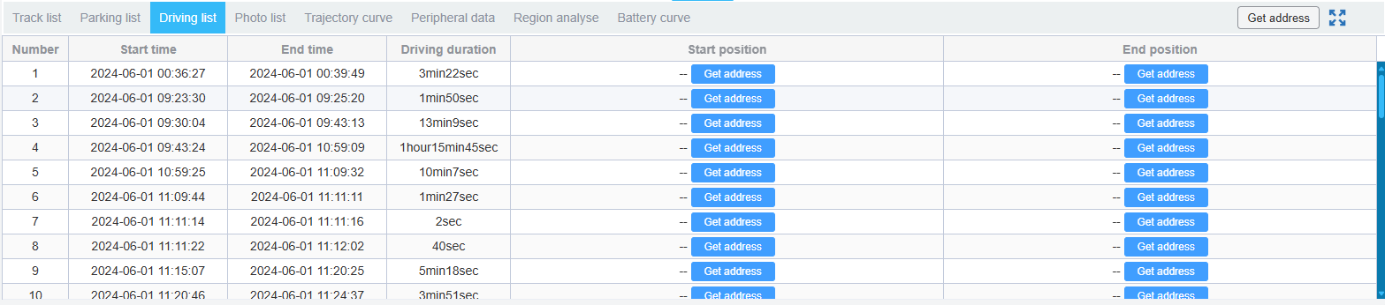

### Photo list

Switch to the photo viewing tab, displaying evidence images and actively captured images. Double click to enlarge the image.

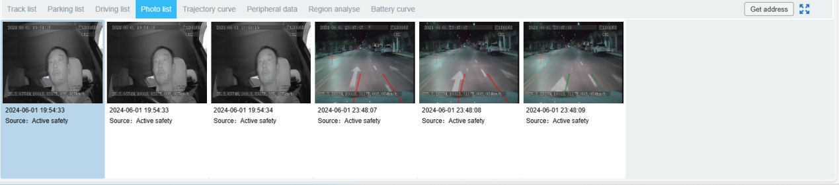

### Trajectory curve

Switching to the trajectory curve label will display trajectory related data in the form of a chart. Clicking on a node on the curve can also move the vehicle.

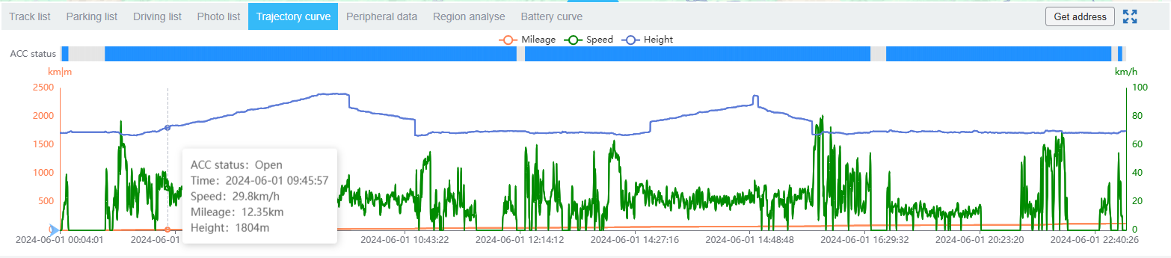

### Peripheral data

Switching to the peripheral data tab will display trajectory related data in the form of charts. Clicking on different buttons on the left can switch to different data curves, and clicking on nodes on the curves can also move the vehicle.

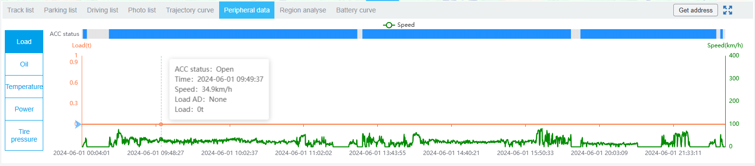

### Region analyse

Switch to the area analysis tab, select the area to be analyzed, and the table will display the relevant vehicle driving information for that area.

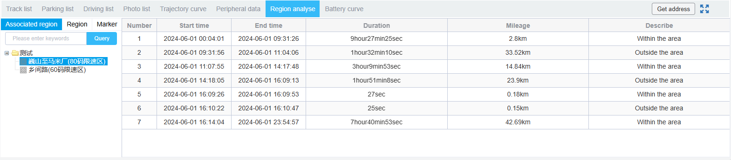

### Battery curve

Switching to the battery curve label will display trajectory related data in the form of a chart. Clicking on different buttons on the left can switch to different data curves, and clicking on nodes on the curve can also move the vehicle.

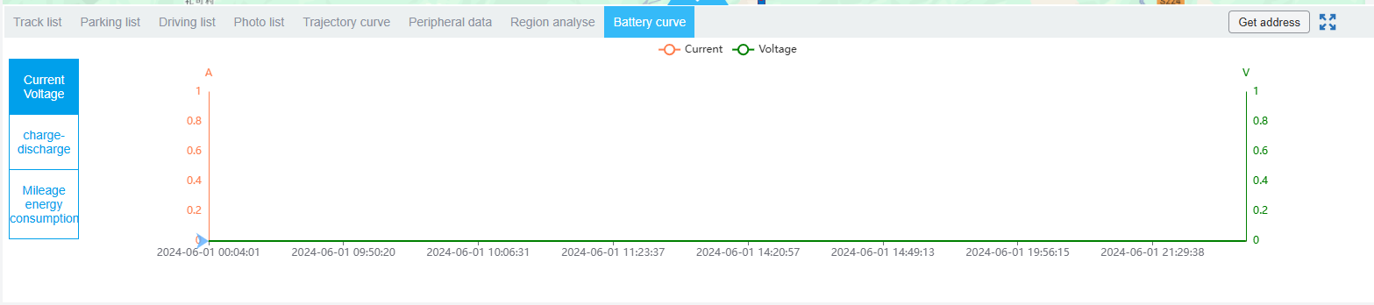

## Alarm management

Click on the alarm icon button in the upper right corner to view the vehicle's alarms. The vehicle's alarms can be divided into different risk levels by users on the platform. Click on the statistical data block at the top to filter the alarm data. Users can view and process alarms in the police monitoring interface.



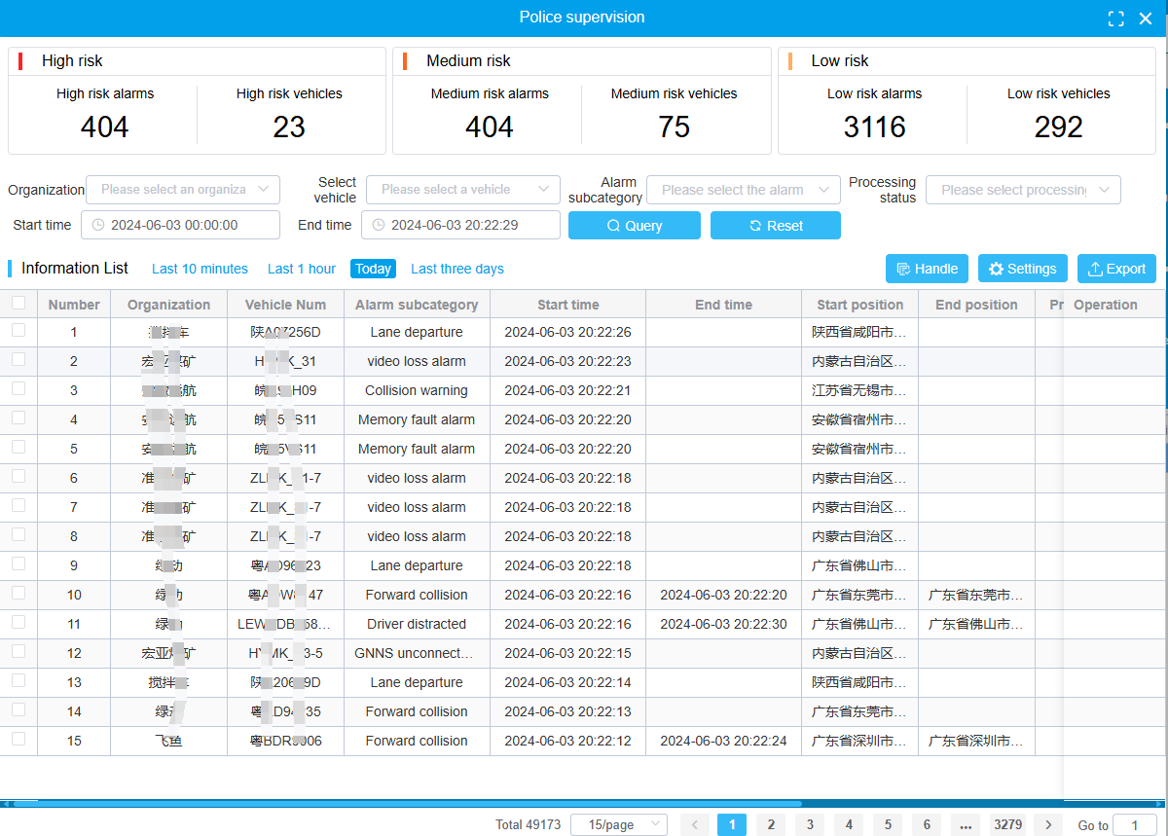

Select the alarm data to be processed in the list, then click the processing button to process the alarm.

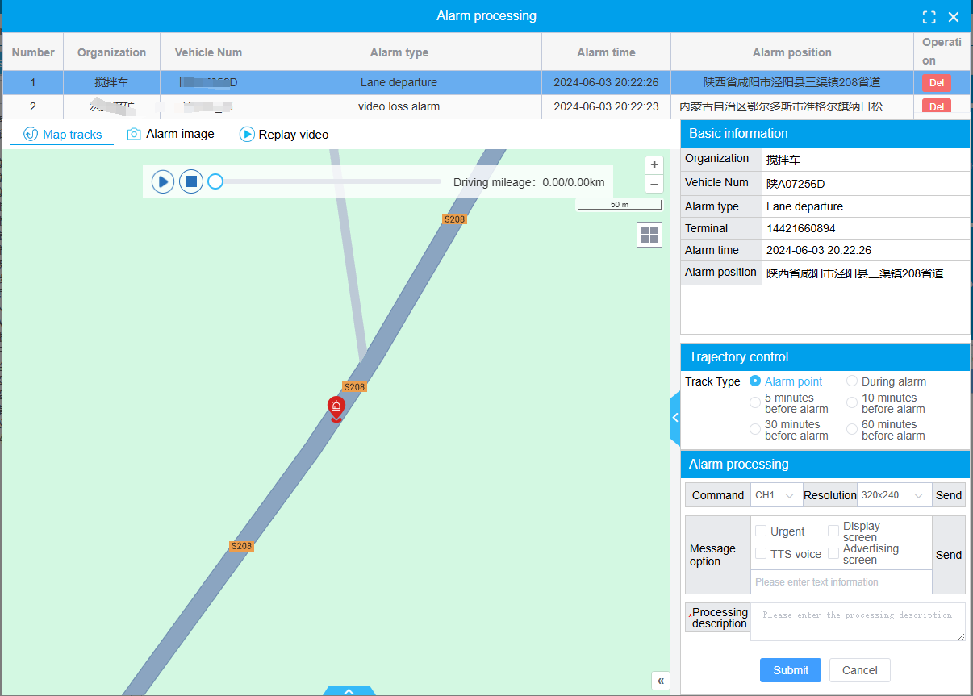

Click on Settings, and the alarm type can be dragged to different level areas for risk level classification.

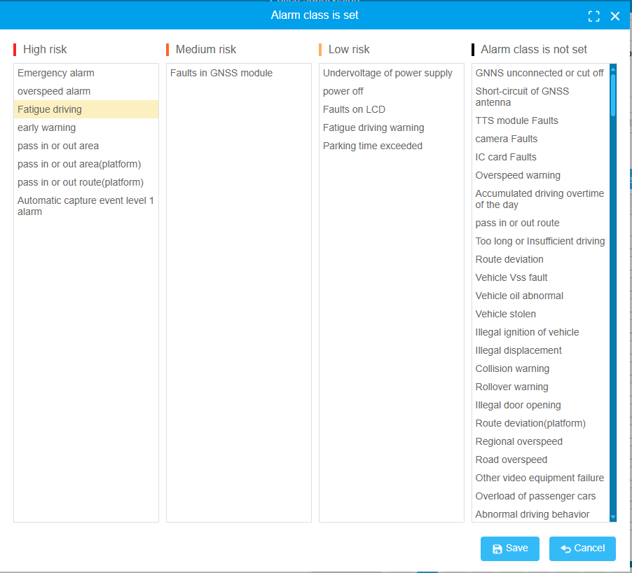

## Other auxiliary functions

### Monitoring parameter settings

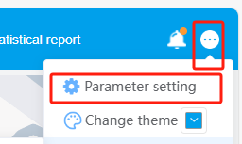

Select More ->parameter settings to enter the monitoring parameter settings interface.

Upper row: Up and down line pop ups, supervision pop ups, inspection pop ups, displaying vehicle status. Correspond to whether various message boxes remind and whether the vehicle organization tree displays the current status of the vehicle.

The middle area indicates whether various alarms are blocked, TTS voice broadcasting, and whether messages are popped up.

Here are some parameter descriptions:

Alarm blocking: Do you need to block the specified alarm display.

Pop up and offline: Whether to pop up a prompt when the device is online or offline, it is not opened by default.

Supervision and job inspection prompts: Do higher-level platforms need to provide prompts during supervision or job inspection.

Vehicle status display: Whether to display the current status of the vehicle on the tree.

Alarm and media file preload time: Some previous alarms and media files will be preloaded in the monitoring bar. This time determines how long the preload takes.

Monitoring automatic refresh time: The time interval between automatic refresh of information on the monitoring bubble

Initial location: The default location displayed on the map after device installation

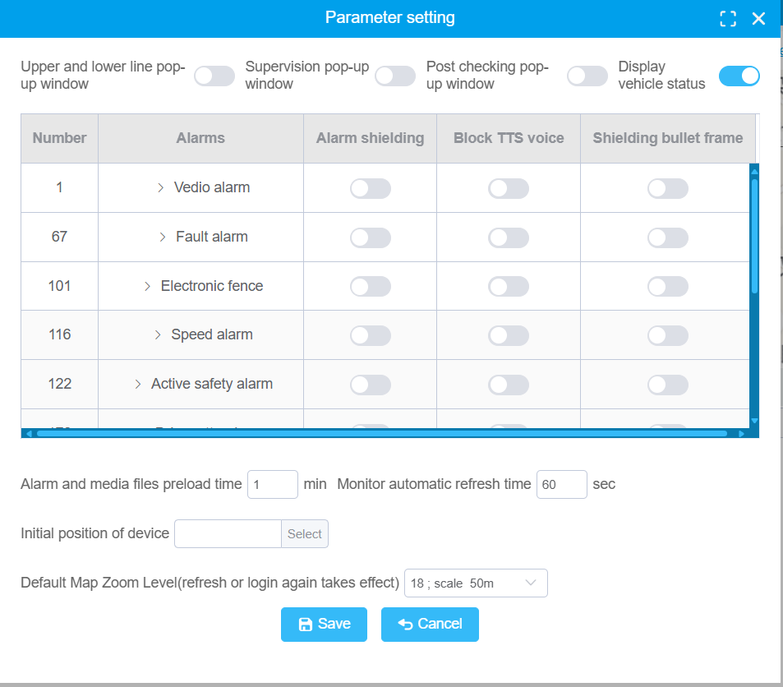

### Changing Passwords

Users can directly change their password. After entering the new password, they will log in with the new password for the next login。

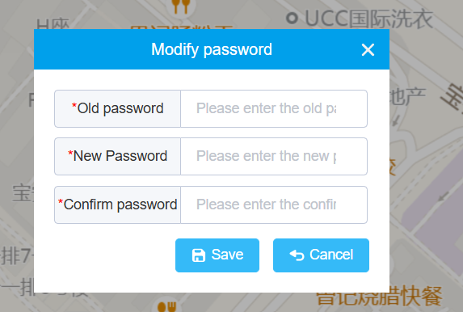

# Playback

Click the playback menu.

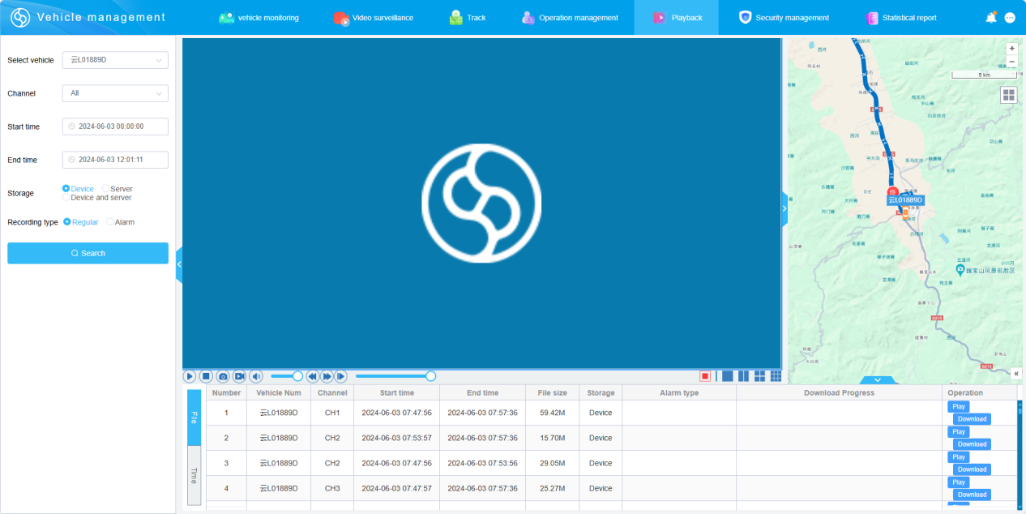

The video playback process is divided into two steps: 1 querying the resource list; 2 Select the resource list for playback.

## Video file query

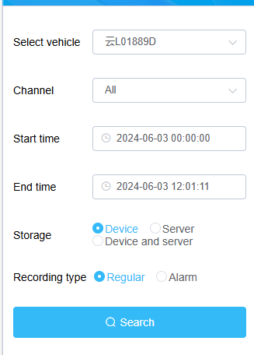

After selecting the search criteria, click search and a list of resources will be found in the list on the right.

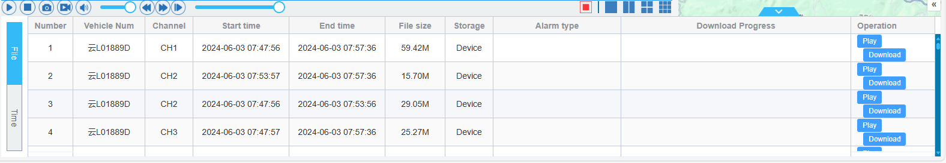

Click the play button in the video recording list to start the playback of the video.

## Video file playback

There are a row of operation buttons under the player, including: start and pause, stop, capture, record, mute, volume adjustment, fast forward, slow forward buttons (currently only some devices have slow forward function), and progress bar dragging. Users click on these buttons, and the platform sends commands to the device to adjust relevant parameters.

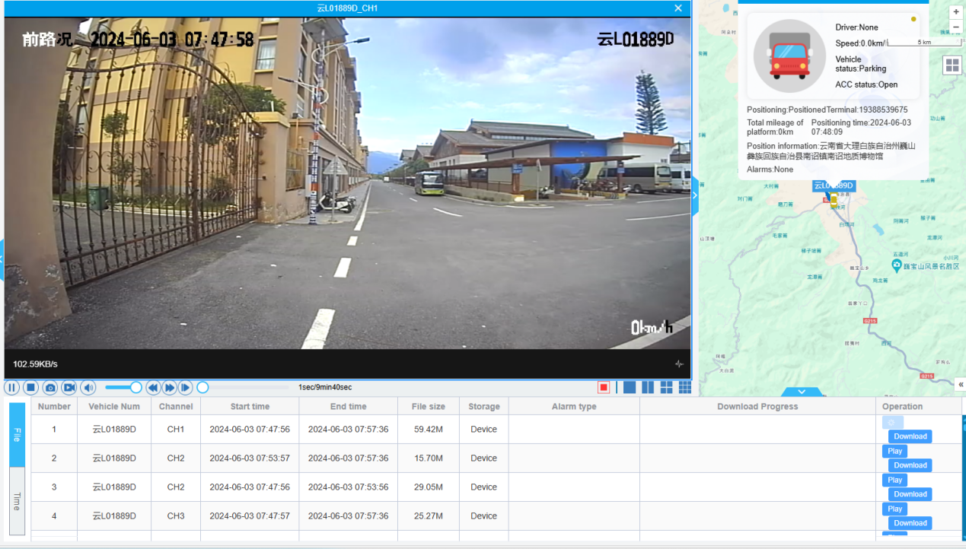

The specific functions of each button are as follows



During the playback of the video, the position of the vehicle will be periodically refreshed on the map on the right.

The map can be switched to timeline mode, and clicking on the location with a video (highlighted) can directly play the playback file of the current time.

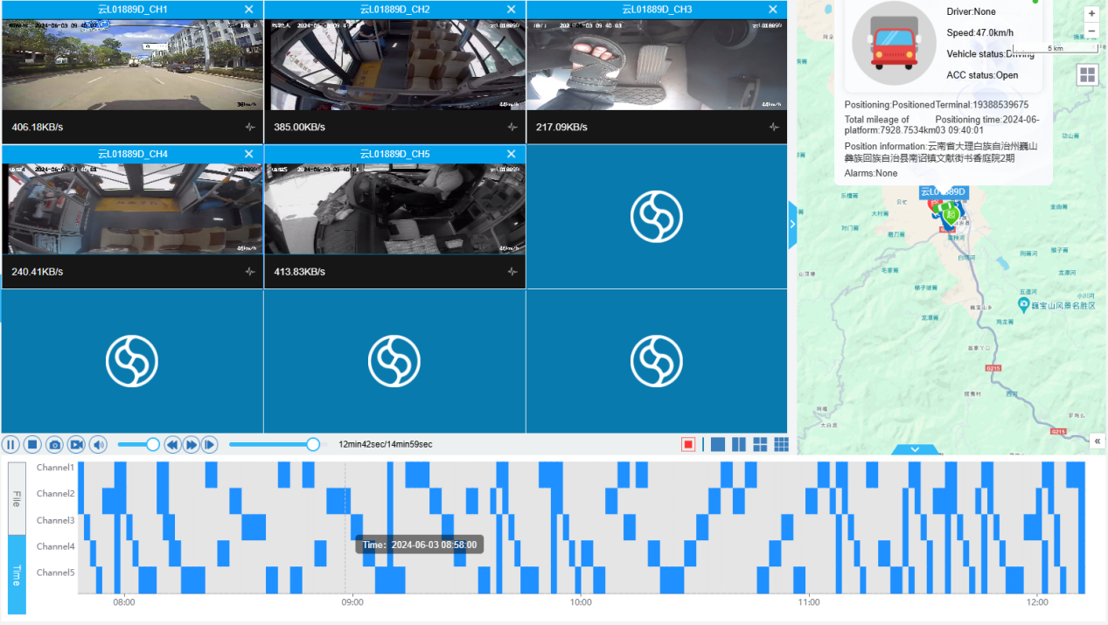

## Video file download

If the data is on the platform, it is downloaded from the server to the local location; If the video file is on the device, it needs to be downloaded in segments, first uploaded to the platform, and then downloaded locally.

Click the download button to start the download process (device resources need to be uploaded from the device to the server and then downloaded locally, which may take a longer time), and then check the download progress on the file download page.



# Operation management

## Vehicle management

### Vehicle information

Manage vehicle information by adding and editing information for individual vehicles, which can be added in batches or imported in batches through Excel spreadsheets. Vehicle information includes organizational structure, license plate number, vehicle type, color, and other information.

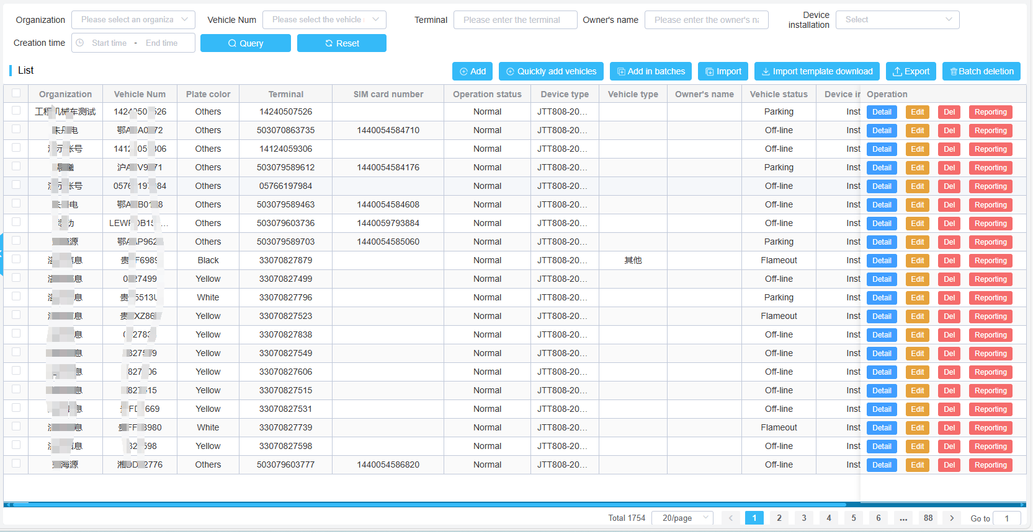

#### Vehicle import

You can import vehicles by downloading an Excel template and entering their institutional information, license plate number, communication number, vehicle type, device type, etc. Note that the red section is mandatory information that must be filled out. After importing the vehicle into the database, if the device information is filled out, it will also be imported along with it.

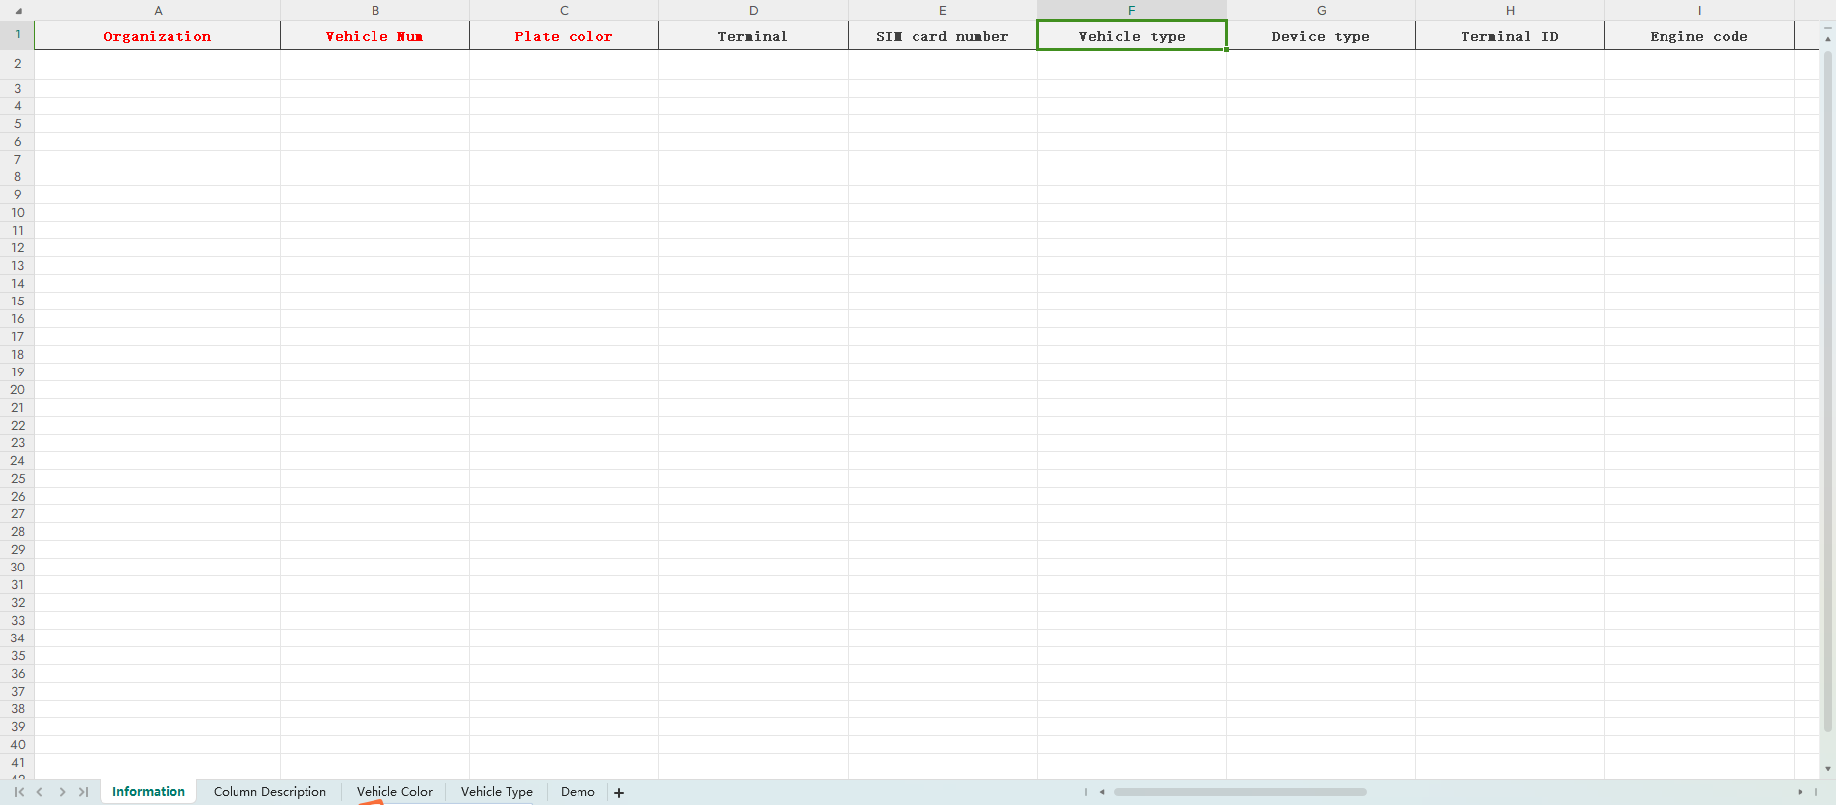

#### Add in batches

You can quickly add vehicles by entering information about a segment of the vehicle. Batch addition of vehicles requires continuous license plate and communication numbers, which is generally quite demanding.

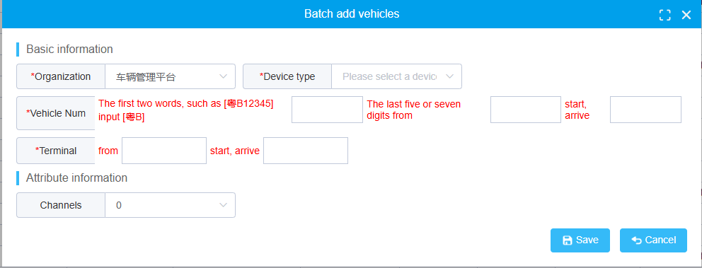

#### Quickly add vehicles

You can quickly add vehicle and device information through this function. After successful addition, a related vehicle and device information will be generated, which can be seen in the vehicle organization tree on the left side of vehicle monitoring.

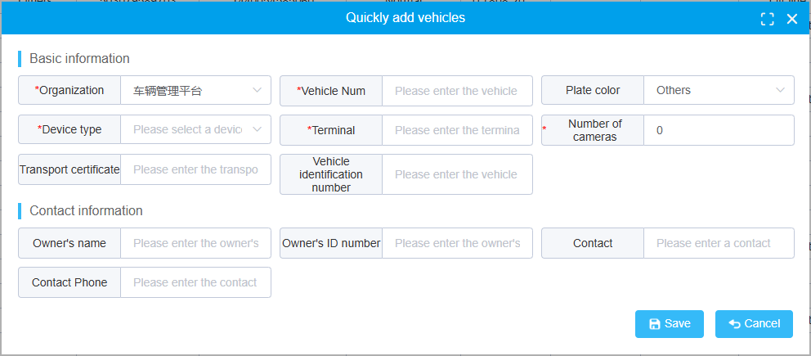

#### Vehicle information maintenance

In the vehicle information management interface, users can delete, modify vehicle information, and modify the vehicle reporting status. Can export a list of vehicle information. Vehicle information can also be queried based on conditions.

### Vehicle query

Query and display comprehensive information of the vehicle, including the real SIM card number, driver's name, device type, vehicle type, etc.

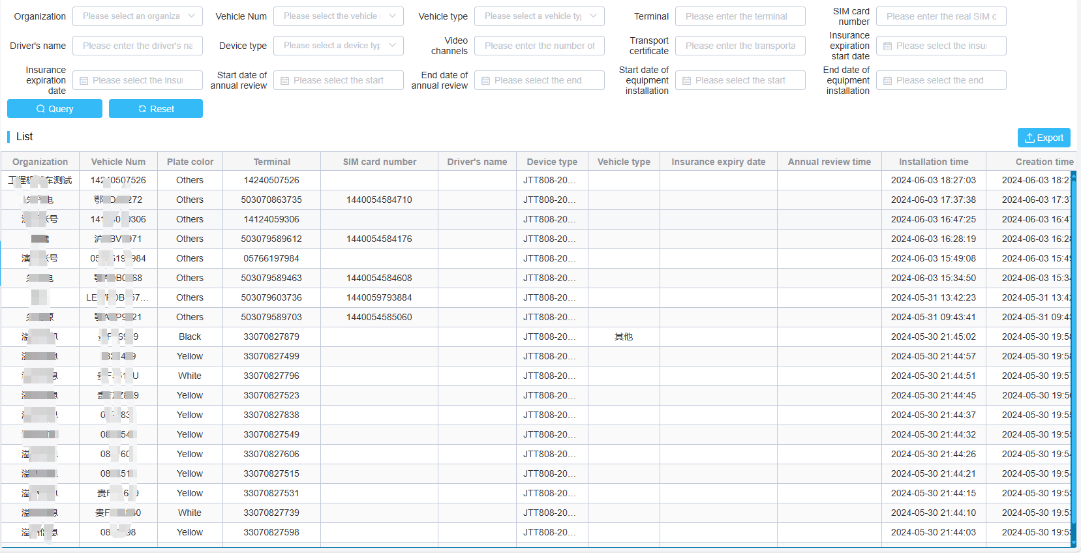

### Device type

The device type abstracts some common information for the same device, such as communication protocol, voice intercom channel, manufacturer, sensor calibration parameters, etc. These information are shared by a type of device.

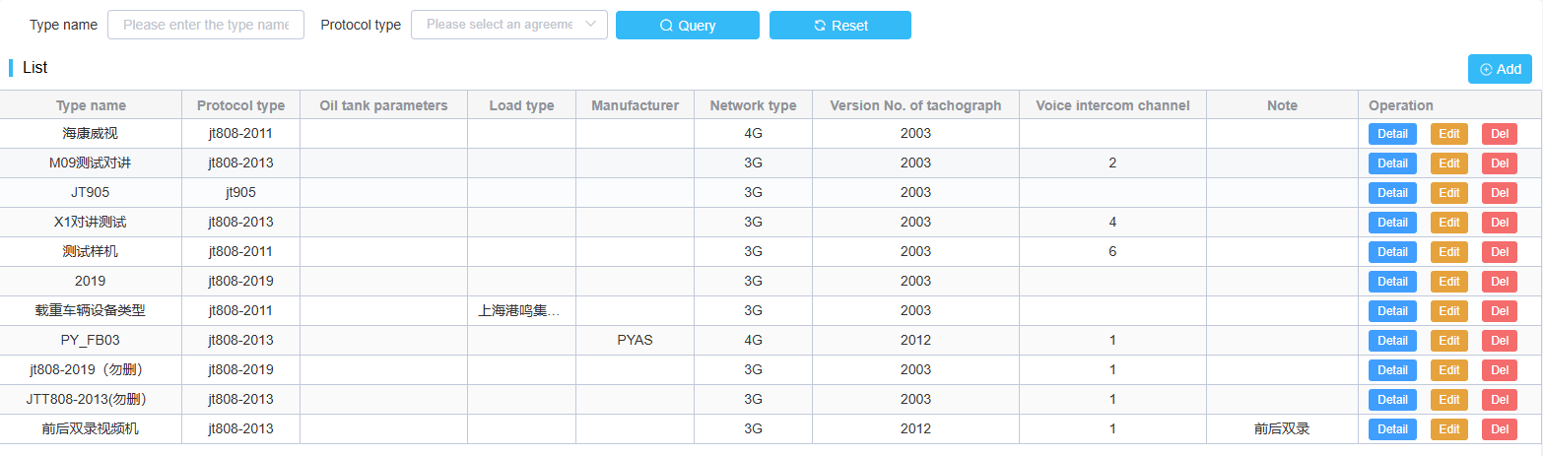

On the device type management interface, you can add, delete, modify, and view device types.

### Device management

The device information management interface is the same as the vehicle management interface, providing functions for adding, modifying, deleting, and querying devices.

Devices can be bound to vehicles and unbound.

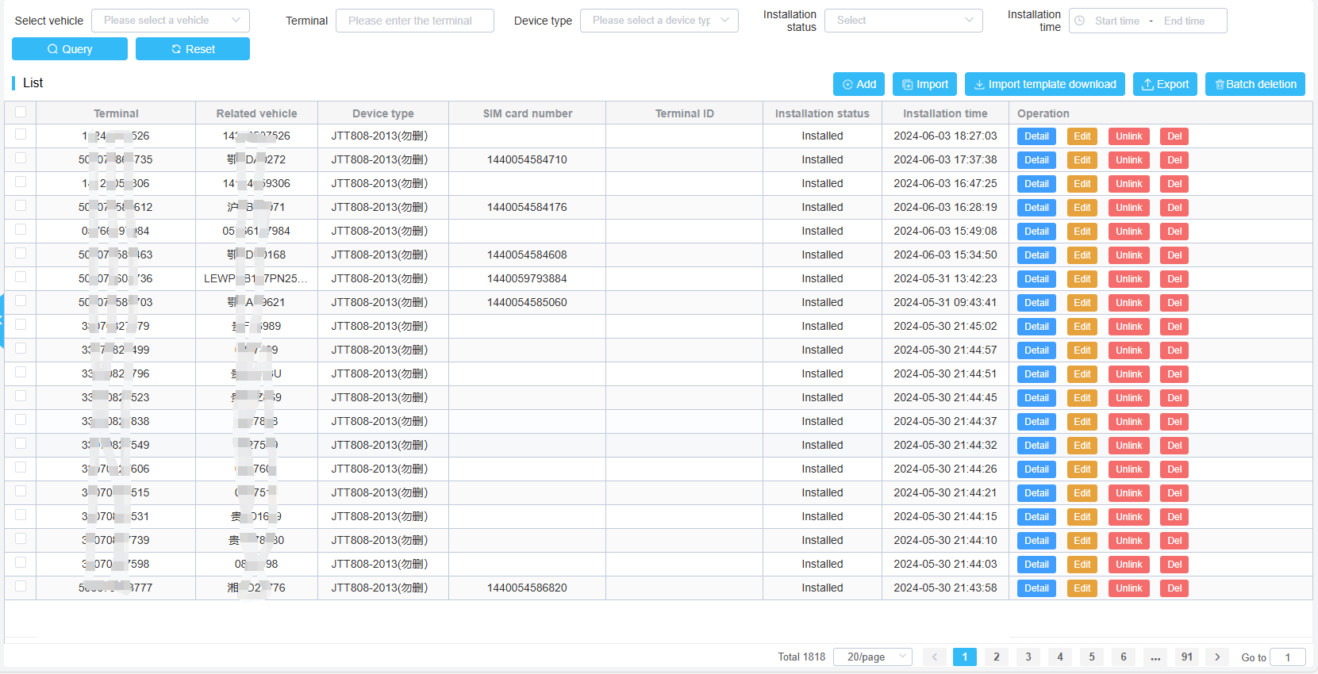

#### Add device

Click the add button to add a device.

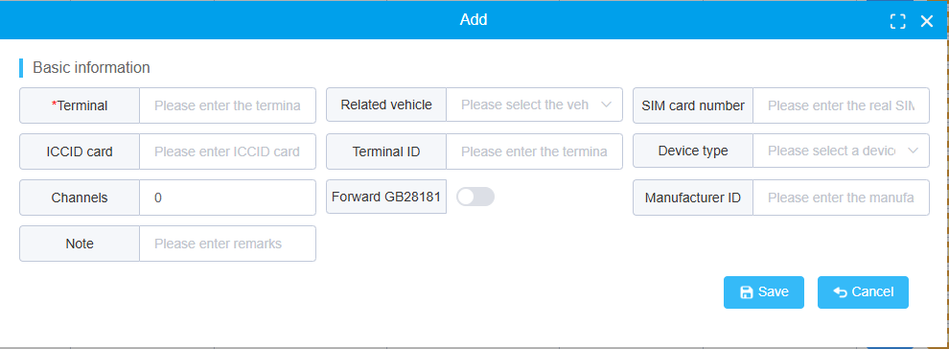

The main input information includes organizational structure, communication number, vehicle, SIM card information, device type, terminal ID, and channel information.

For example, the addition of 808 device: Add a device with the communication number 13800000001. The selected vehicle for installation is Test A0001, which includes a total of 4 channels. The selected device type is GT808-2013

If it is a GB28181 device:

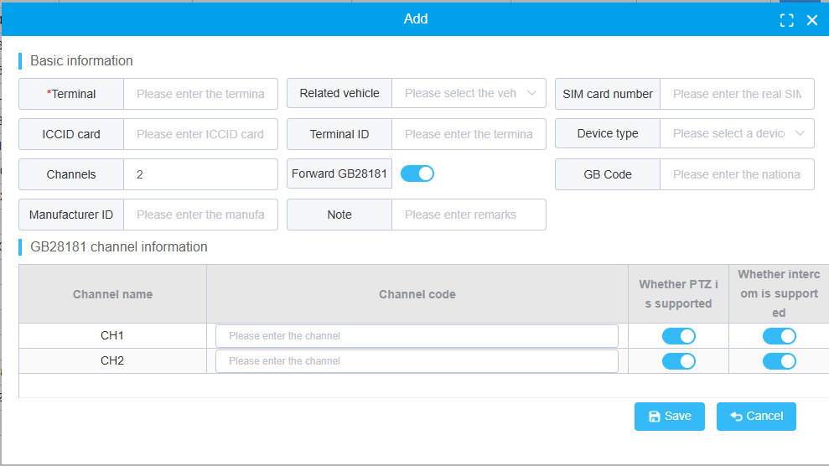

The national standard code of the input channel is required. It should also be noted that support for GB28181 requires the server to install relevant components separately.

If the device is a GB32960 device.

The protocol for selecting electric vehicle equipment is GB32960, and the equipment will interpret and process data according to the standard of GB32960.

#### Device binding and vehicle unbinding

Click the bind vehicle button to bind a device to a vehicle. Only devices bound to vehicles/vehicles bound to devices will be displayed on the vehicle tree.

### Driver management

Driver information can be imported through the interface or Excel. The driver's information includes the driver's name, professional qualification certificate, pictures of various certificates, etc. It should be noted that the Excel import method currently cannot import images, so images need to be uploaded separately.

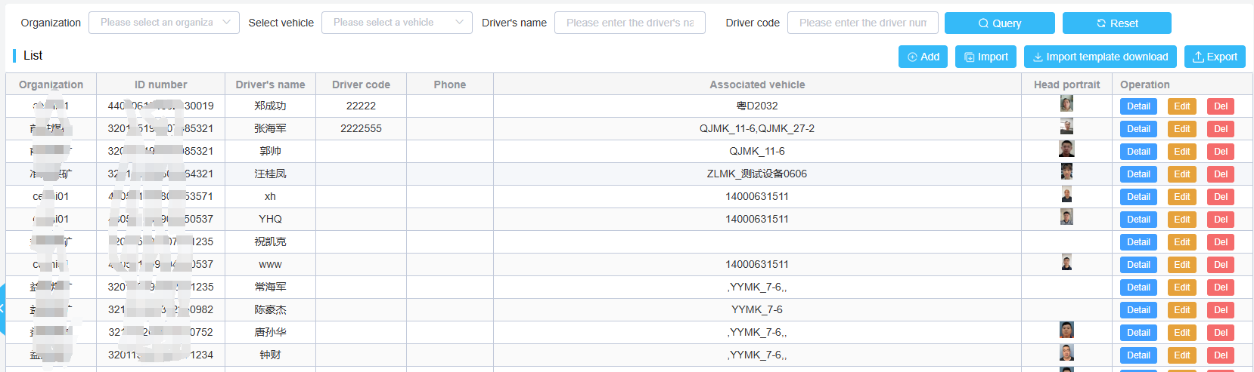

The management system supports facial recognition function. If the device supports Jibiao, etc., you can click the "Send to Device" button next to the image to complete the synchronization of the platform driver image and the device.

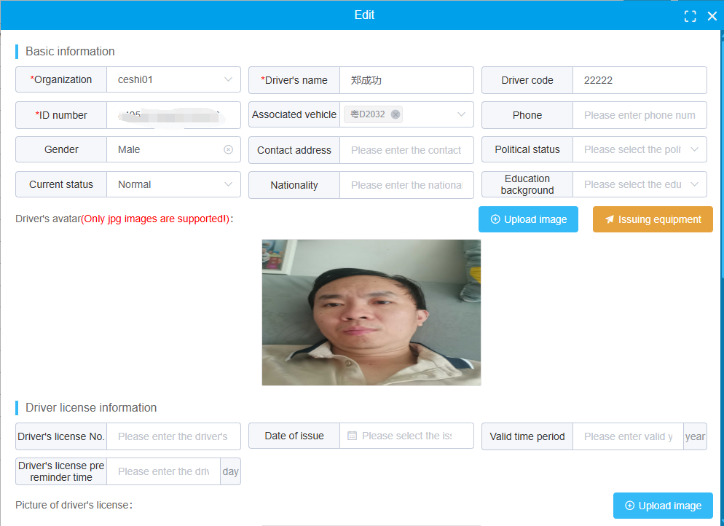

The results of facial recognition will be displayed in the attendance report.

## Rule management

The rule mainly specifies a series of driving guidelines and ranges, and when the vehicle triggers this rule, an alarm will be triggered.

After an alarm occurs, the platform will send a voice message to the device terminal. The following are some usage instructions and scenarios for the platform's rules.

### Fatigue driving

The fatigue driving rules mainly input the proportional relationship between the driving time and rest time of the vehicle at a specific speed.

When the driving intensity of the vehicle is too high, an alarm will be triggered. Of course, this rule also takes effect within the validity period of the rule.

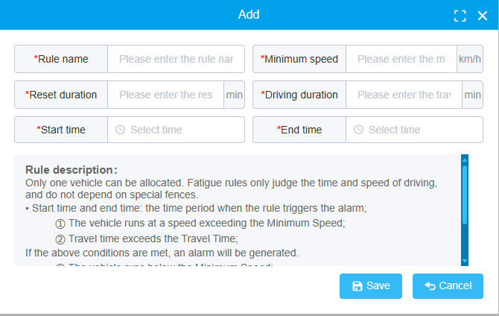

### Rule for prohibiting access

The prohibition rule mainly alerts when a vehicle enters an area.

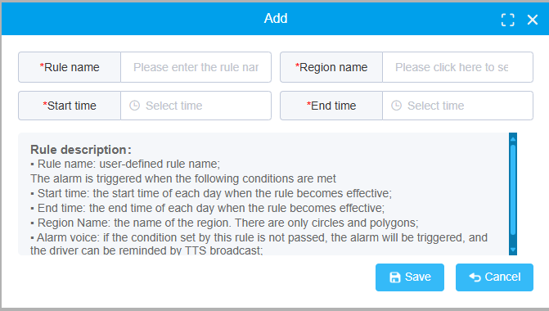

### Rule for prohibiting out

Like the no entry rule, the no exit rule mainly restricts vehicles from alerting when leaving the area.

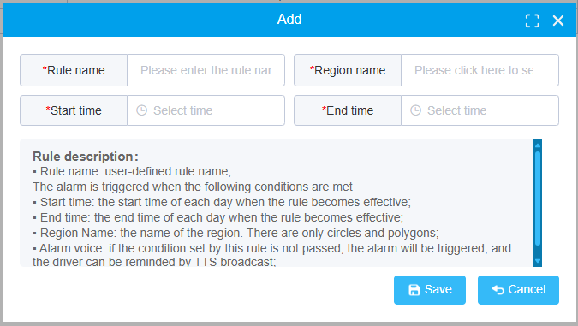

### Regional speed limit

The regional speed limit rule is mainly used to limit the speed of vehicles in a certain area. When the vehicle's driving speed exceeds the maximum threshold of the rule or falls below the minimum threshold, the platform will generate an alarm.

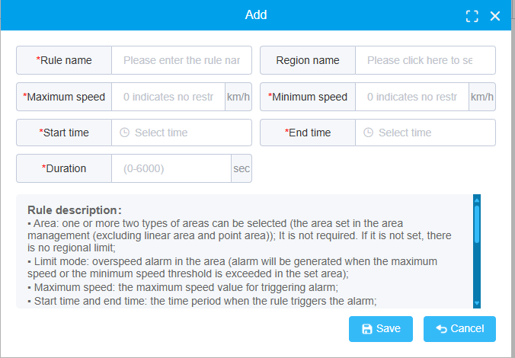

### Route section rule

In regional management, we have designated certain routes on which vehicles must operate. Once deviations occur,

The system will automatically generate an alarm. To set route rules, you need to set the width of the alarm generated by the route.

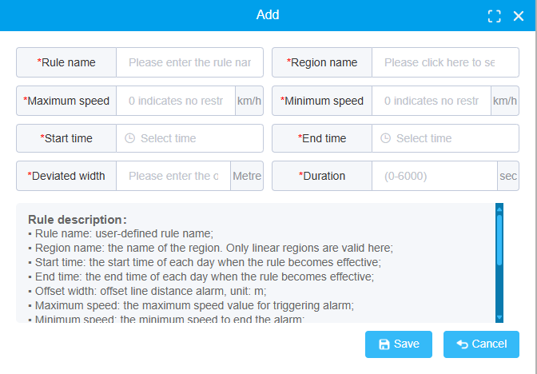

### Key point

The key point alarm mainly refers to whether the vehicle has arrived or left at the characteristic location. Otherwise, an alarm will be generated.

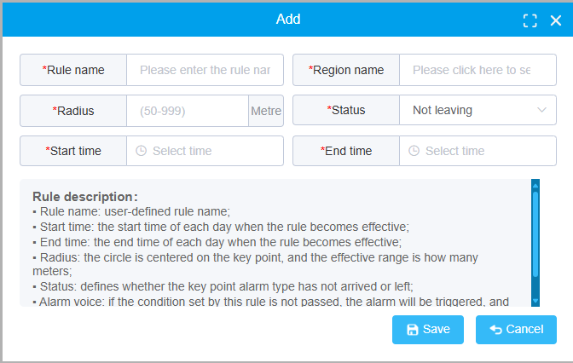

### Parking time exceeded

The timeout parking rule is mainly used to restrict vehicles from staying for a long time, and to alert and handle vehicles that are staying.

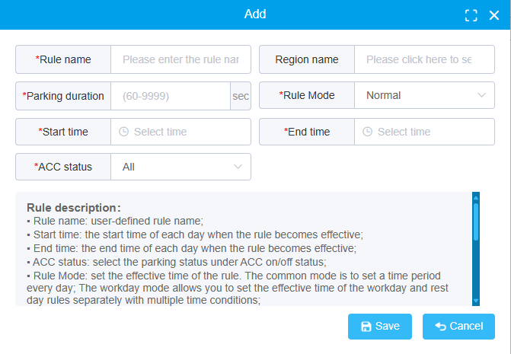

### Scheduled photographing

Timed photography is a special rule that allows vehicle devices with cameras to upload photos according to a time schedule.

After setting the time and camera. The system will regularly send instructions to capture photos and store them on the platform.

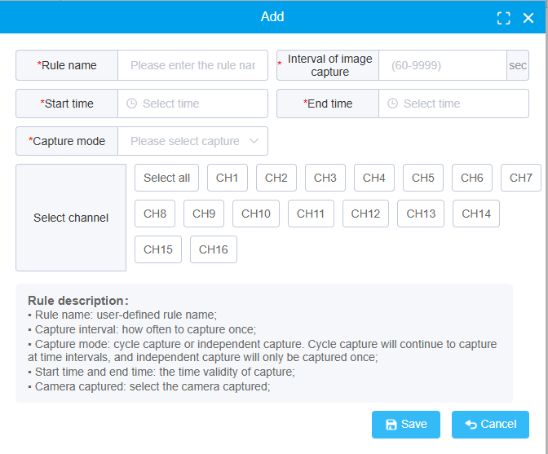

### Alarm linkage

Alarm linkage is also a special rule, which involves developing some plans to determine whether to take photos and record videos when an alarm occurs, which is equivalent to obtaining audio and video information at the time of the alarm as on-site evidence. Alarm linkage is effective for all types of alarms.

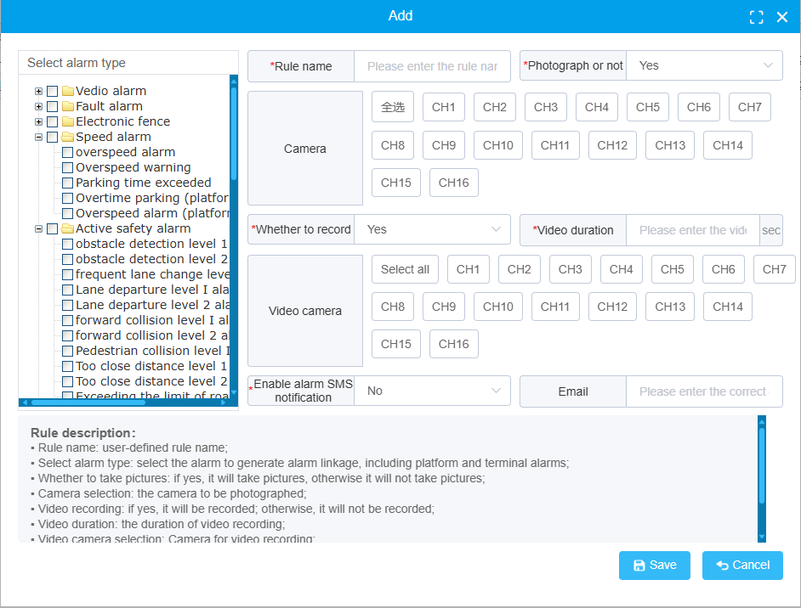

### Abnormal position

Abnormal position alarm refers to the situation where the terminal ACC of the vehicle is in an open state and the device does not upload GPS position continuously; Or to put it another way, the position has been in an undefined state, and the device's position is abnormal at this time.

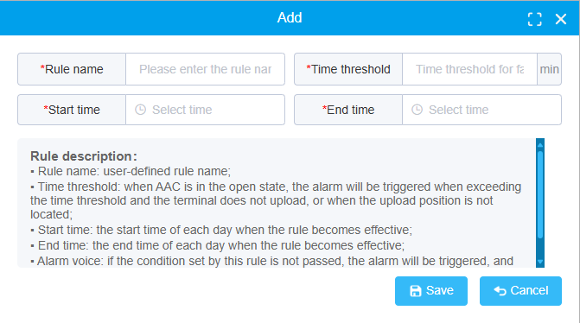

### Abnormal ACC signal

ACC abnormality refers to the situation where the vehicle is continuously in a certain speed state while the ACC is in a stall state for a period of time. At this point, the stalling information is false, and the actual vehicle is still moving. At this point, the platform generates an alarm.

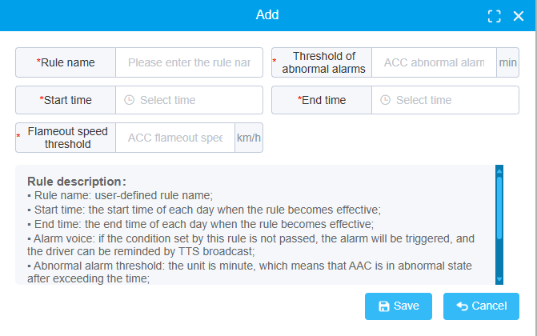

### Off-line alarm

Offline alarm is a platform rule that automatically generates alarms for devices that have been offline for a long time. So as to enable management personnel to understand which vehicles have not been used for a long time or have terminal problems.

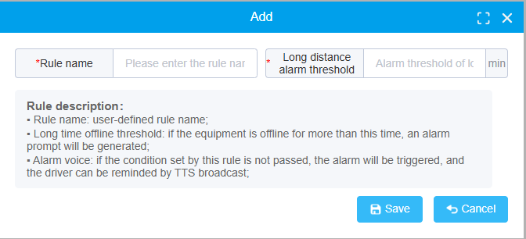

## Regional management

### Region setting

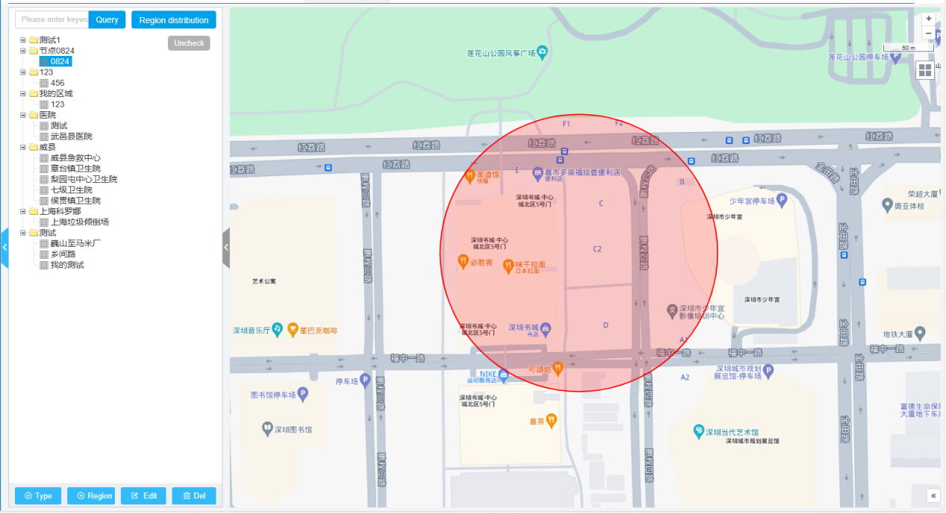

#### Add regional grouping

Click type +,to add a group

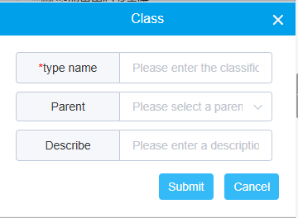

#### Add region

Click region +,to add a region,the main types of regions include centers, rectangles, polygons, line segments, and points.

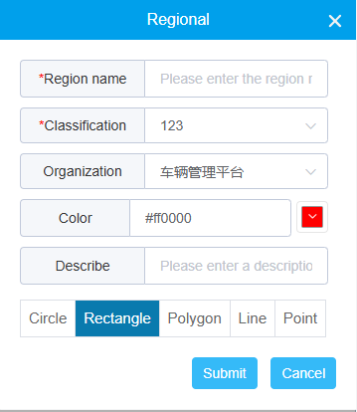

#### Edit and delete groups/regions

Select a group or area, click the edit and delete buttons to edit and delete information.

#### Region distribution

Click the area distribution button to distribute some area rules to designated vehicles。

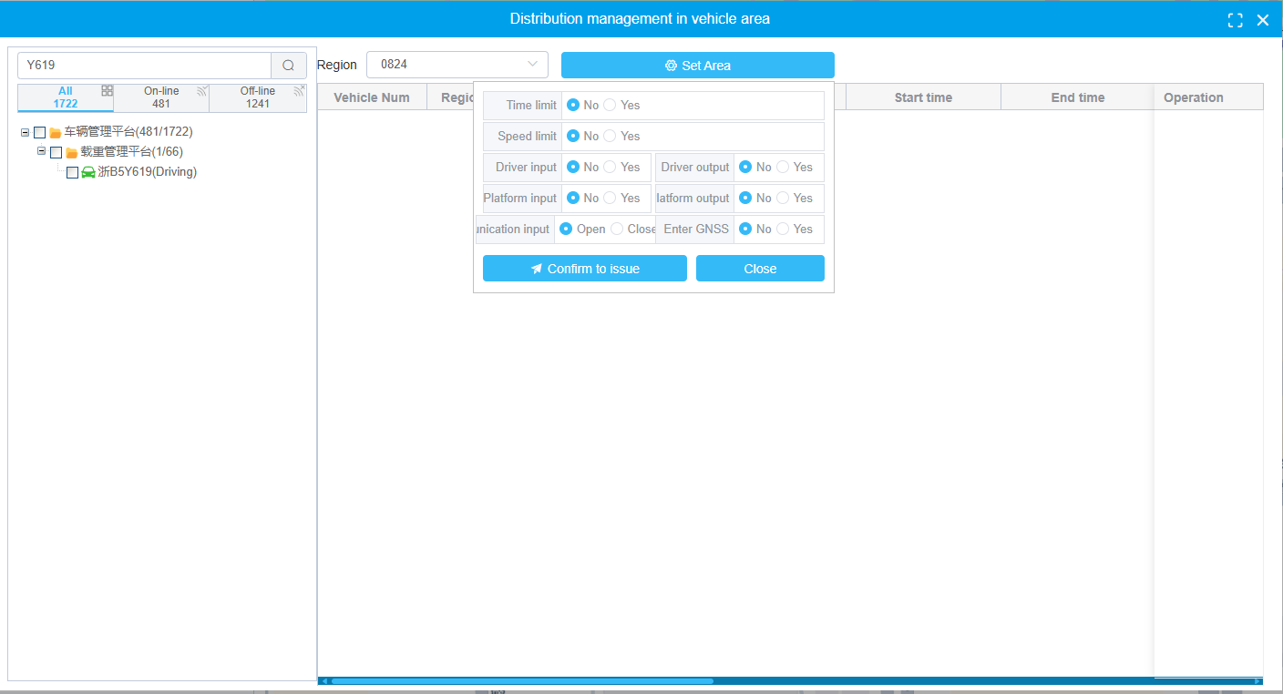

### Region monitoring

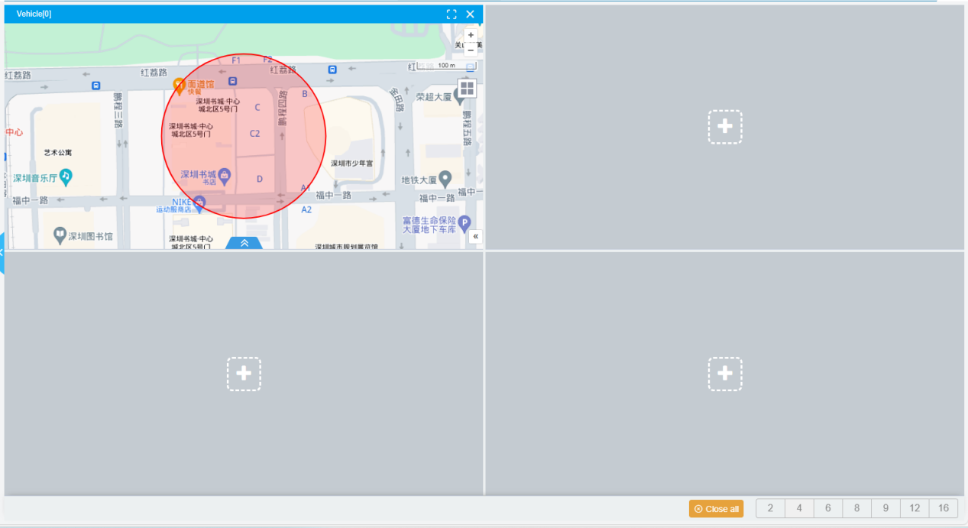

In the area monitoring operation panel, select an area. You can monitor the number and status of vehicles in the area.

### Prohibited entry region

According to the selected prohibition rules, the current illegal entry vehicles, as well as the vehicles that entered and left illegally today, will be counted.

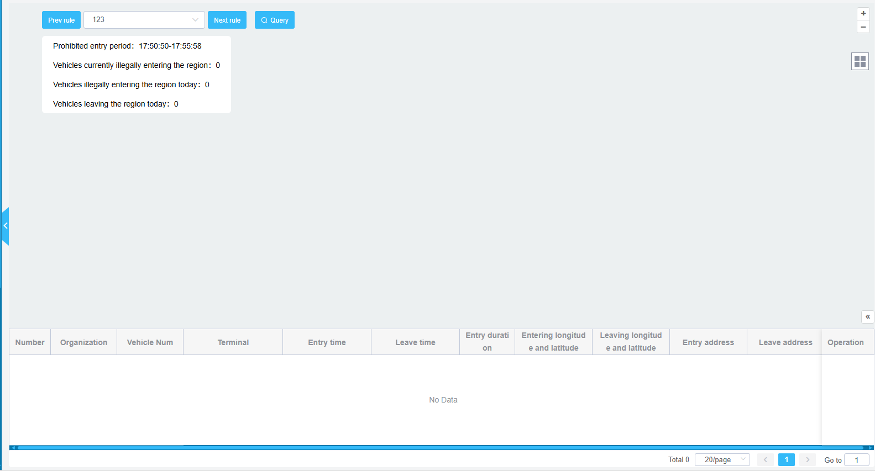

### Prohibited leave region

According to the selected prohibition rules, the current illegally driven vehicles, today's illegally driven out and returned vehicles will be counted.

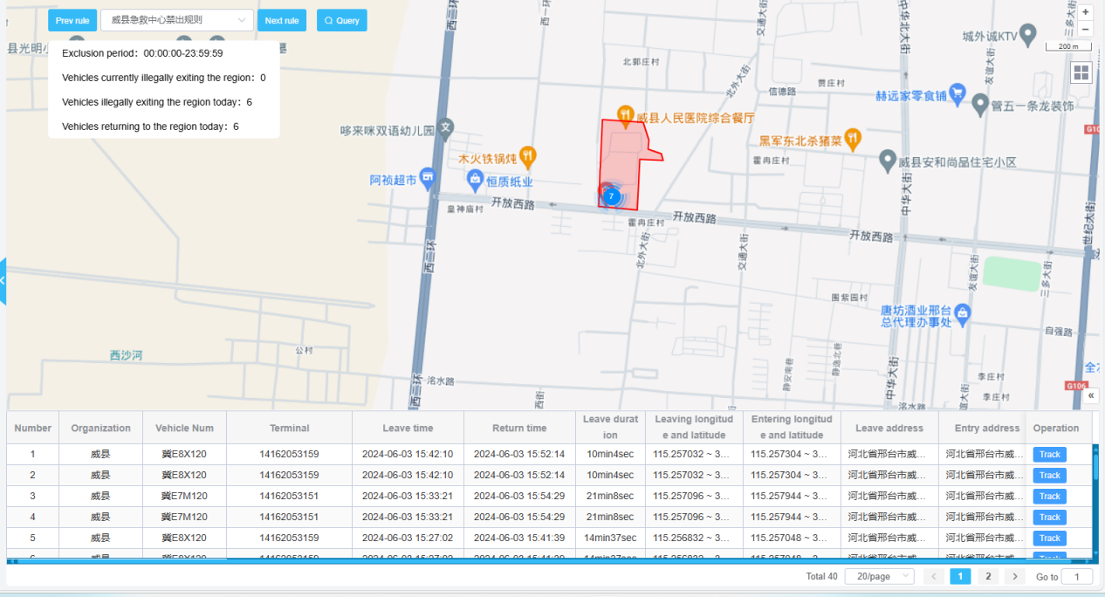

### Markers management

You can draw your own location annotations on the map, and you can see these annotation areas where you use the map.

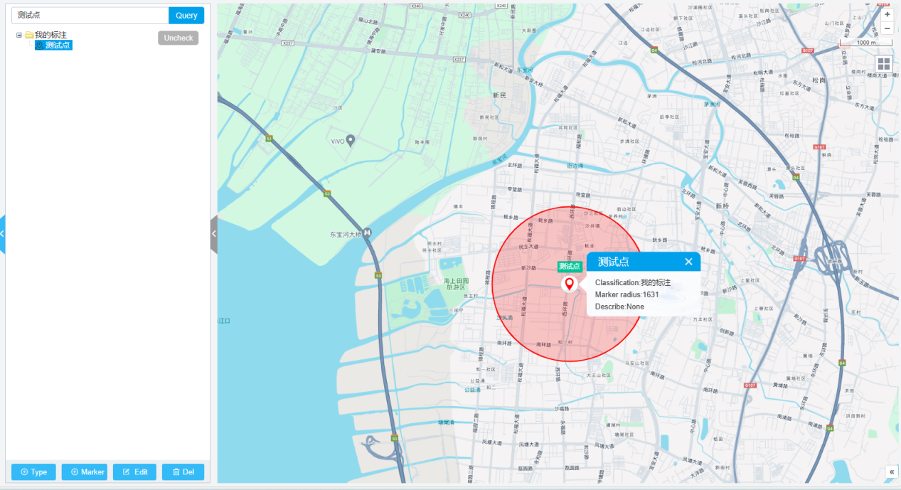

## DevOps manage

### Instruction sending

The platform supports issuing commands to device terminals. Mainly includes issuing server parameters, setting alarms and electronic fences, modifying camera parameters and image resolution, etc.

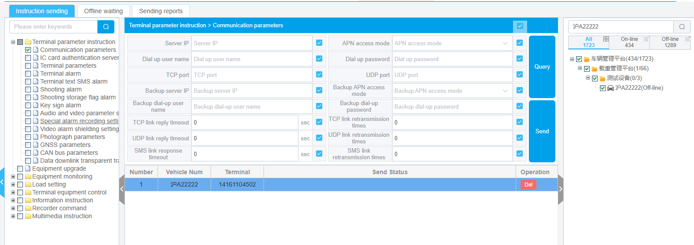

The platform supports offline issuance function. If the device is not online, the server will store instructions. Once the device is online, the instructions will be issued to the device.

#### Configure server parameters

Under the terminal parameter command, select communication parameters and select the vehicle to be configured on the right side. You can click on query to find the communication server address and port of the device. After modifying the query results, you can click send. Complete the modification of server parameters.Note: Do not easily modify server parameters. Once modified, the device will no longer be under platform control.

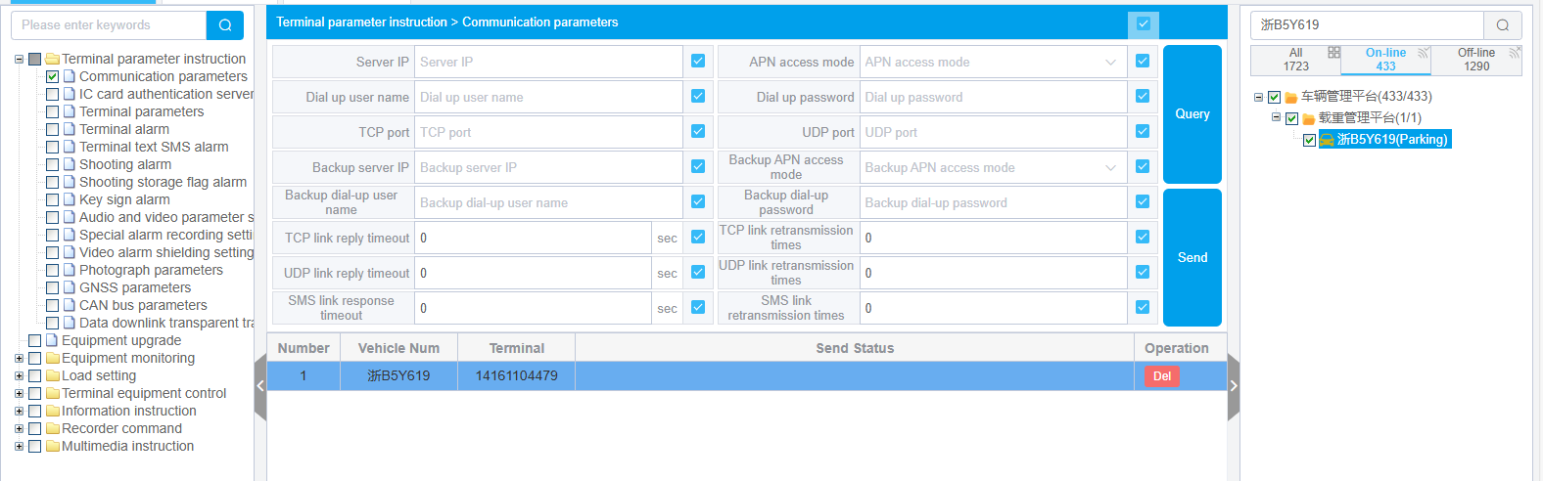

#### Configure GPS upload interval

Under the device monitoring interface, select Continuous Monitoring.

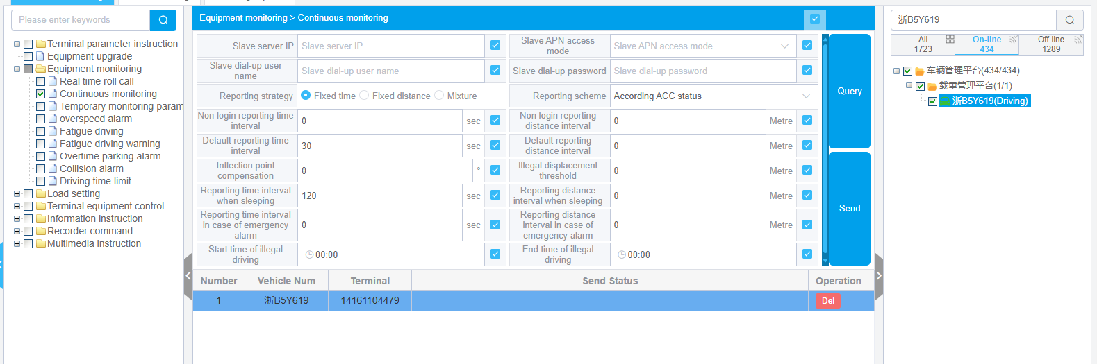

Set the GPS upload time and report time during sleep, select the vehicle to be uploaded on the right side, and send instructions to the device to modify the GPS upload time interval.

#### Configure alarms

Select terminal alarm and select the alarm item. Select the device on the right and click send. The selected alarm will be reported to the platform once the alarm conditions are met.

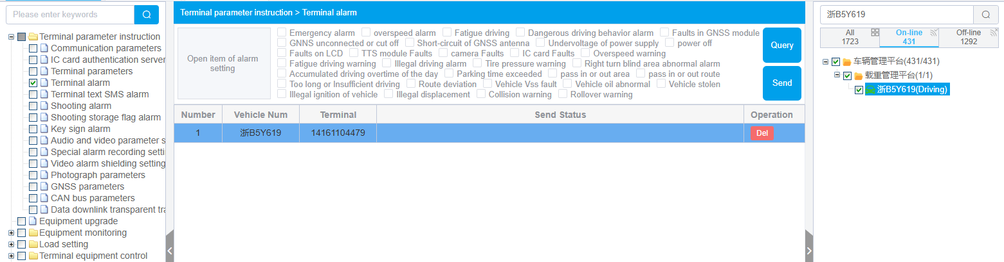

#### Other instructions issued

The platform also supports monitoring parameters, driving record instructions, device terminal control, and mass sending of text messages.

#### Offline waiting

For devices that are not online, the information sent will be temporarily saved on the platform and recorded as offline pending. Wait for the device to go online before sending instructions to the device.

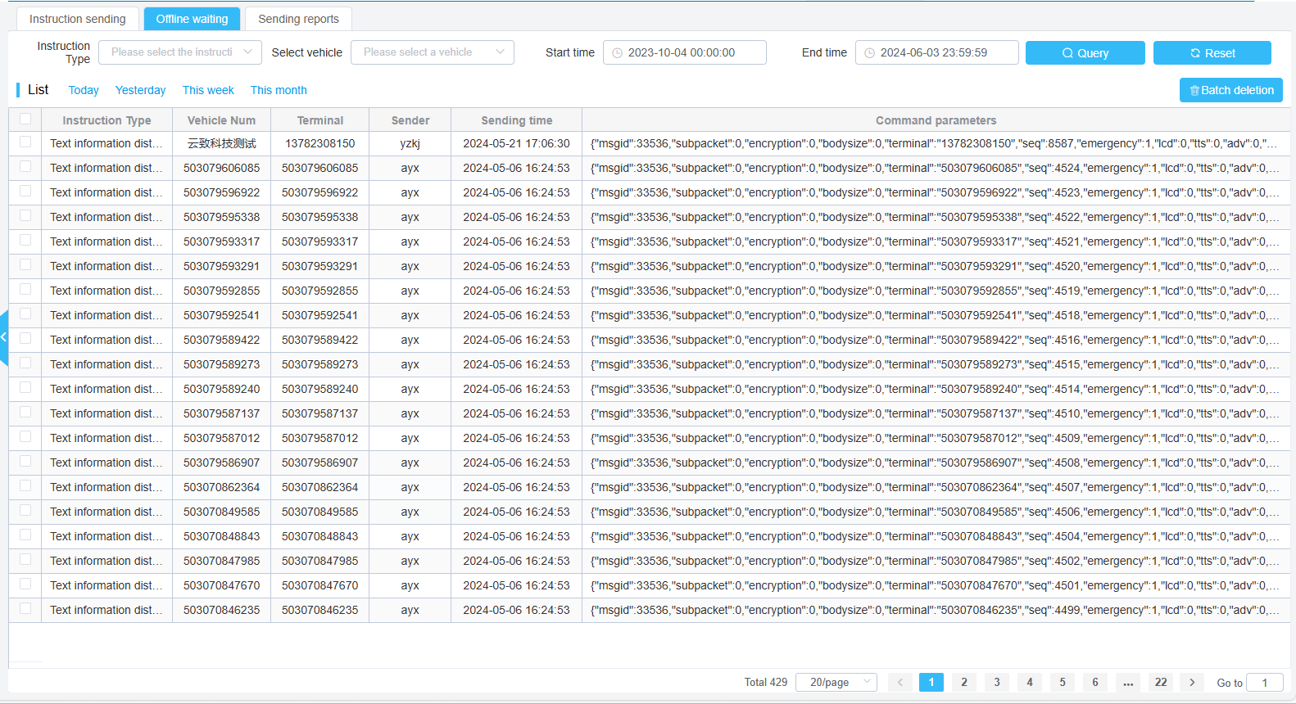

#### Sending reports

The platform can view the sent records, including the sending device, time, content of instructions, etc.

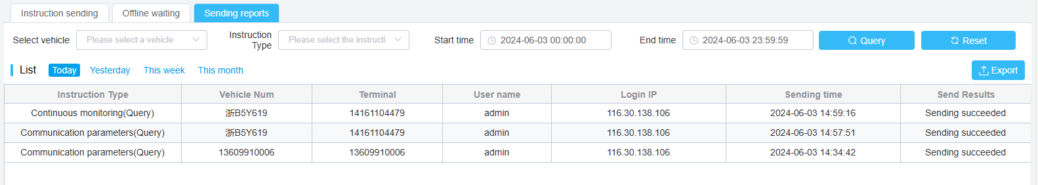

### Device information Query

Check the vehicle on the left to view all device information for that vehicle。

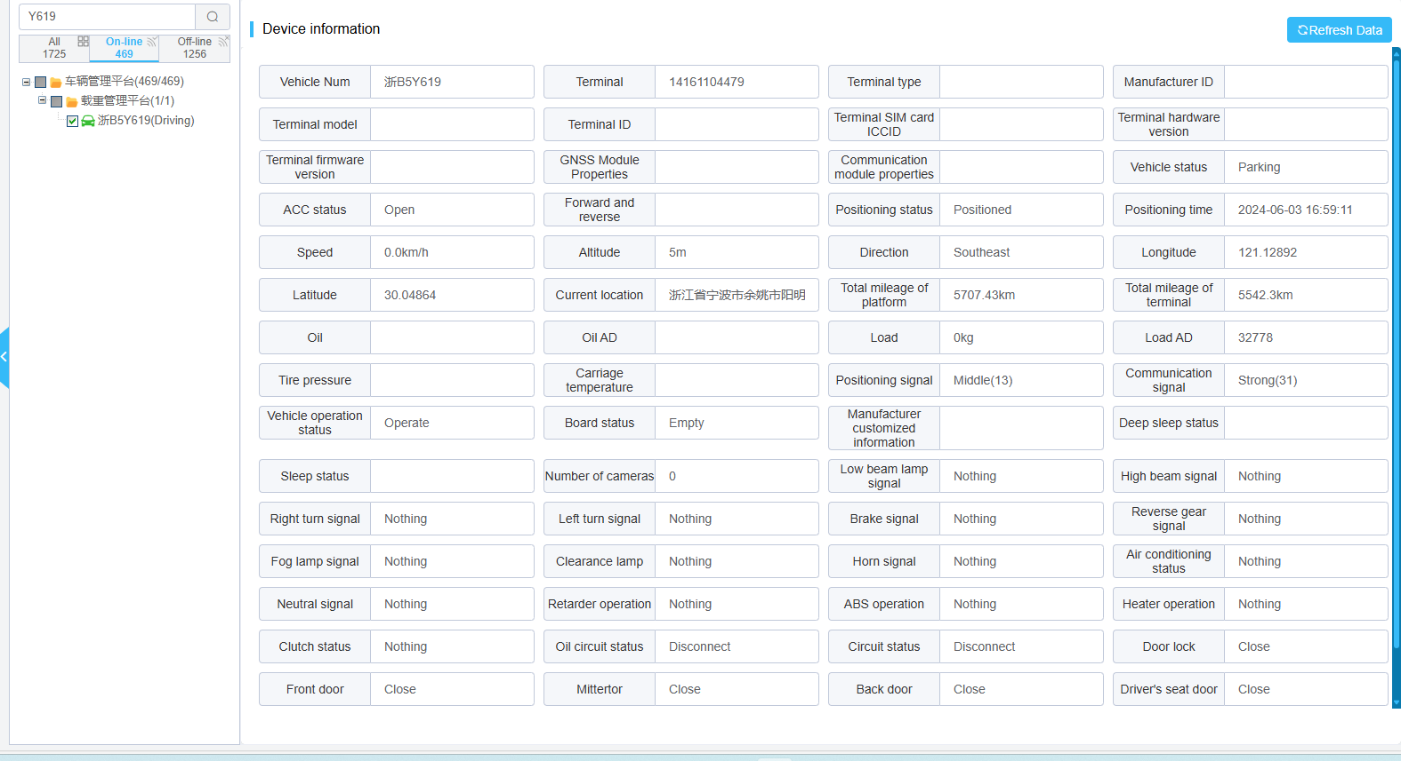

### Informative templates

Manage upgrade templates, regular templates, and log download templates. Once created, they can be directly used for other necessary functions.

On the add page, click the fill in type button to define the dynamic content of the template. The content generated by clicking the button should not be changed during editing. The corresponding content for this section is automatically generated and filled in by the system.

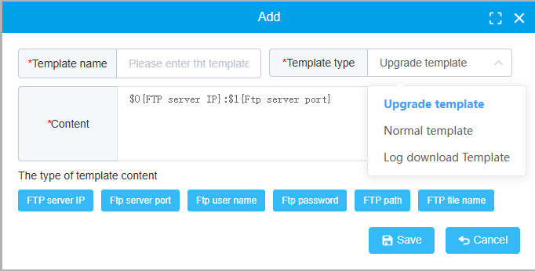

### Software update

#### Send text information to update

Select the vehicle equipment to be upgraded, click the upgrade button, select the upgrade file and template in the pop-up box, and click upgrade to perform remote device upgrade operations.

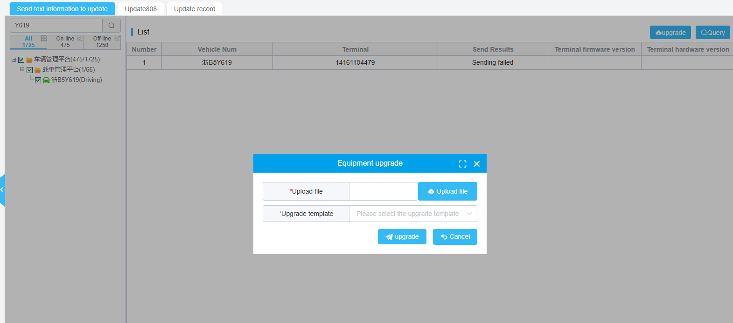

#### Update 808

Select the vehicle equipment to be upgraded, click the upgrade button, select the upgrade file in the pop-up box, enter the upgrade version number, and click upgrade to remotely upgrade the equipment.

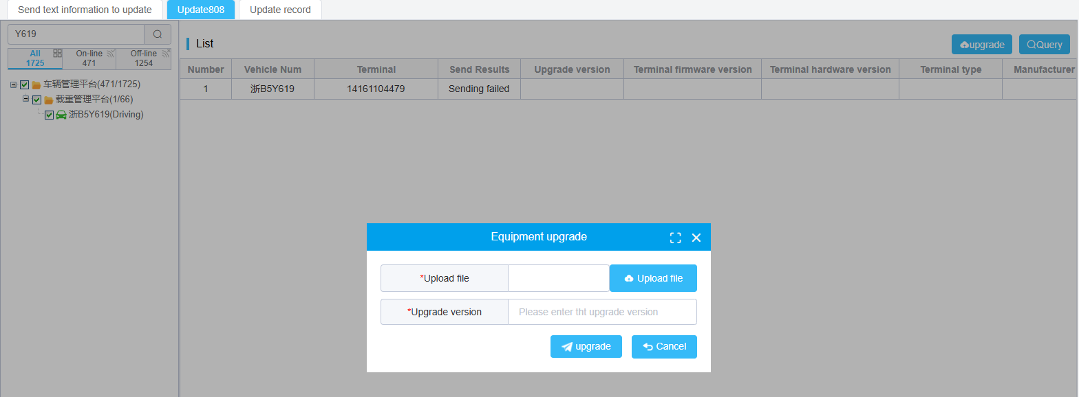

#### Update record

All remote upgrade records can be viewed in the upgrade record function.

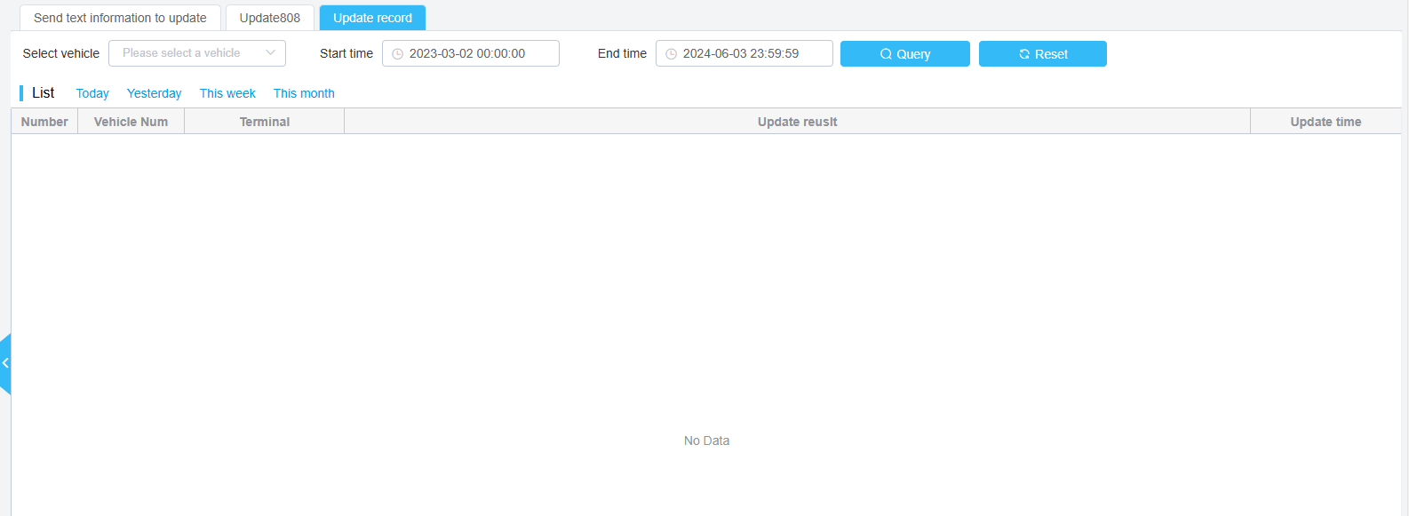

### Online and offline analysis

#### Organization online rate

Display the online and offline changes of all vehicles within the query time range in the form of curves.

Display the total number of vehicles, online total number, and online rate of different institutions within the query time range in a table format.

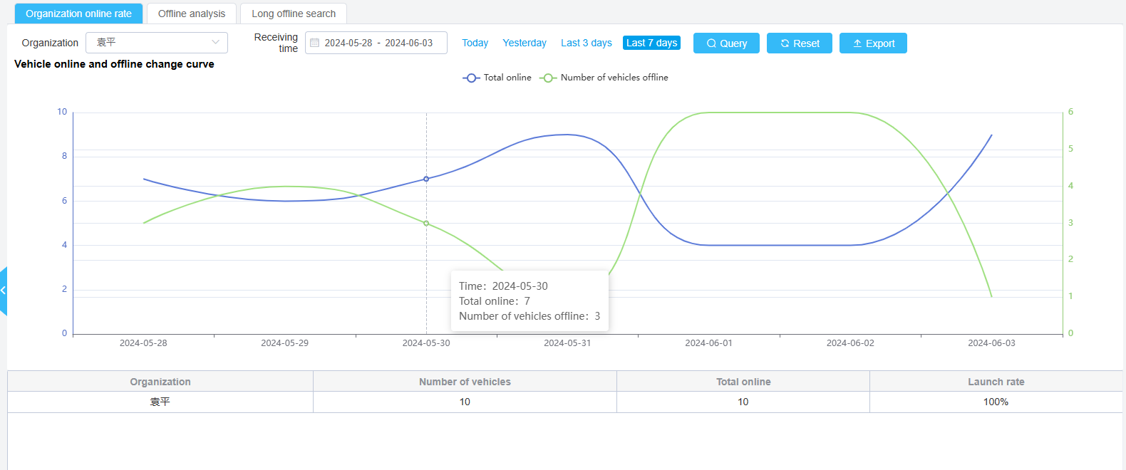

#### Offline analysis

Display the proportion of vehicles with different offline times in the form of pie charts.

Display the offline status and last offline time of each vehicle in the form of a table.

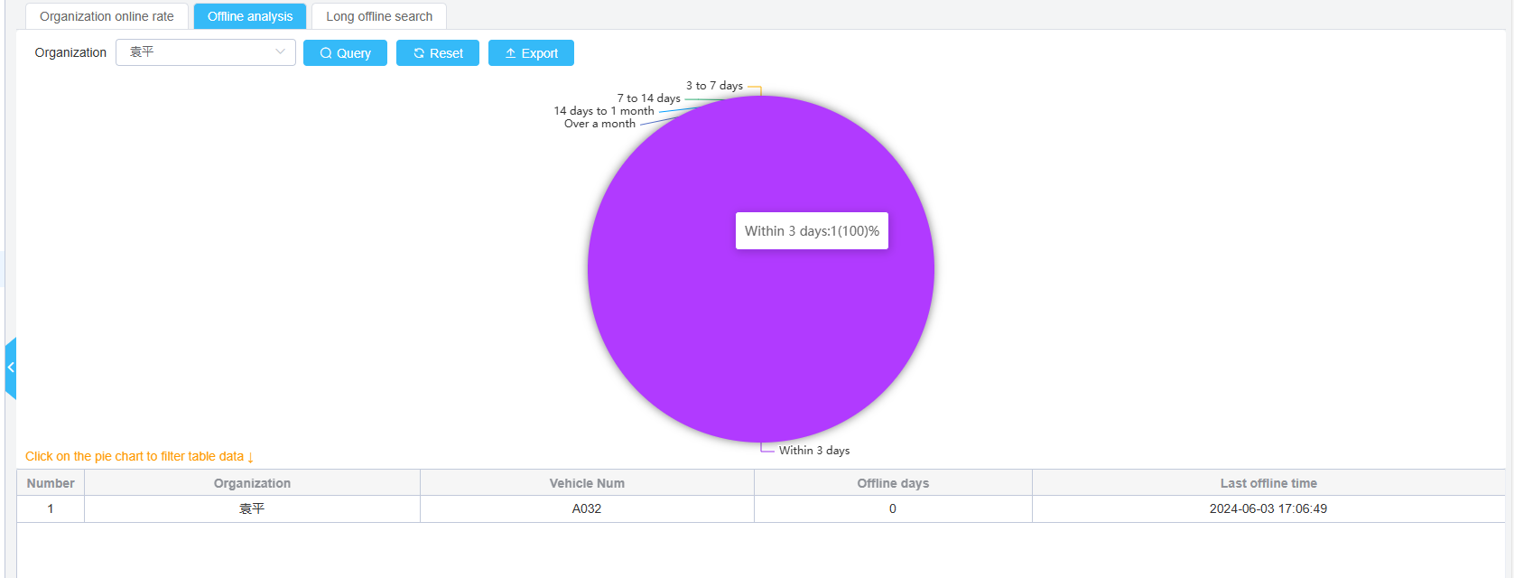

#### Long offline search

According to the query criteria, search for vehicles that meet the criteria, including the current status, location, and most recent location time.

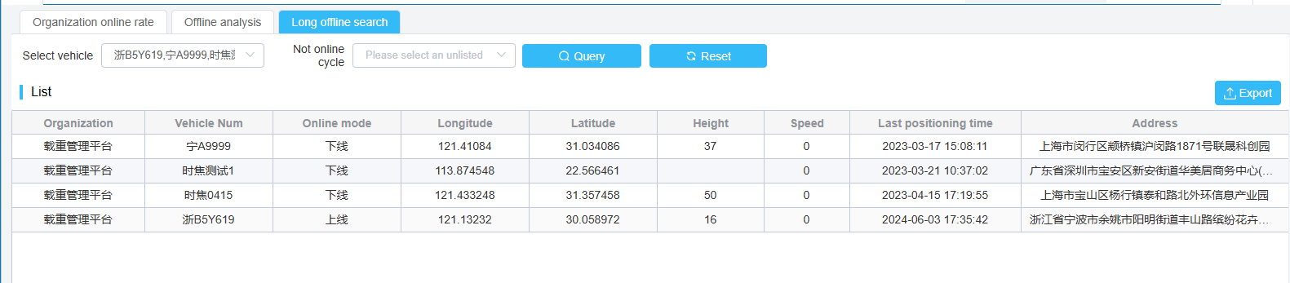

### Fault analysis

It is possible to query various types of device fault data and their proportions, as well as the time changes of fault occurrence, as well as the current status, fault time, and current location of the faulty vehicle.

Clicking on the pie chart can filter the data in the table.

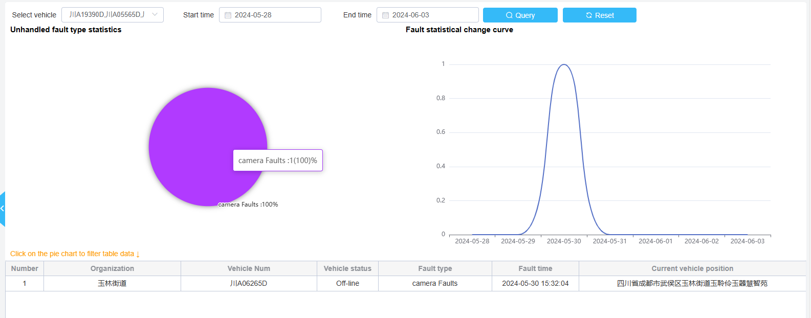

## Sensor Management

### Calibration of oil quantity labeling

After installing the oil sensor on the vehicle, it needs to be calibrated before use. The system is calibrated in two ways.

1. Calibration: Input the AD of the oil quantity and the numerical value of the oil quantity for calibration. This method is relatively accurate but difficult to implement. This method is used to calibrate some irregular fuel tanks.

2. quickly Calibration of refueling receipts. Can quickly calibrate at time points based on changes in oil volume and AD. This method is fast, but the disadvantage is that it is only suitable for calculating regular fuel tanks.

If the fuel tanks of all vehicles are consistent, you can directly input the fuel tank parameter type for quick calibration. Actually, it's also a way of annotation.

Click on the rule description to provide a detailed list of the specific meanings of some parameters used by sensors.

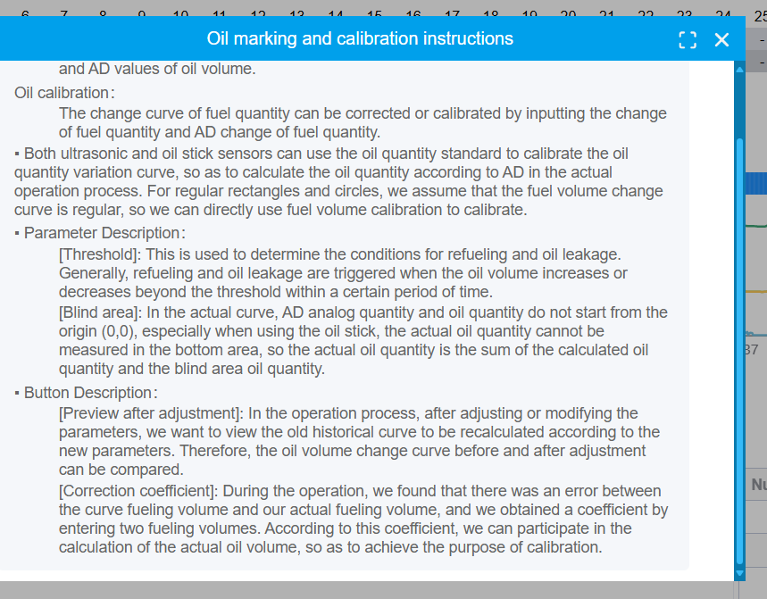

The operation manual for operation labeling is as follows:

1. Enter the annotated parameters, the AD of the oil quantity, and the corresponding oil quantity. Click Add to add an oil quantity annotation point

2. Input analog quantity and oil quantity multiple times

3. Click to save the current annotation

4. The preview button after calibration can be used to preview the comparison of the oil volume curve before and after calibration.

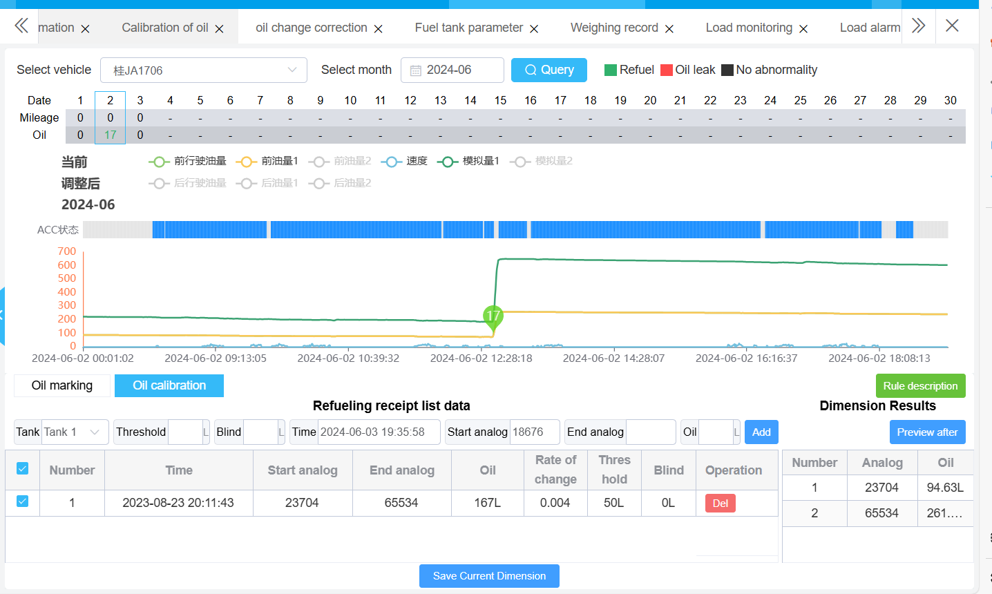

The method of operating oil level calibration is as follows:

1. Input parameters

2. Select the start analog input box with the mouse, click on the starting position of the refueling point on the curve with the mouse, and the data will be automatically filled into the input box

3. Select the input box for the end analog quantity with the mouse, click on the position of the end refueling point on the curve, and the data will be automatically input into the input box.

4. Click save to complete the oil level calibration.

### Add oil leakage correction

Users can correct the refueling and oil leakage information generated by the system. Including deleting refueling oil leakage records and modifying the values of refueling oil leakage

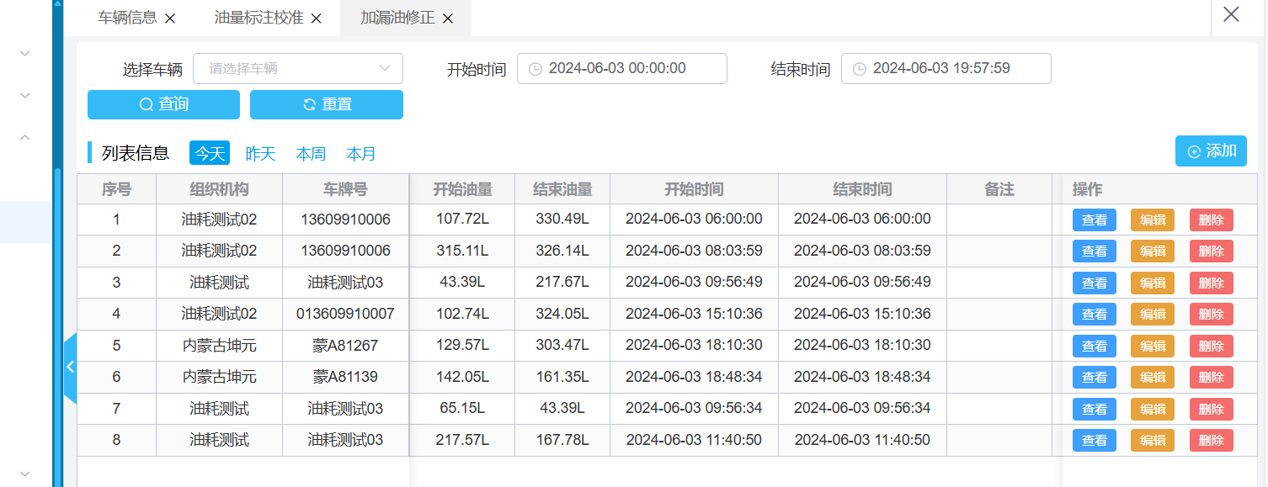

The deleted records will not be displayed on the curve, nor will they be counted in the fuel leakage report. The system will not automatically restore statistics that have already generated alarms and lasted for a long time.

### Load monitoring

The system has the function of monitoring the load situation. It should be noted that the load sensor needs to be properly connected (as defined by the sensor manufacturer).

The specific operation steps are as follows:

1. Select the vehicle, vehicle status, and ACC status

2. Click on the query to display the real-time load data of the system

3. Click on the load curve to view the time curve of weight change.

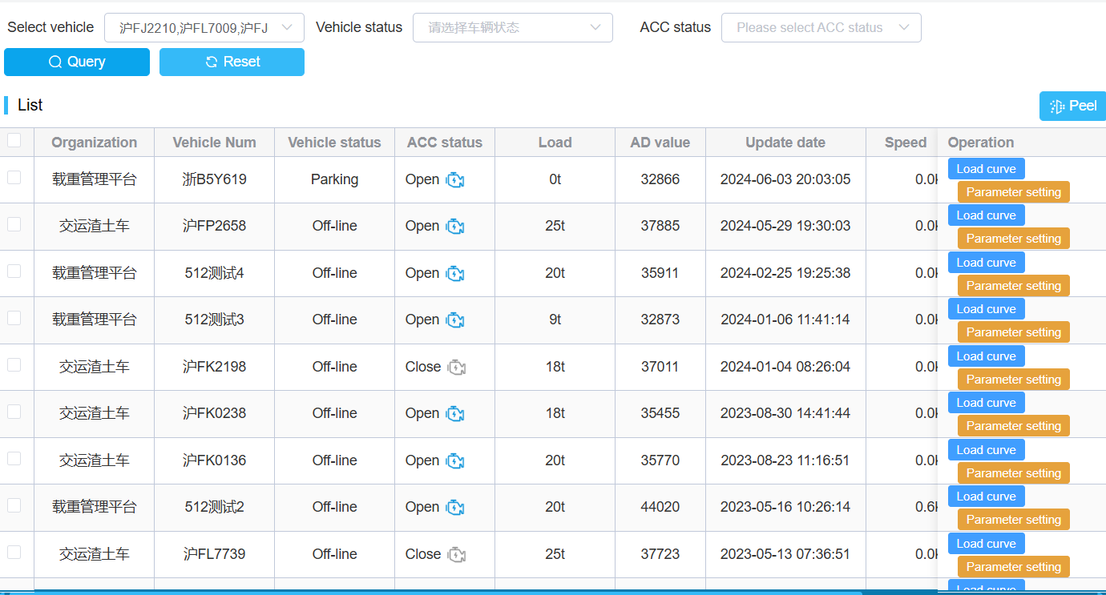

### Load events

The loading and unloading events generated by the system can be queried. The specific operation steps are as follows:

1. Choose the right vehicle and time

2. Click on the query to find all events related to vehicle loading and unloading.

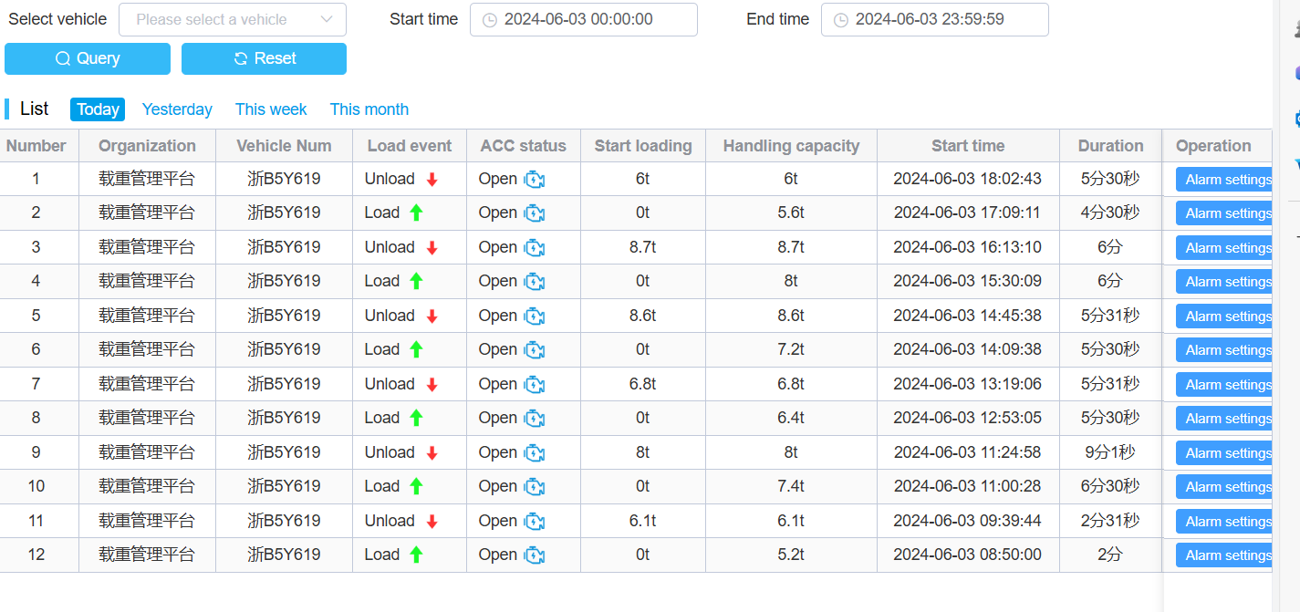

### Load alarm

System support, illegal unloading, unloading too long, and unloading alarm outside the fence. After the system detects these alarms, it can be queried on the load alarm interface.

## System parameters

### Role Management

The role is used to control the permissions of user menus. The specific steps to add a role are:

1. Click the add button to add a role

2. Enter name, description, and save

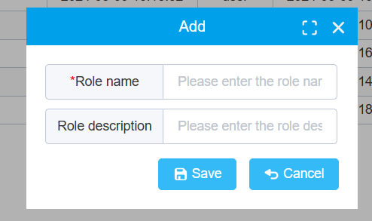

The system assigns various roles to users. Different character views are different. The functions and access permissions of different roles also vary. Click on permission assignment to assign permissions to the role.

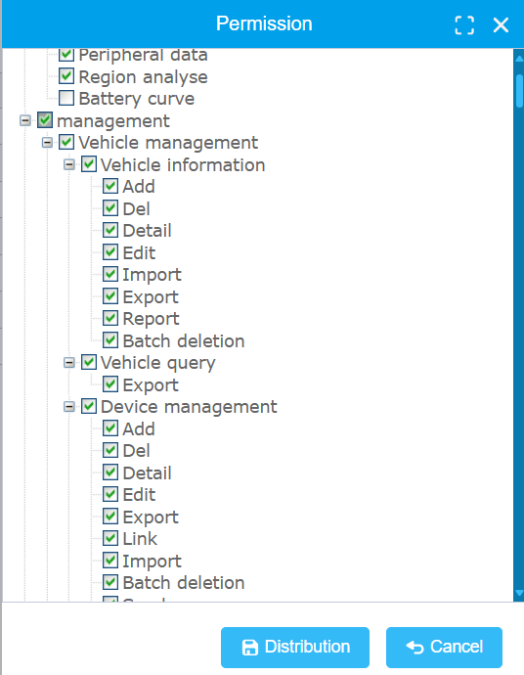

The role is of great significance for systems that require multiple users and permission management.

### user management

User management provides different login accounts for the system, requiring input of information such as organizational structure, role, login name and password, and more

User's personal information, system title and logo that the user sees.

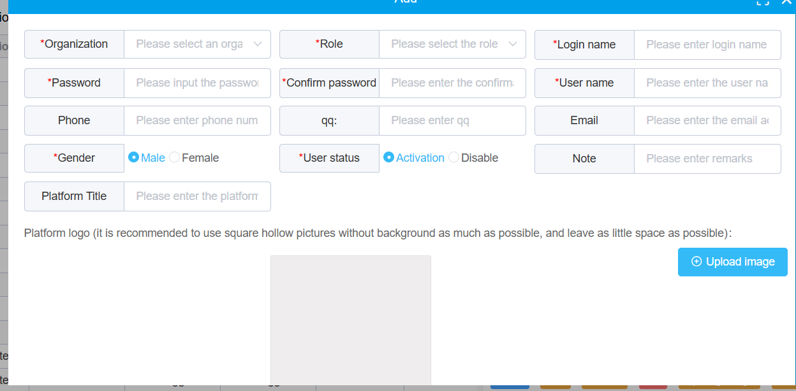

Users can only see vehicles, drivers, equipment, statistical information, and alarm information belonging to their own organization and subordinate organizations. Users can only see the menu under the permissions of their role. Many pieces of information, such as alarm configurations and notification messages, are also privately customized for users.

### Organizational structure management

All personnel, vehicles, equipment, users, and other information on the platform are organized through institutions. An organization can be a company, its department, or a fleet.

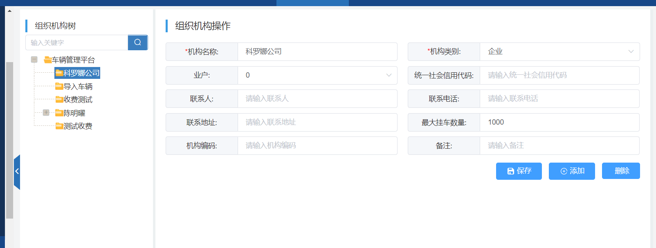

Organization can add sub institutions, delete or modify them. Special reminder: Once an organization is deleted, all information related to vehicles, people, and equipment under that organization will be deleted. So deleting organization requires special attention.

## Vehicle service

### Vehicle maintenance and testing

Vehicle insurance, annual inspection, and maintenance can all be managed by inputting them into the platform, including the time, cost, and factory information of vehicle maintenance, for future reference.

The important operating steps are as follows (using annual inspection as an example)

1. Click the add button

2. Enter the vehicle for annual inspection, time, qualified/unqualified, inspection cost, upload inspection images and invoices

3. Click on save

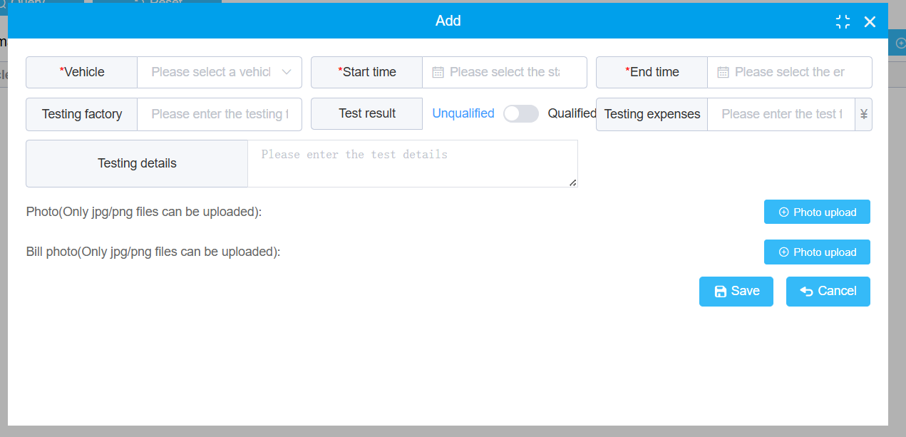

The annual inspection information will be automatically synchronized to the vehicle's main information.

### Vehicle maintenance management

Vehicle maintenance records include maintenance items, repair shops, maintenance costs, maintenance time, and maintenance status (such as application and review).

The operation steps are similar to vehicle maintenance

### Vehicle service expiration reminder

The vehicle service expiration reminder includes information such as vehicle annual inspection, insurance, and driver's employment certificate. When the expiration date is reached, the owner will be notified. Check the expiration status of the certificate. If the certificate expires in the system, it will be displayed on the platform in the form of an alarm. If there is a linkage configuration, the owner will be notified by email or SMS.

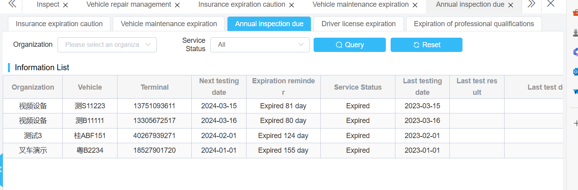

### Input of operating expenses

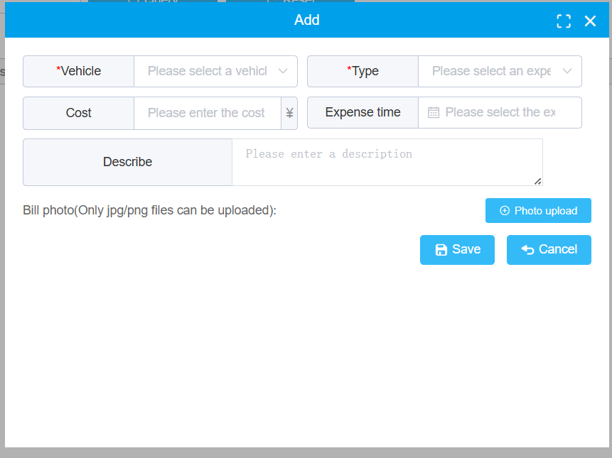

The expenses during vehicle operation can be managed uniformly through the platform, including refueling, charging, toll fees, etc. Invoices can be uploaded to the platform for unified management.

## Message Notification Management

Users can send messages to devices or another user through the platform. Users can send a message to multiple users besides themselves.

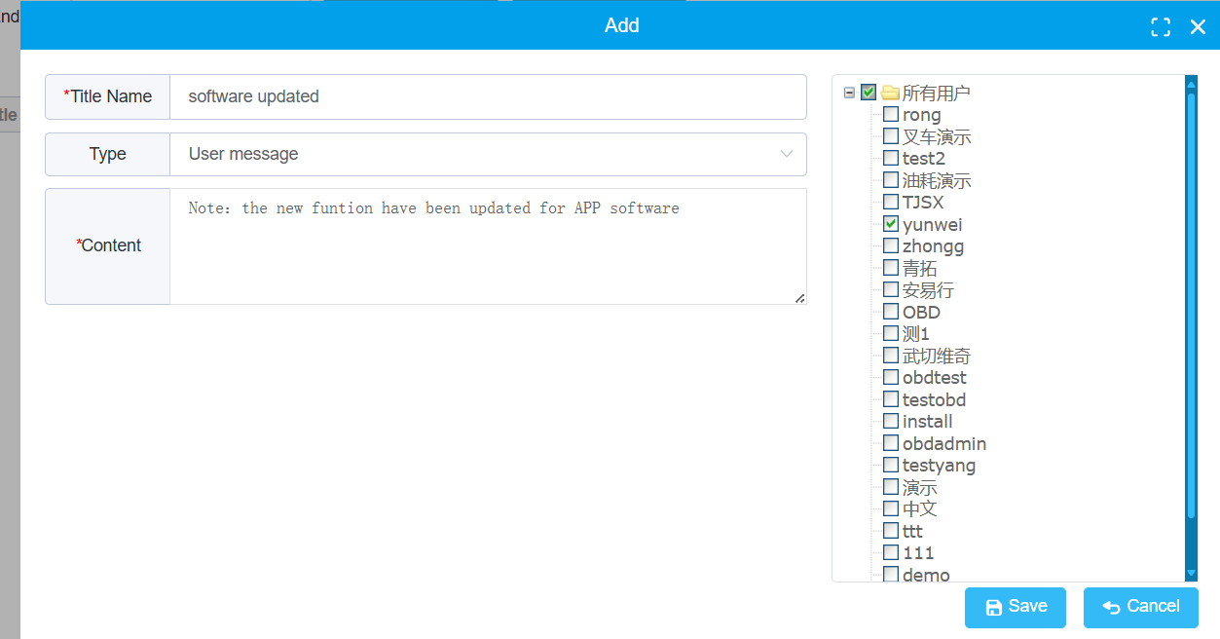

Users can send voice prompts to the vehicle. The message sent can be urgent or non urgent.

You can click on "My Messages" to view messages related to the current user.

# Security management

## Enterprise scoring standard

Enterprises can develop their own rating system to assess drivers, and the rating is based on the number of alarms triggered within 100 kilometers

By deducting points, users can assign the maximum deduction point value to the type of active safety alarm. The maximum score for the driver is 100, and points will be deducted for every 100 kilometers of alarm attempts until the maximum deduction for that alarm type is reached.

**Note: The deduction criteria are recursive from superiors to subordinates. The superior sets a deduction standard, and all subsidiary institutions follow this scoring standard.**

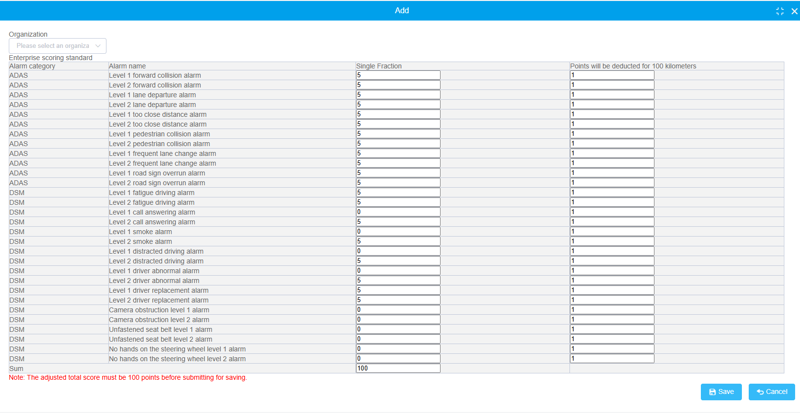

## Evidence statistics

Search for active safety alarm records based on conditions, including license plate number, alarm type, start and end time, start and end position, speed, and other information.

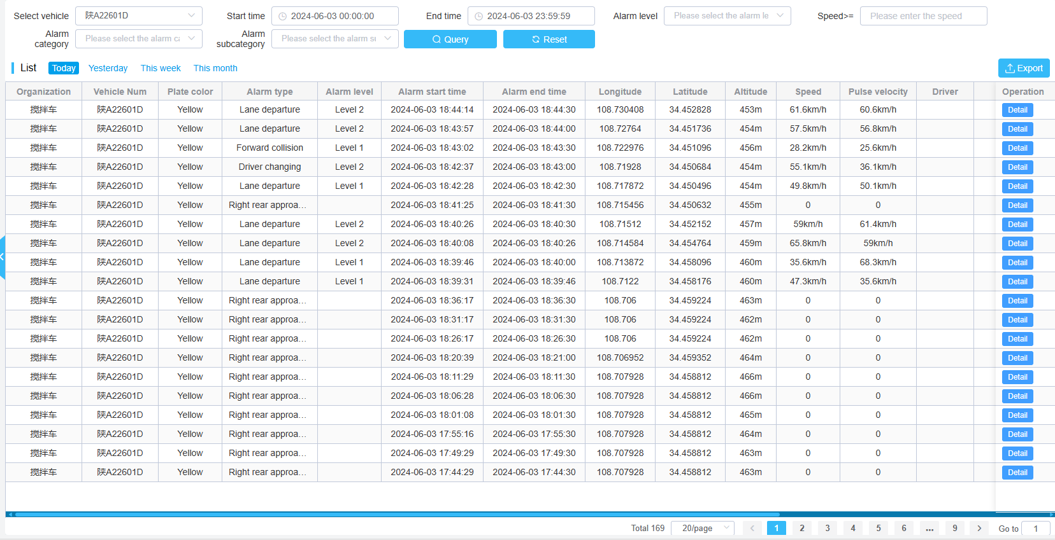

Click the view button to see more detailed content. The videos inside can be played by clicking, and the images can be enlarged by clicking.

You can also export evidence and view the meaning of the status by clicking the corresponding button.

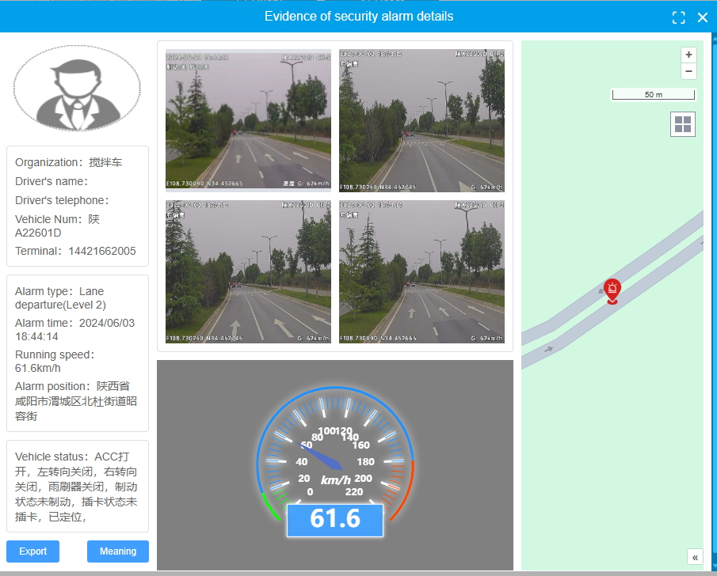

## Security report

### Enterprise alarm analysis

According to the conditions, the number and proportion of active safety alarms at different levels can be queried by institutions, the number and proportion of forward warning alarms, the number and proportion of abnormal driving alarms, the time curve changes of each alarm type, as well as the total number, total mileage, total duration, and specific types of alarms counted by each institution.

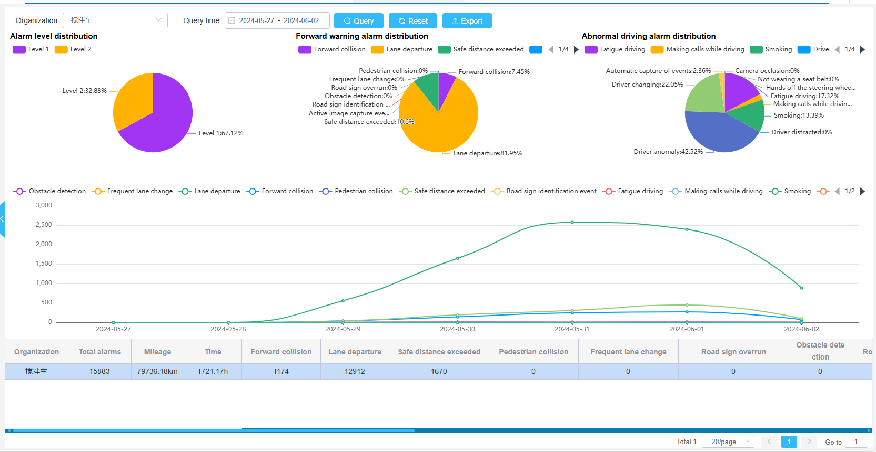

### Vehicle alarm analysis

According to the conditions, the number and proportion of active safety alarms at different levels can be queried by vehicle, the number and proportion of forward warning alarms, the number and proportion of abnormal driving alarms, the time curve changes of each alarm type, as well as the total number, total mileage, total duration, and specific number of alarms for each vehicle.

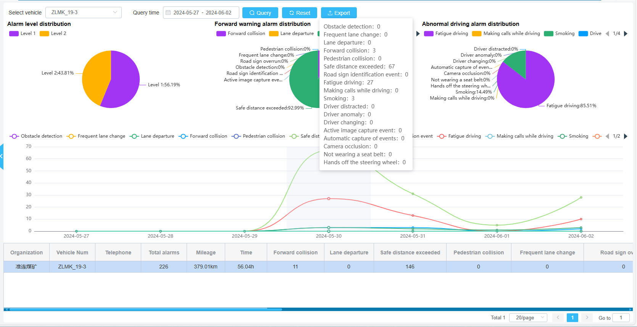

### Driver alarm analysis

According to the conditions, the number and proportion of active safety alarms at different levels can be queried by the driver, the number and proportion of forward warning alarms, the number and proportion of abnormal driving alarms, the time curve changes of each alarm type, as well as the total number, total mileage, total duration, and specific types of alarms counted by each driver.

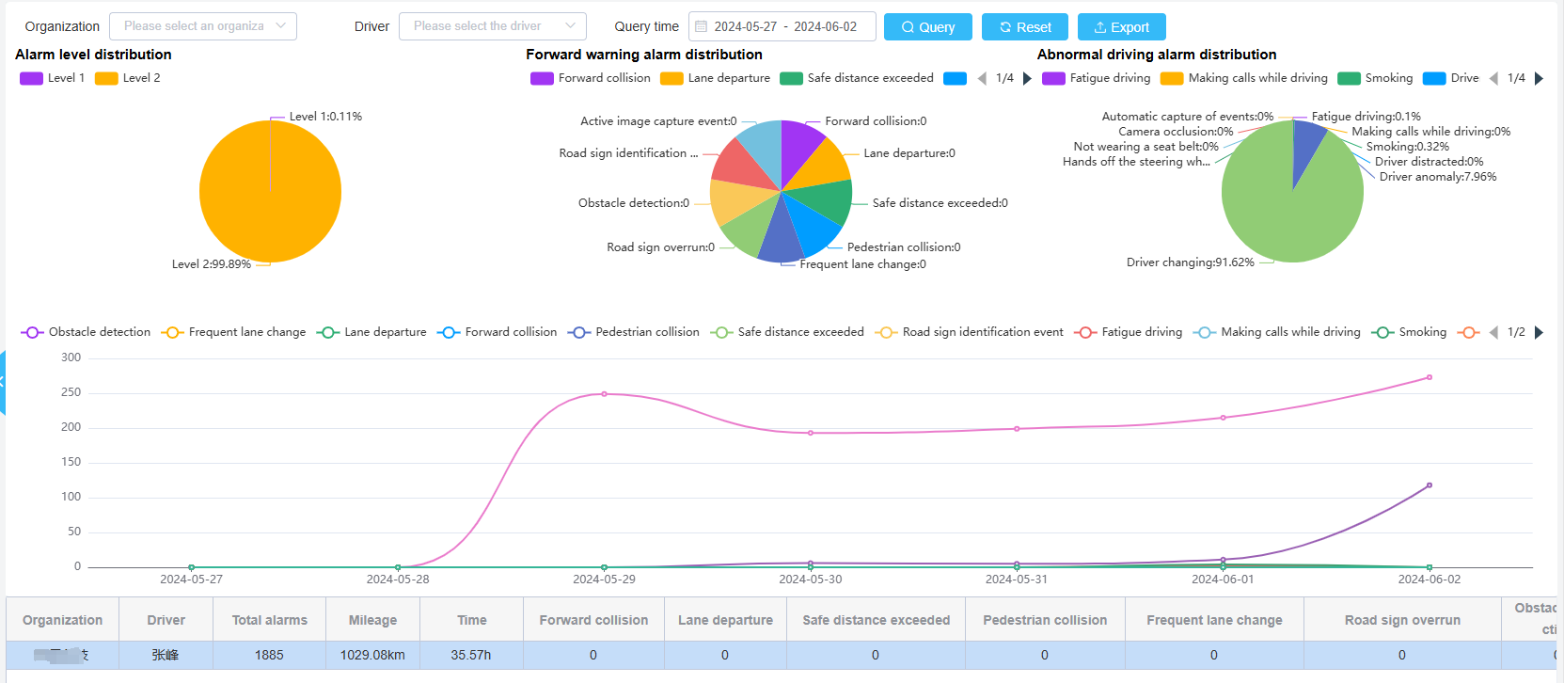

### Driver rating

When an active safety alarm occurs, the system will rate the driver based on the set scoring criteria. Here you can see the driver's score and details of various deductions.

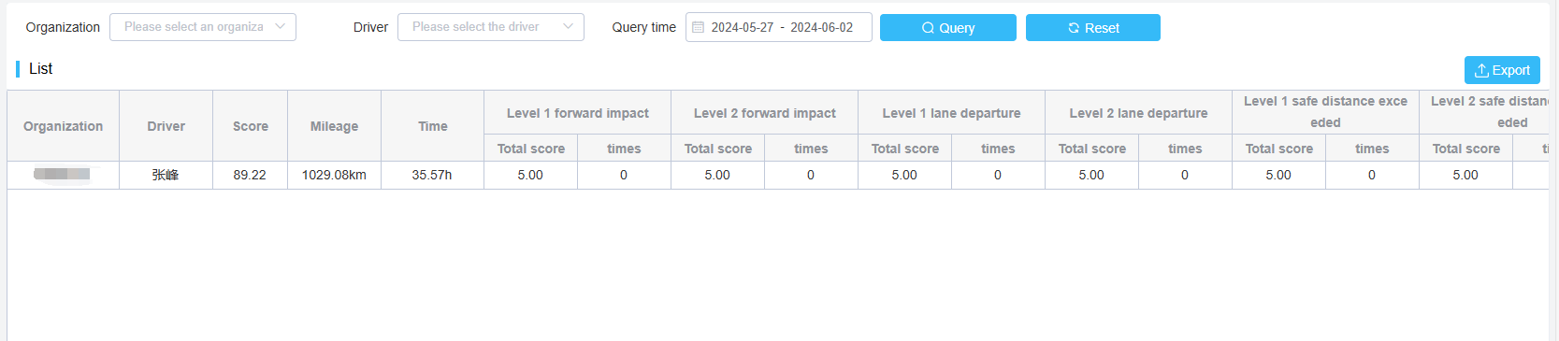

## Daily safety analysis

You can view the occurrence of active safety alarms by selecting the vehicle, date, and alarm type.



The system will calculate the total number of forward warning ADAS, driving abnormality DSM, blind spot BSD, and tire pressure TPMS based on the query conditions.



Under the statistical data, there are three parts of alarm related data. The left side shows the total number of alarms that meet the query criteria based on vehicles, the middle is the record of each alarm, and the right side shows the alarm personnel, phone speed, and geographical location displayed on a map.

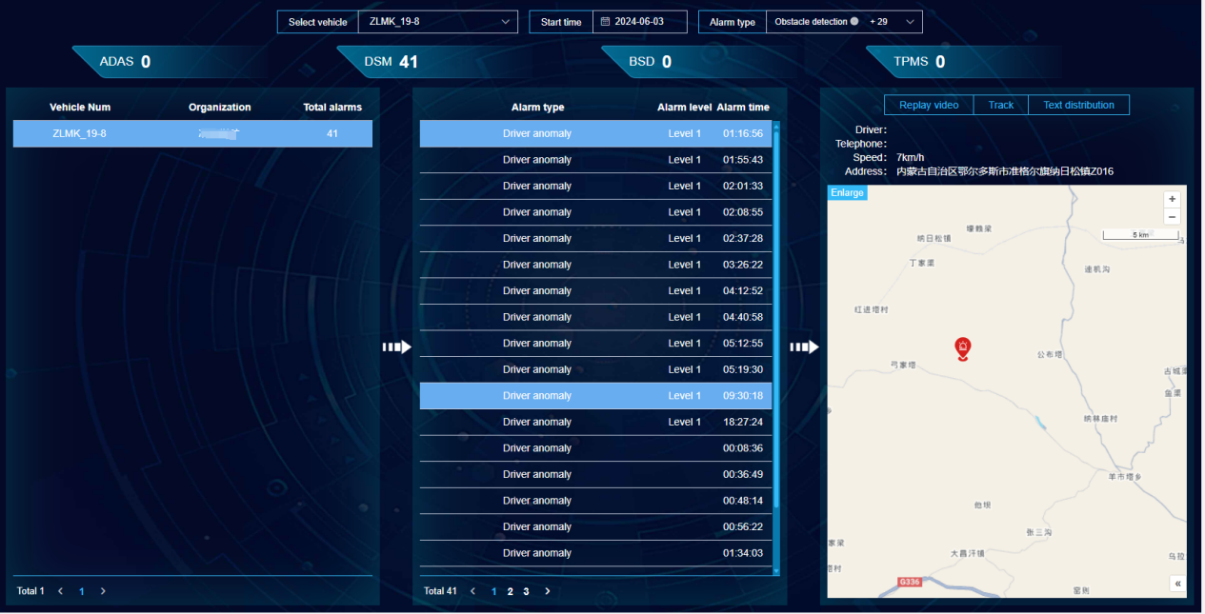

There are also three function buttons on the right, which are video playback, trajectory playback, and text distribution. Video recording and trajectory playback refer to the playback of recordings and trajectory conditions near the alarm time. Text distribution can directly distribute text content to devices.

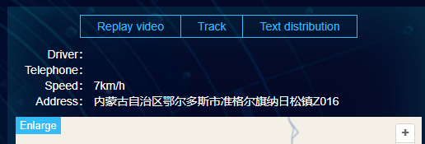

# Statistical report

## Quick navigation

Users can quickly find the corresponding report and operate related reports in the shortcut navigation.

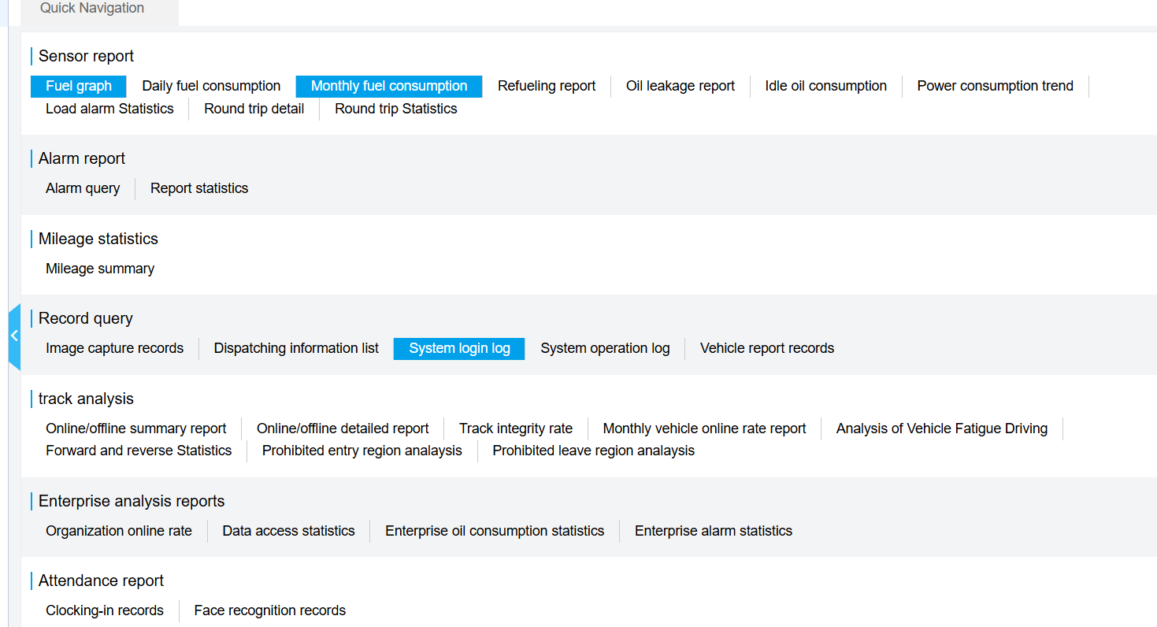

### Report Collection

Click on the asterisk on the right side of a report in the shortcut navigation of the mouse to complete the collection of the report. The collected reports will be displayed with a highlighted background, making it convenient for customers to quickly find the corresponding reports.

## Sensor report

The sensor report contains statistical information on external extended sensors, such as fuel consumption, load capacity, etc.

### Time and fuel consumption report

The time fuel consumption report is used to view the trend of changes in the fuel consumption sensor on the timeline, as well as the situation of refueling and oil leakage.

The specific operating steps are

1. Click on the menu for time and fuel consumption, select the vehicle you want to query, start and end times.

2. Click the query button. Display time fuel consumption curve

In the time fuel consumption chart, there are elements such as driving fuel volume, analog quantity, ACC switch, mileage, speed, altitude, etc. The status of the ACC switch is fixed and displayed, while other parameters can be selected by clicking on it.

The specific data of the vehicle is displayed in the table below, and the data in the chart is presented in chronological order.

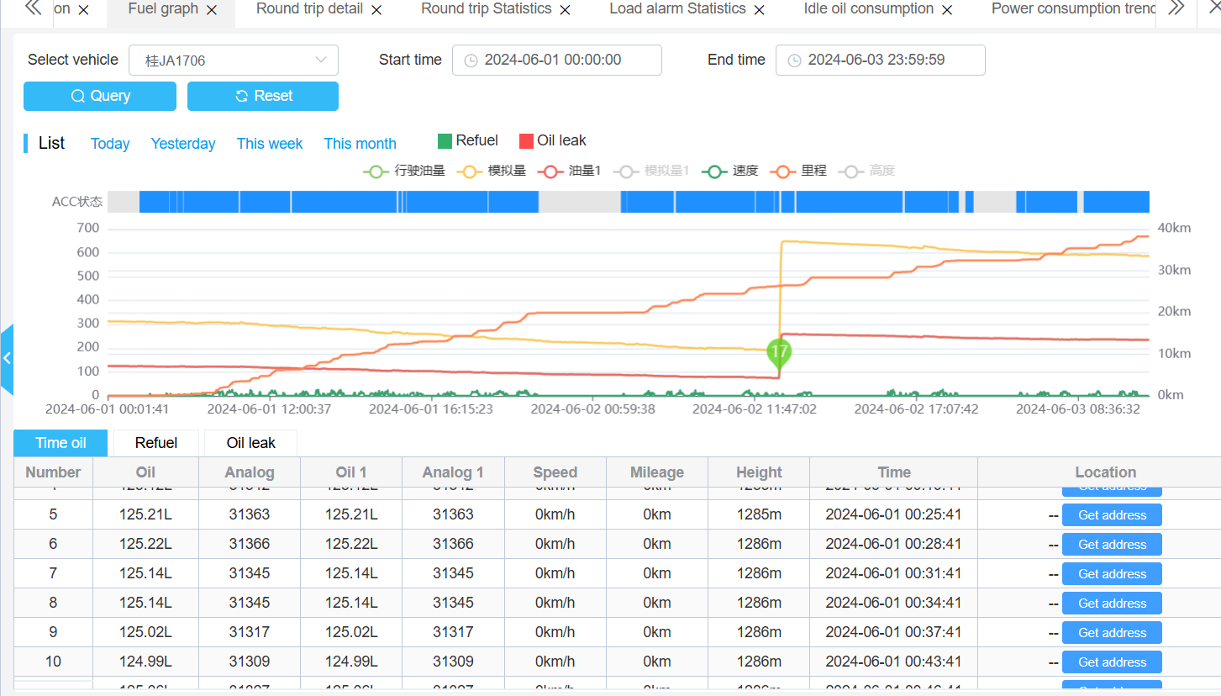

### Daily fuel consumption report

The fuel consumption daily report is used to display the query time of fuel consumption. During the visit, statistical information in days includes the vehicle's fuel consumption per 100 kilometers,

Mileage, fuel consumption, refueling volume, oil leakage volume, working time.

The specific operation steps are:

1. Select the vehicles to be counted (multiple choices are allowed)

2. Select the time to be counted and click on the query.

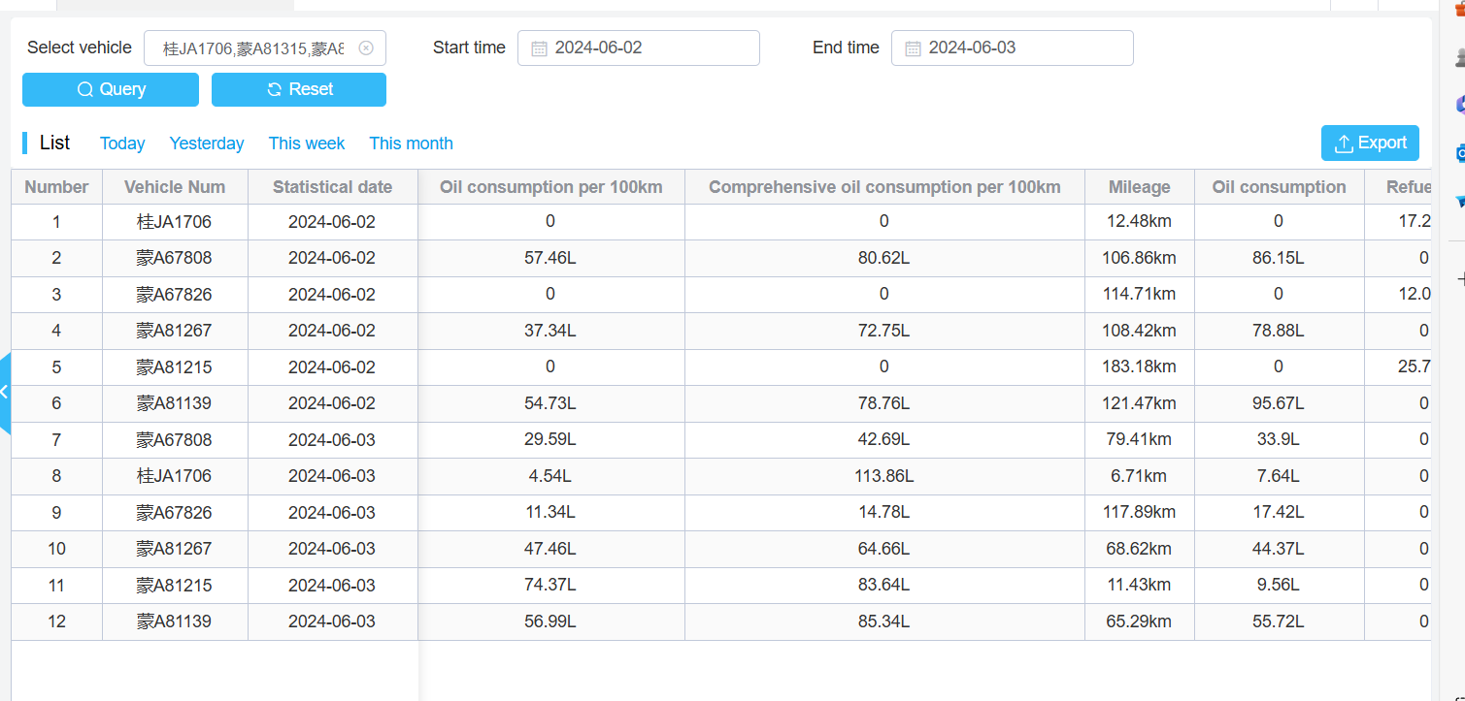

### Monthly fuel consumption report

The monthly fuel consumption report is used to track the monthly fuel consumption statistics of selected vehicles. The specific operation steps are:

1. Select the vehicle to be counted (multiple choices are allowed)

2. Select the month to be counted

Click the query button to display the fuel consumption of the vehicle in the month that needs to be counted, and the statistical information can be exported to Excel.

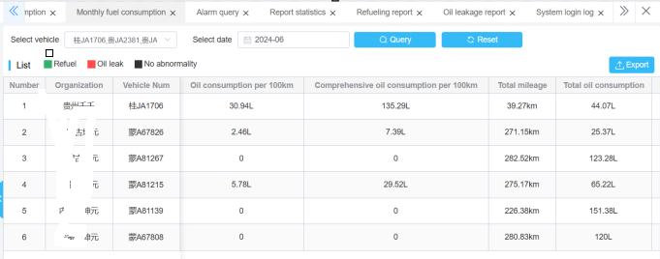

### Refueling report

The refueling report is used to query and record the refueling status of vehicles within a specified time range.

The specific operation steps are:

1. Select the vehicles to be counted, including the start and end times

2. Click on the query to display the vehicle plus report. Export can be done through Excel.

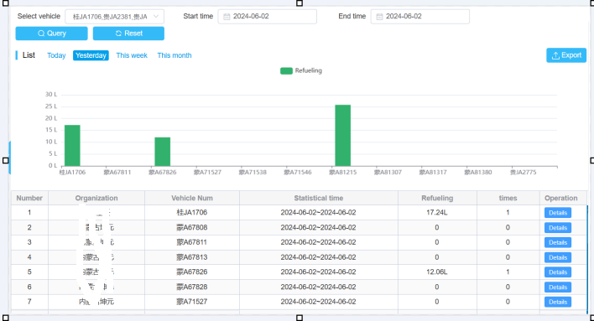

During the time of refueling the vehicle, you can click on the details to view the details of refueling.

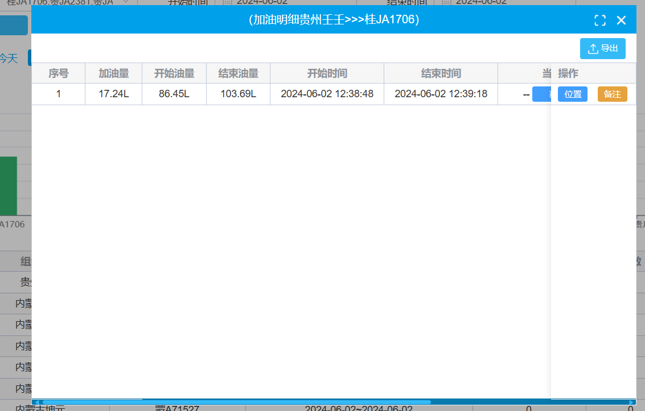

### Oil Leakage Report

The operation method of the oil leakage report is the same as that of the refueling report, displaying the oil leakage situation of the specified vehicle within the time range.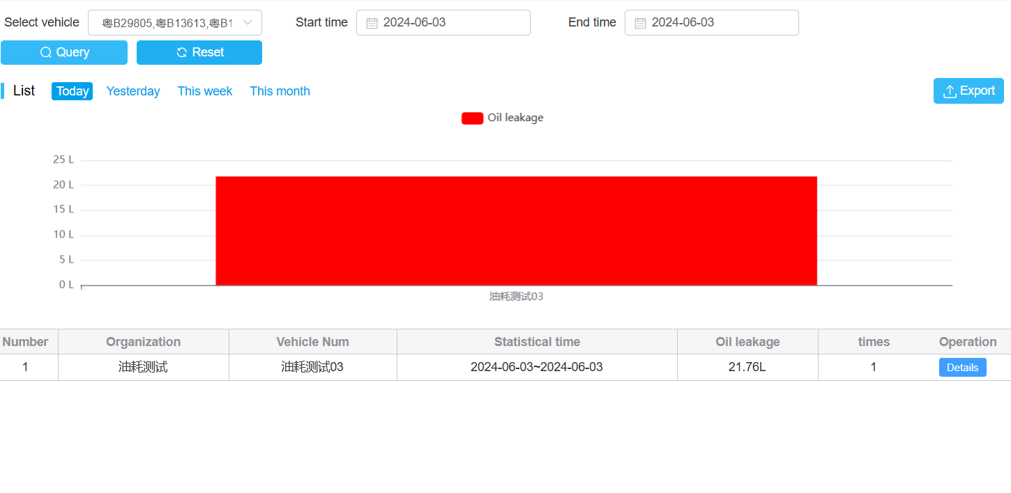

### Idle fuel consumption

Idle fuel consumption refers to the fuel consumption generated when the vehicle is in ACC mode but at a speed of 0 within a specified time range. For more accurate statistics, the idle fuel consumption can be calculated at a specific time and the amount of fuel consumption generated. Click on the details to see the time period during which idle fuel consumption occurs.

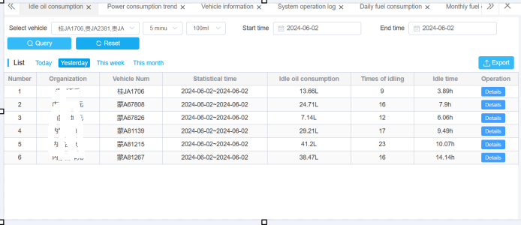

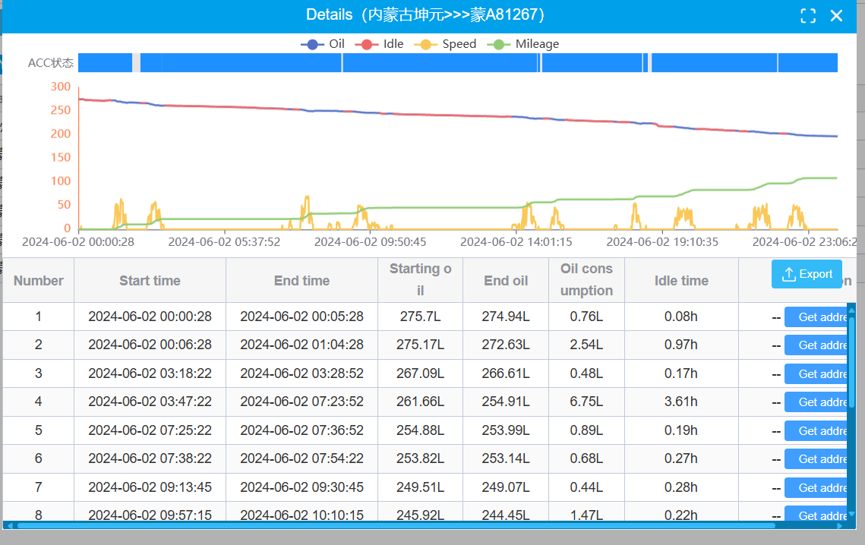

### Power consumption trend chart

The power consumption trend chart is used to display the changes in vehicle power consumption trend.

The specific operation steps are:

1. Select the vehicles for statistics

2. Select the statistical time and click the query button

Calculate the working time range

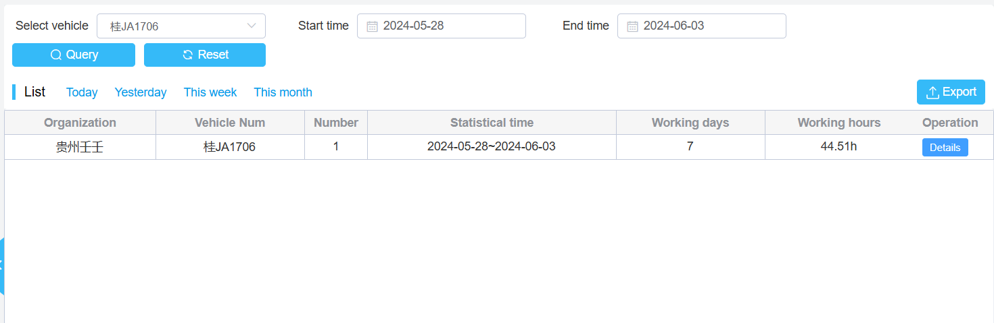

Click on the details to view the trend of power consumption within the time range

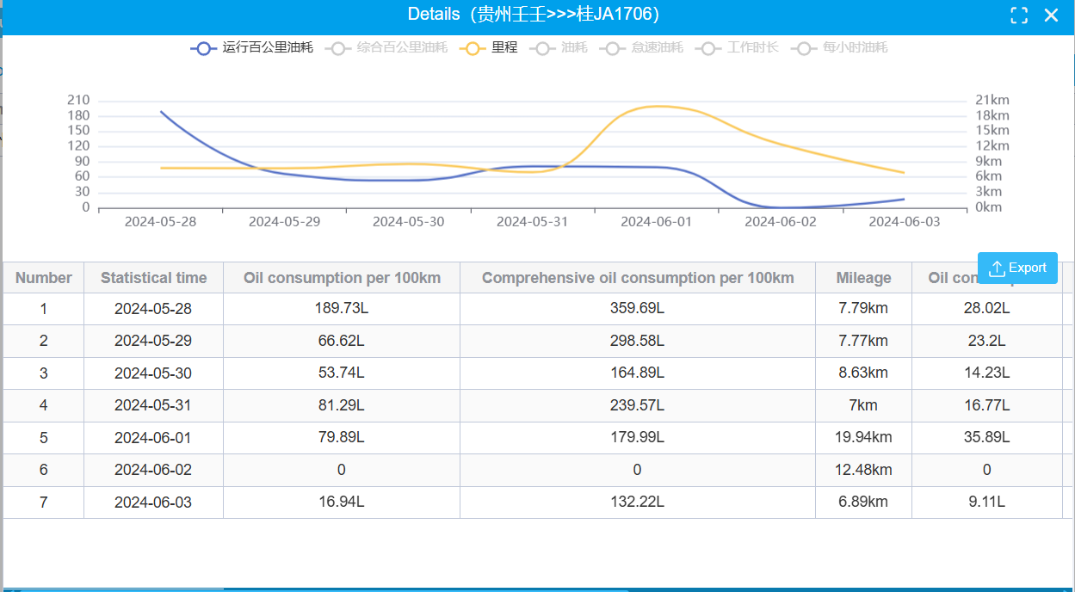

### Load alarm statistics

Load alarm statistics are used to display the vehicle's load alarm situation within a time range. Including unloading outside the fence, unloading timeout, incomplete unloading. The specific operating steps are

1. Choose a good statistical vehicle and time range

2. Click on query to display the number of alarms

### Trip details

The trip details are used to track the process of vehicles from loading to unloading. Including the loading weight of the vehicle, the start time and location of the trip, and the end time and location.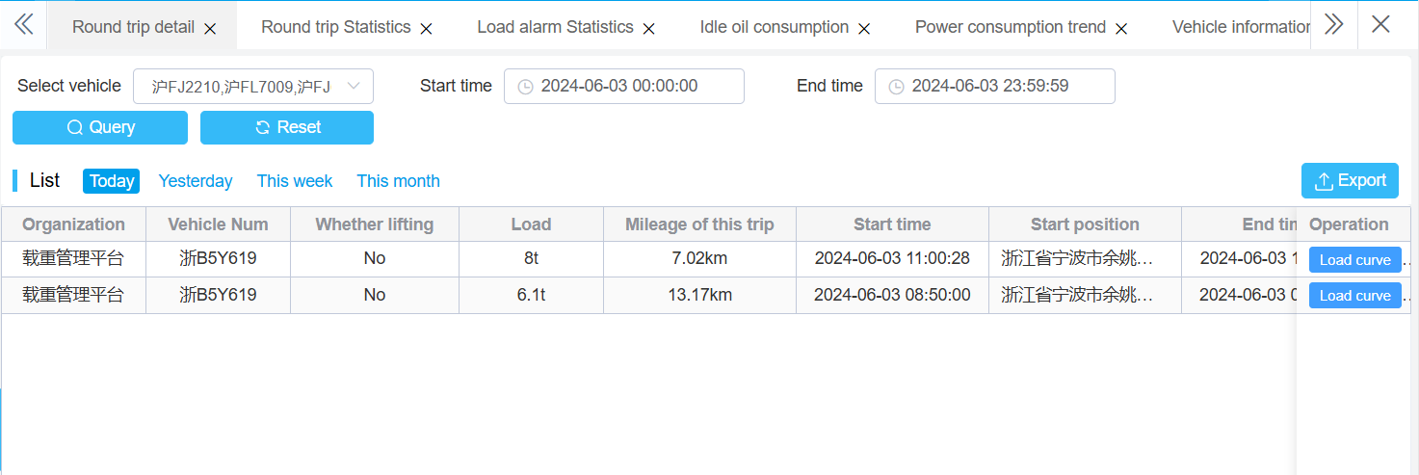

### Trip statistics

Trip statistics are used to calculate the number of trips within a vehicle's time range, including freight weight, total trips, and total mileage.

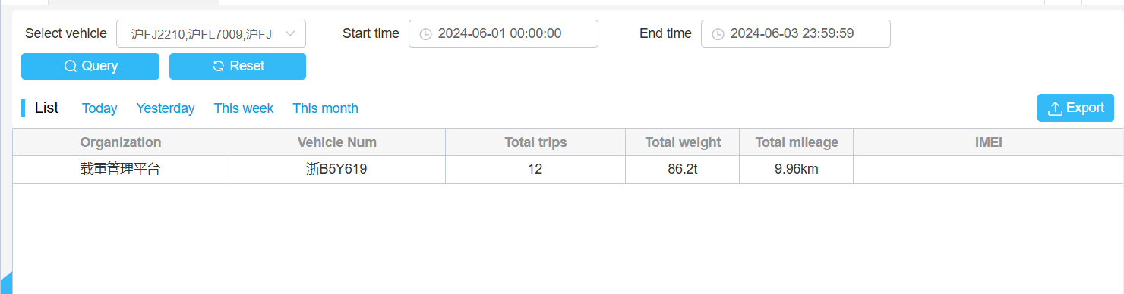

## Alarm report

### Alarm Query

Query vehicle alarm information details, including driver, communication SIM card number, alarm type, alarm source (platform or device), start and end time, processing status, and other information.

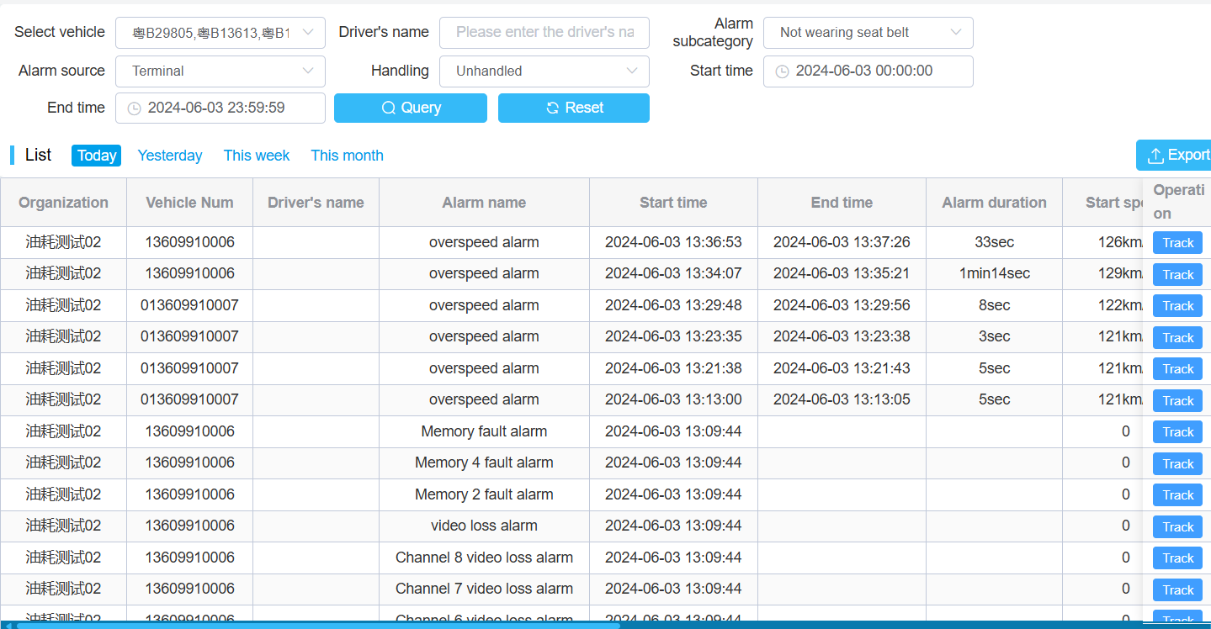

### Alarm Statistics Report

Users can perform statistics based on organizational structure, alarm type, statistical method (by driver or vehicle), and start or end time as conditions.

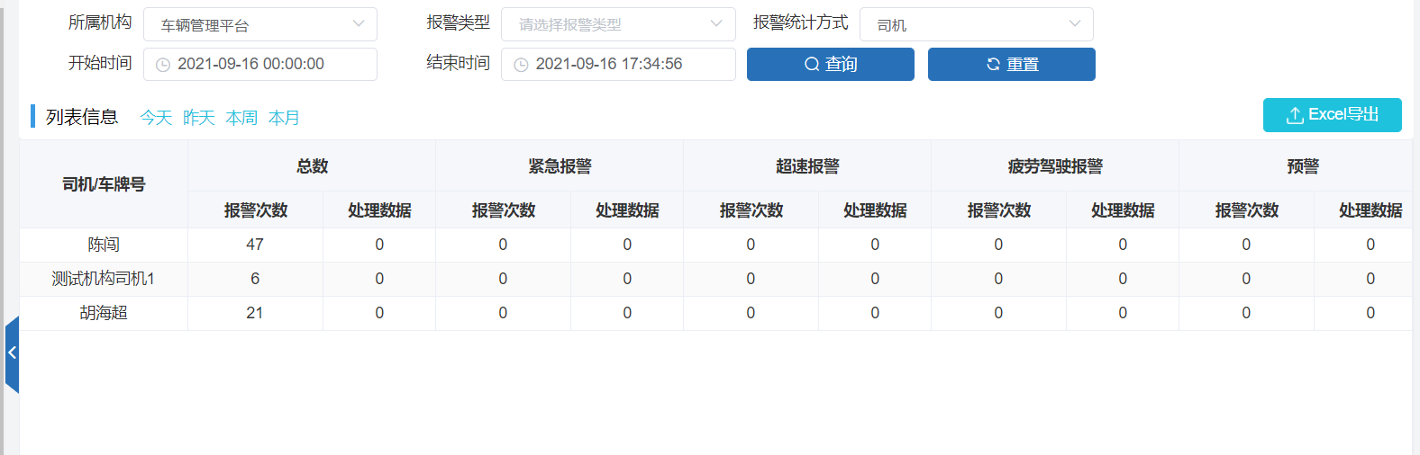

## Mileage statistics

Multiple vehicles can be selected, and the mileage, starting and ending mileage of the vehicles within the specified time can be counted.

The steps of the operation are:

1. Select vehicle

2. Fill in the required statistical time range.

3. Click on query to start mileage statistics.

The mileage report can be exported through Excel.

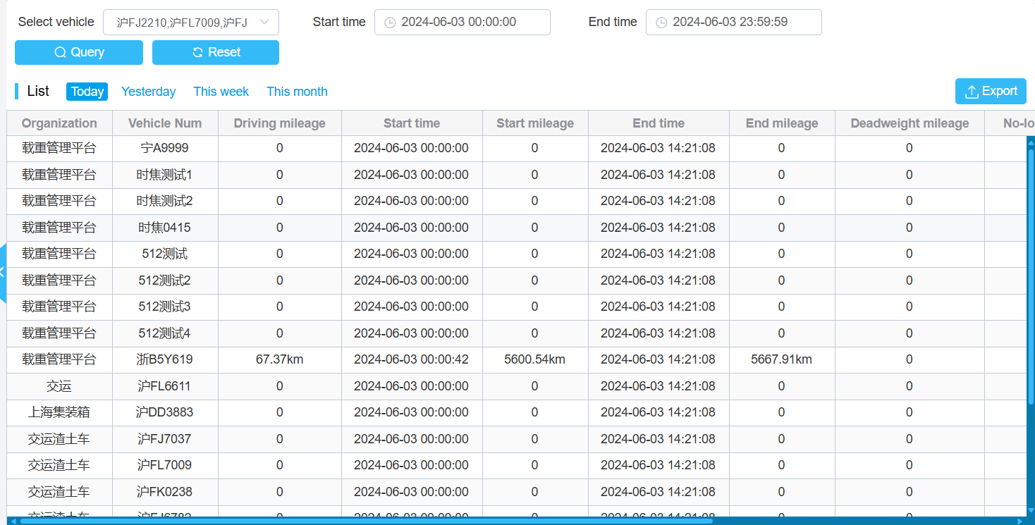

## Record Query

### Image capture records

By selecting the captured vehicle, the image information of the vehicle can be queried. The information can come from manually captured photos, as well as from system scheduled photography or alarm linkage.

The detected images can be viewed by clicking the "View" button on the operation bar at the end of the image, and then clicking the download button to download the images locally

### System operation logs

The system will remember the time, login status, login username, and IP address of all users who log in to the platform.Authorized users can query the login status of other users based on the query criteria

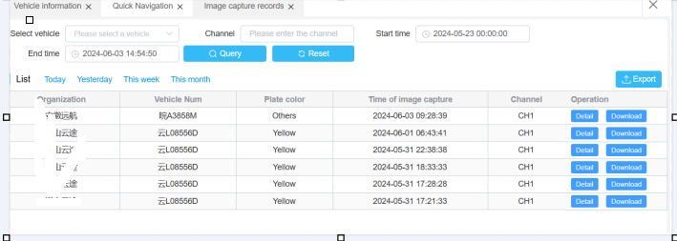

### Scheduling Information List

Scheduling information refers to the platform sending text messages to remotely control instructions to devices. The query for scheduling information is

Find out which scheduling information has been sent to the device within the specified time.

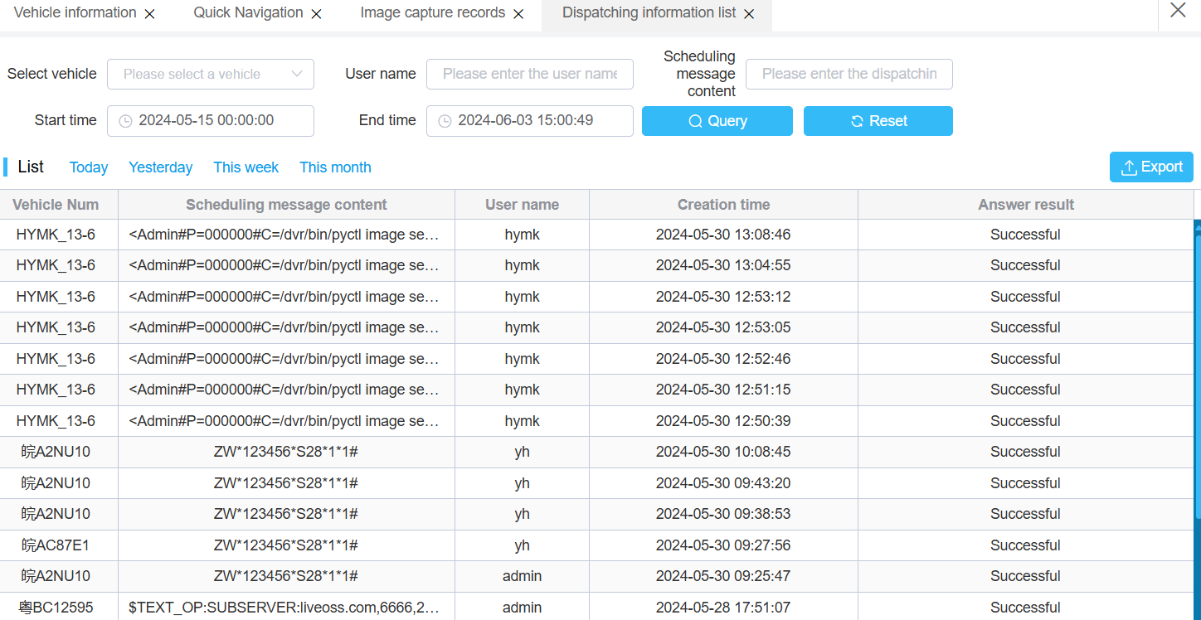

### System login logs

The system will remember the time, login status, login username, and IP address of all users who log in to the platform. Authorized users can query the login status of other users based on the query criteria

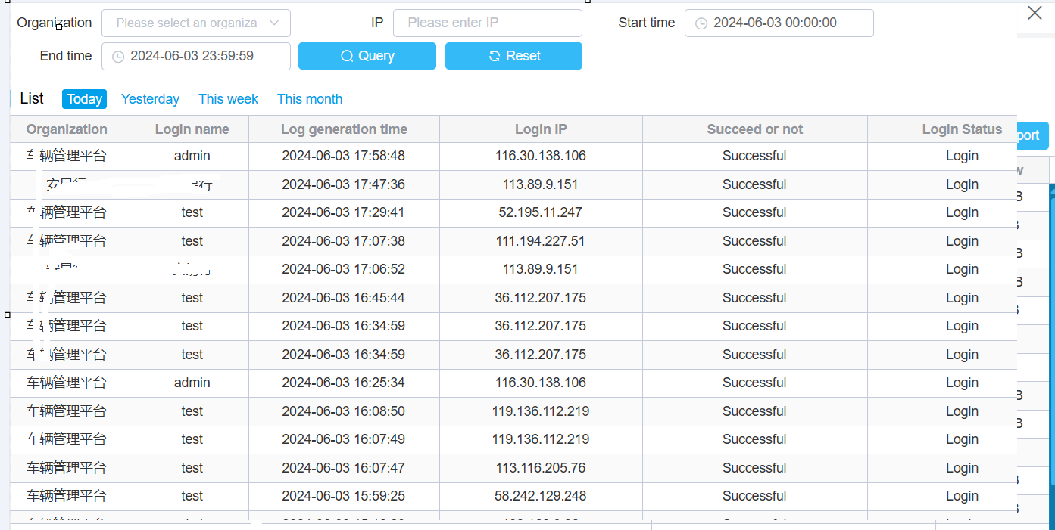

## Driving analysis

### Online and offline summary

Record the number of times a vehicle goes online or offline during a certain period of time.

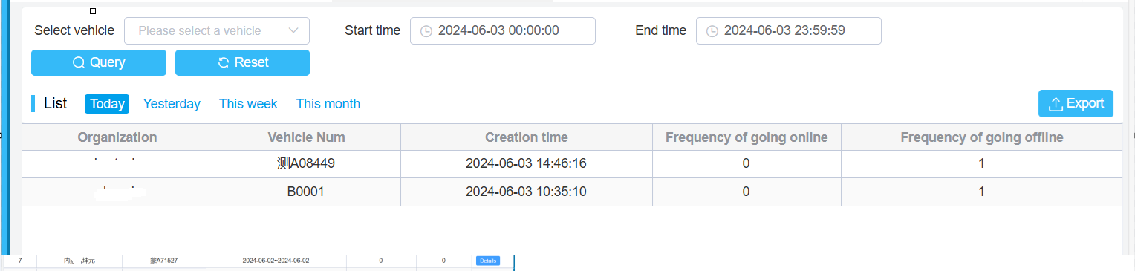

### Online and offline details

The vehicle online and offline details display the online and offline status of the vehicle within the specified time.

The specific operation steps are:

1. Select vehicle

2. Select online/offline status

3. Enter the start and end times and click the shortcut button below.

4. Click on the query to find out the online/offline status of the vehicle under certain conditions.

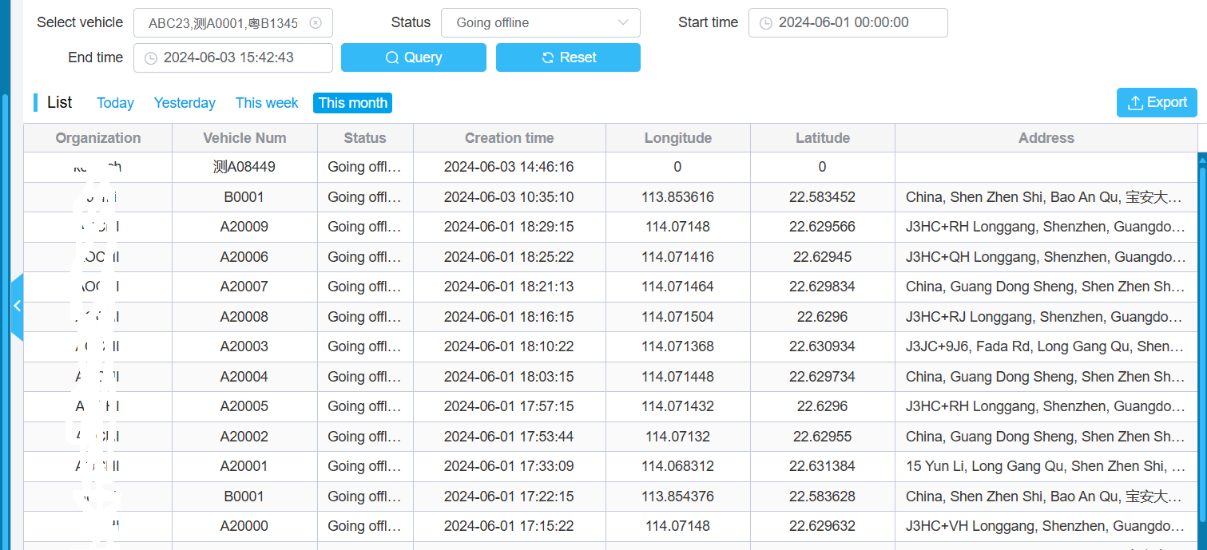

### Track Integrity Statistics

Selecting the trajectory completeness menu allows for analysis and statistics of vehicle trajectory anomalies based on time.

Including the number of positioning points, number of incorrect positioning, positioning qualification rate, positioning information drift rate, error rate, etc.

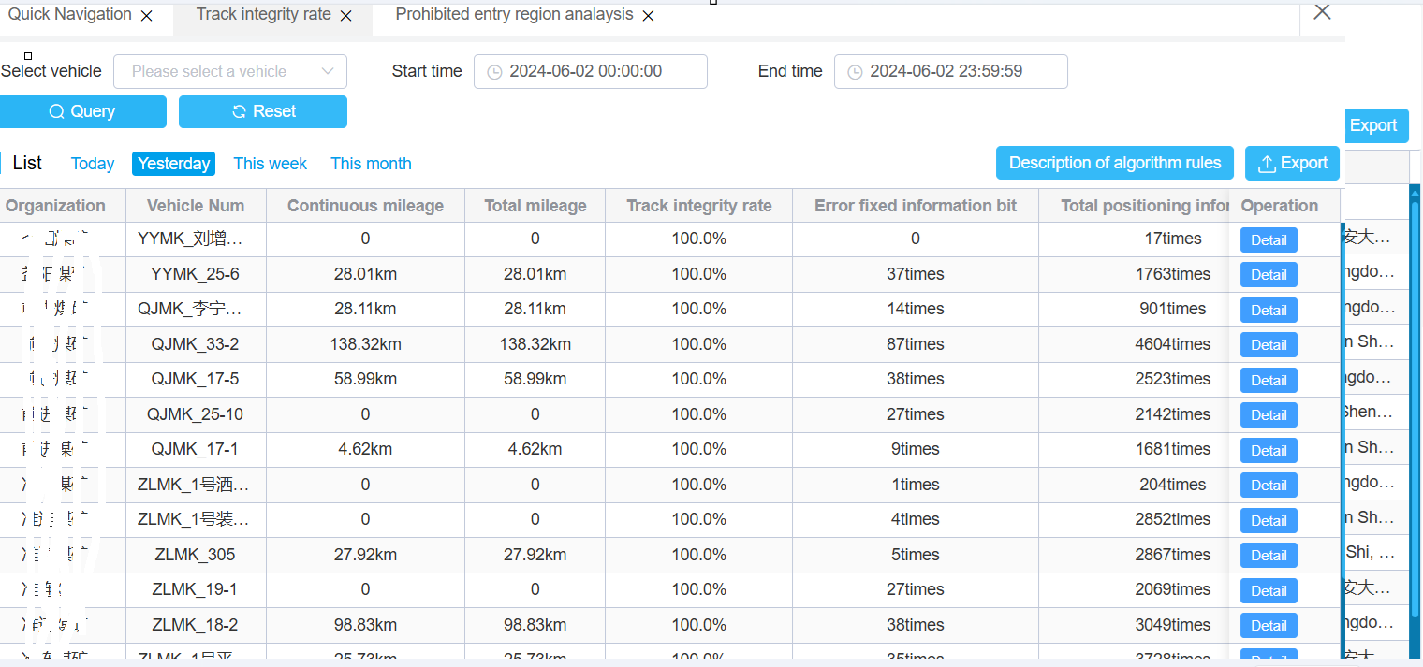

Click  button allows you to view the rules of the algorithm, and clicking on the detailed button allows you to view the trajectory Error details

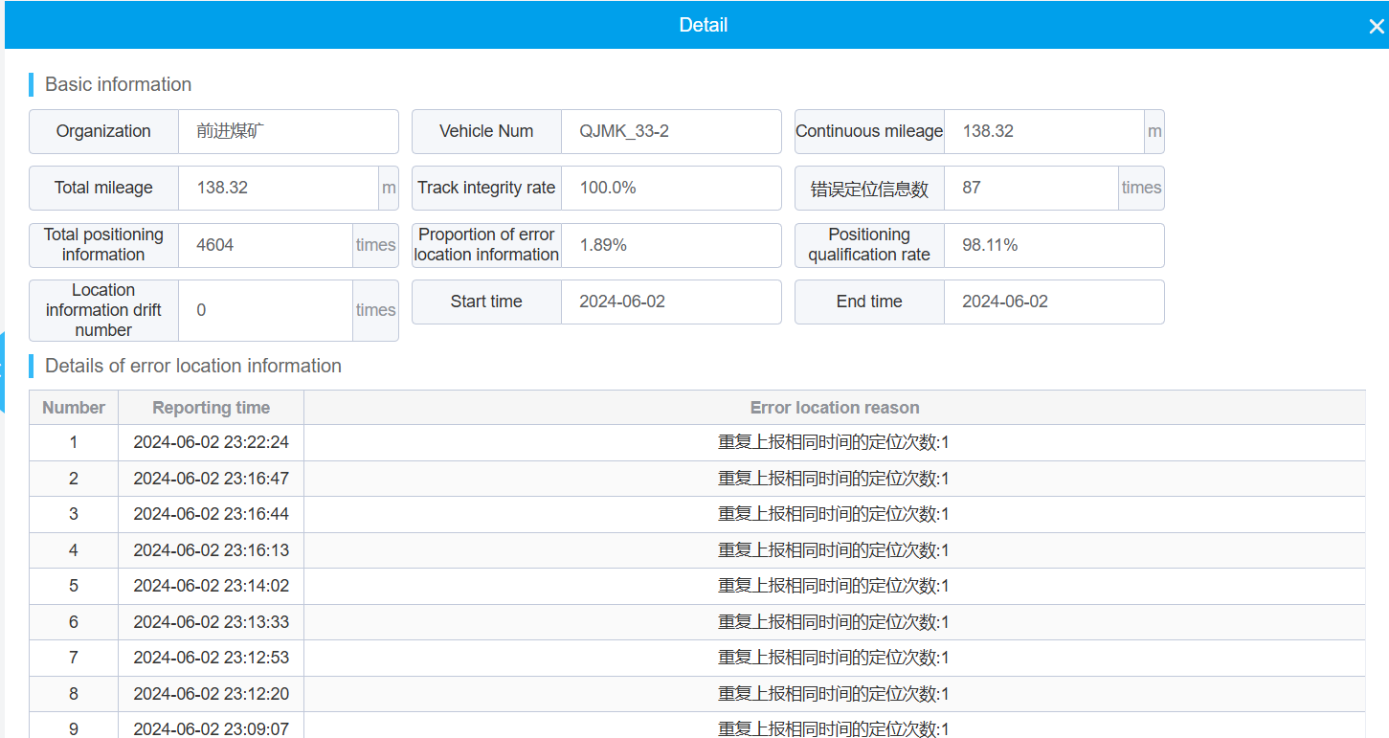

### Monthly Vehicle Online Rate

You can view the online status of vehicles in a specified month, and click View to see the daily online status.

The specific operation steps are:

1. Click on the menu for monthly online rates

2. Select vehicles and months for statistics

3. Click on the query to calculate the monthly online rate of all selected vehicles.

4. Click on details to view the specific online and offline status of the vehicle within the month.

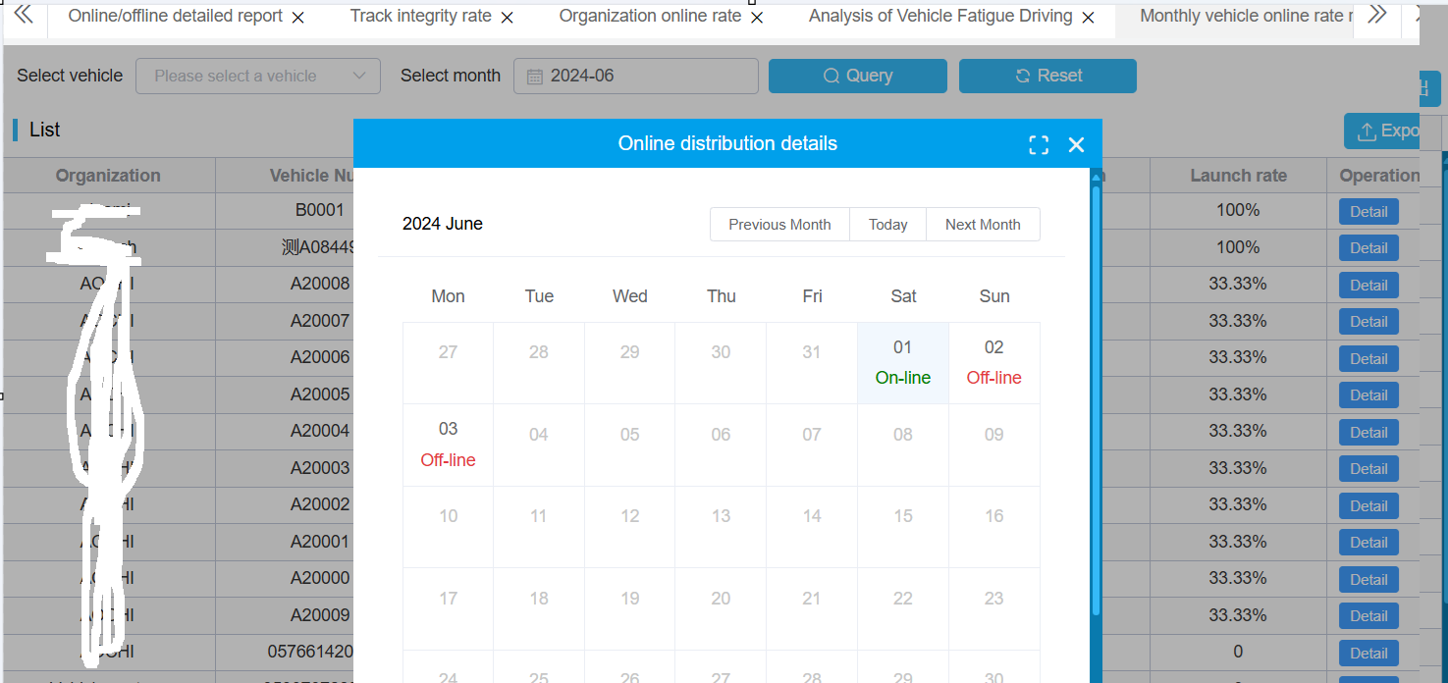

### Analysis of Vehicle Fatigue Driving

According to the query criteria, fatigue driving vehicles that meet the conditions can be found, and the fatigue driving duration and time position can be displayed.

Explanation of the meaning of query conditions

Continuous driving time (M): The time during which the vehicle is in a driving state.

At least rest time (N): The minimum time the vehicle is in a resting state.

These two conditions are effective together, and the result of the query is that the vehicle must be driven for at least M minutes and cannot have more than N minutes of rest.

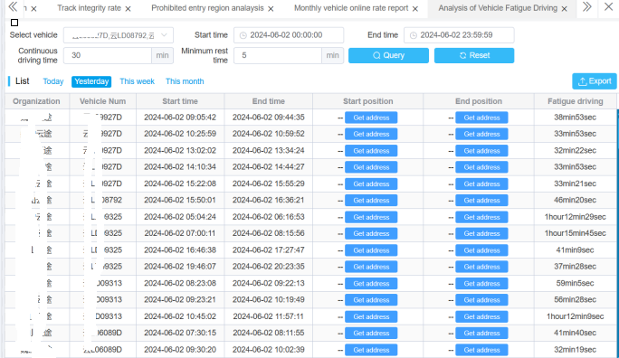

### Forward and Reverse Statistics

To view the forward and reverse situation of a specified vehicle within a specified time, presented in the form of a chart.

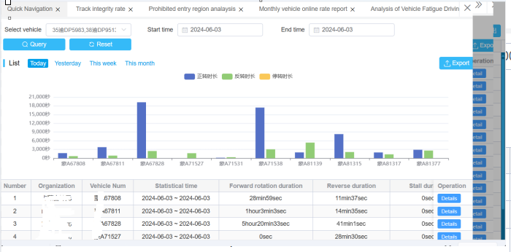

## Enterprise Analysis Report

### Institutional Online Rate Report

The institutional launch rate report is used to statistically analyze the number and launch rate of vehicles launched by companies within a time range.

The specific operation steps are:

1. Select Institution

2. Fill in the required statistical time range

3. Click the query button to calculate the online rate of vehicles under the selected institutions and sub institutions.

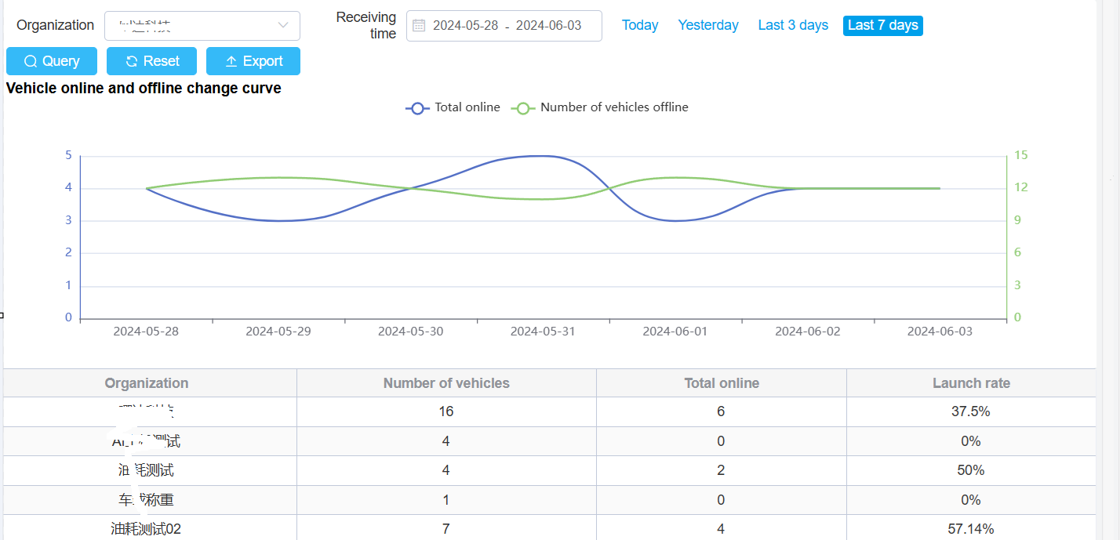

### Data Access Report

The enterprise data access volume report refers to the analysis of the report uploaded by all device data.

The specific operation steps are:

1. Select Institution

2. Fill in the required statistical time range

3. Click the query button to count the vehicle data access volume under the selected institution and sub institution.

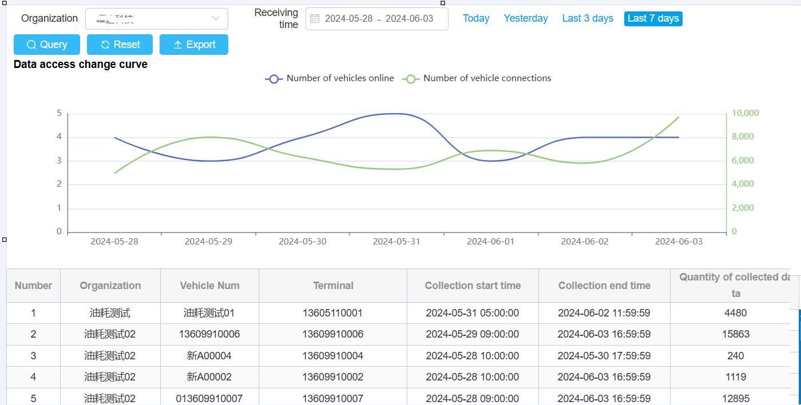

### Enterprise fuel consumption report

Enterprise fuel consumption statistics are used to display the driving mileage and fuel consumption per 100 kilometers of all vehicles in the enterprise.

The specific operation steps are:

1. Select Institution

2. Fill in the required statistical time range

3. Click the query button to collect vehicle fuel consumption statistics for the selected institution and sub institution.

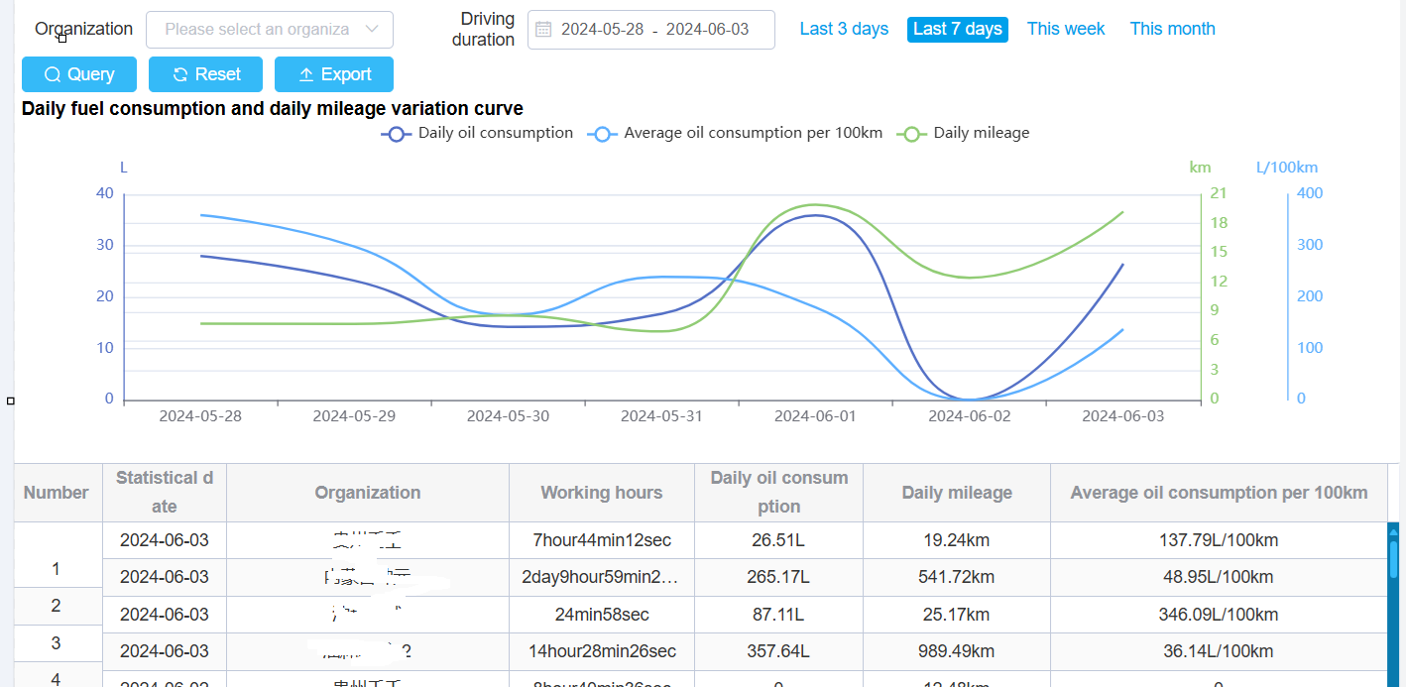

### Enterprise alarm statistics

Statistical analysis of enterprise alarm distribution from the perspective of enterprises

The specific operation steps are:

1. Select Institution

2. Writing requires statistical time range

3. Click the query button to collect alarm statistics for the selected institution and sub institution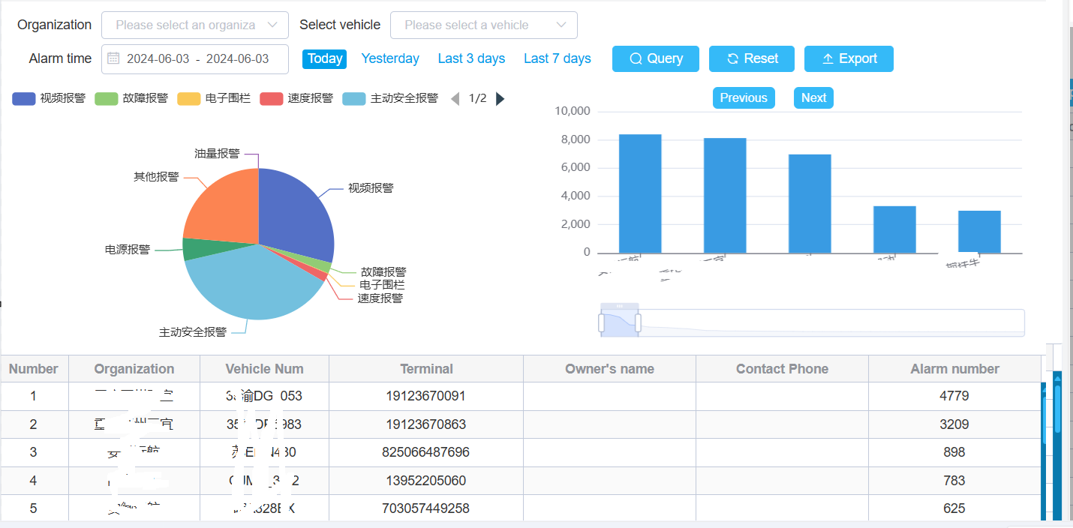

## Attendance Report

### Check in Record Query

The clock in record report is used to display the time records of employees clocking in and out.

The specific operation steps are:

1. Select the vehicle, type of check-in, driver's name, and time

2. Click on query

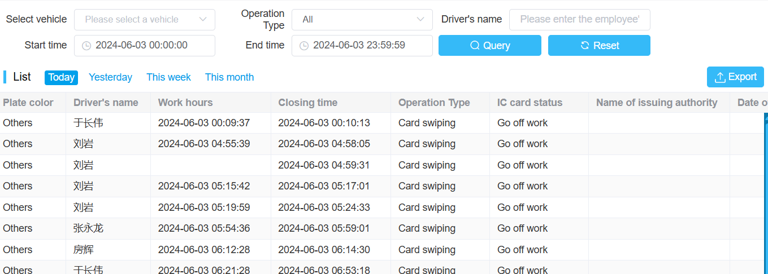

### Facial recognition records

For devices that meet the Jilin standard, facial recognition information can be queried.

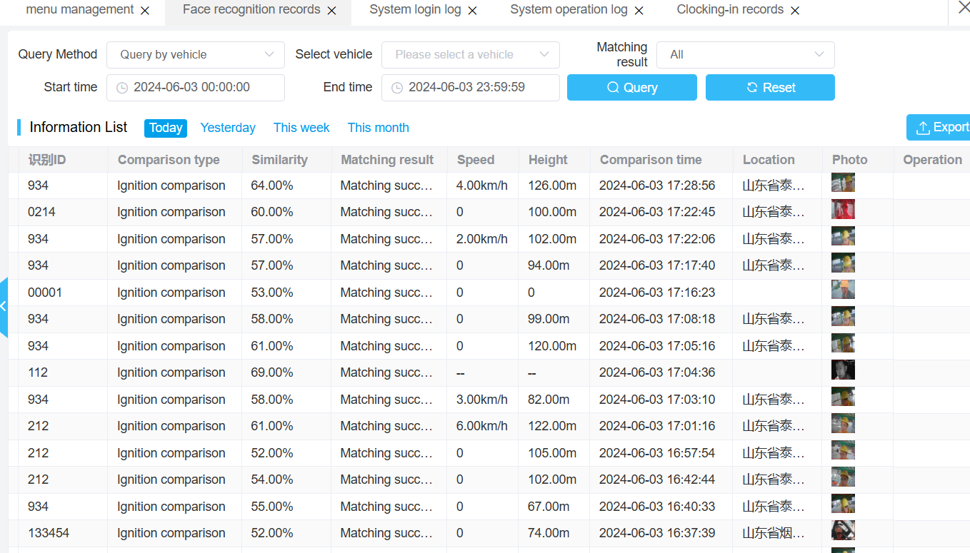

Including recognition time, recognition results, recognition location, driver information, vehicle information, similarity, and driver photos.

### Vehicle Labor Hours Report

Vehicle working hours report is used to gather information on vehicle working hours

The specific operation steps are:

1. Select the vehicle and enter the time

2. Click on query to calculate the working hours of the vehicle

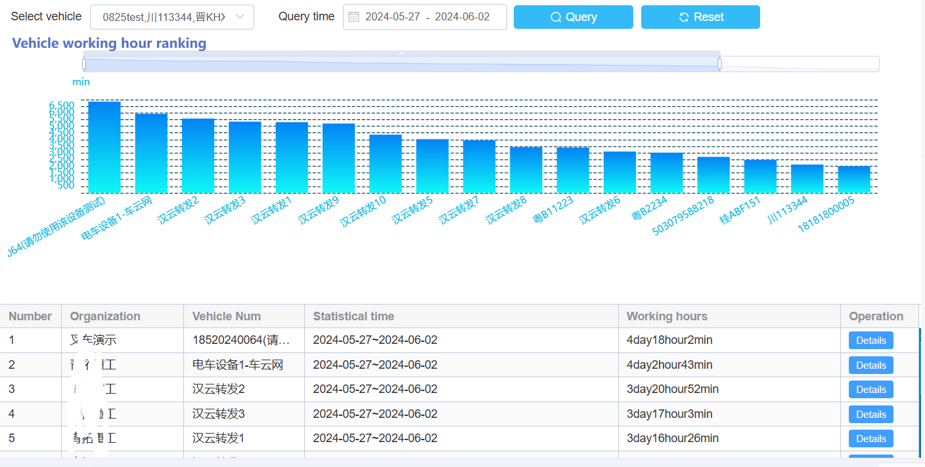

### Driver work time report

The driver's working hours report is used to track the working hours of drivers. The specific steps are as follows:

1. Enter the driver's name and the time range for query

2. Click the query button to start the query.

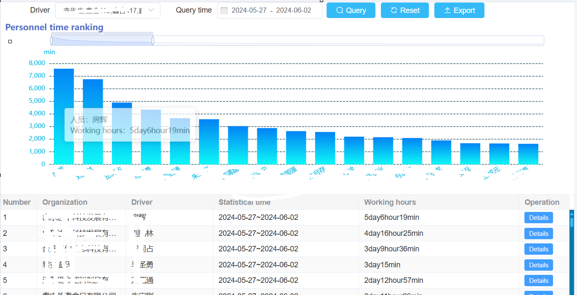

## Other reports

### data usage

The device transmits videos or actively uploads security alarm evidence to the platform, and the platform calculates the data usage. The data includes the start time of watching videos, uplink traffic, downlink traffic, and the reasons for traffic generation (mainly video or attachment uploads).

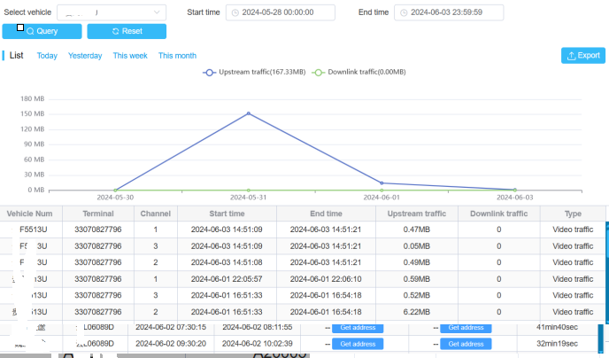

### Multi vehicle data usage statistics

The system can calculate the data usage of multiple vehicles:

The specific operating steps are

1. Select vehicle and time

2. Click the query button

Display the upstream and downstream data and total data of the vehicle.

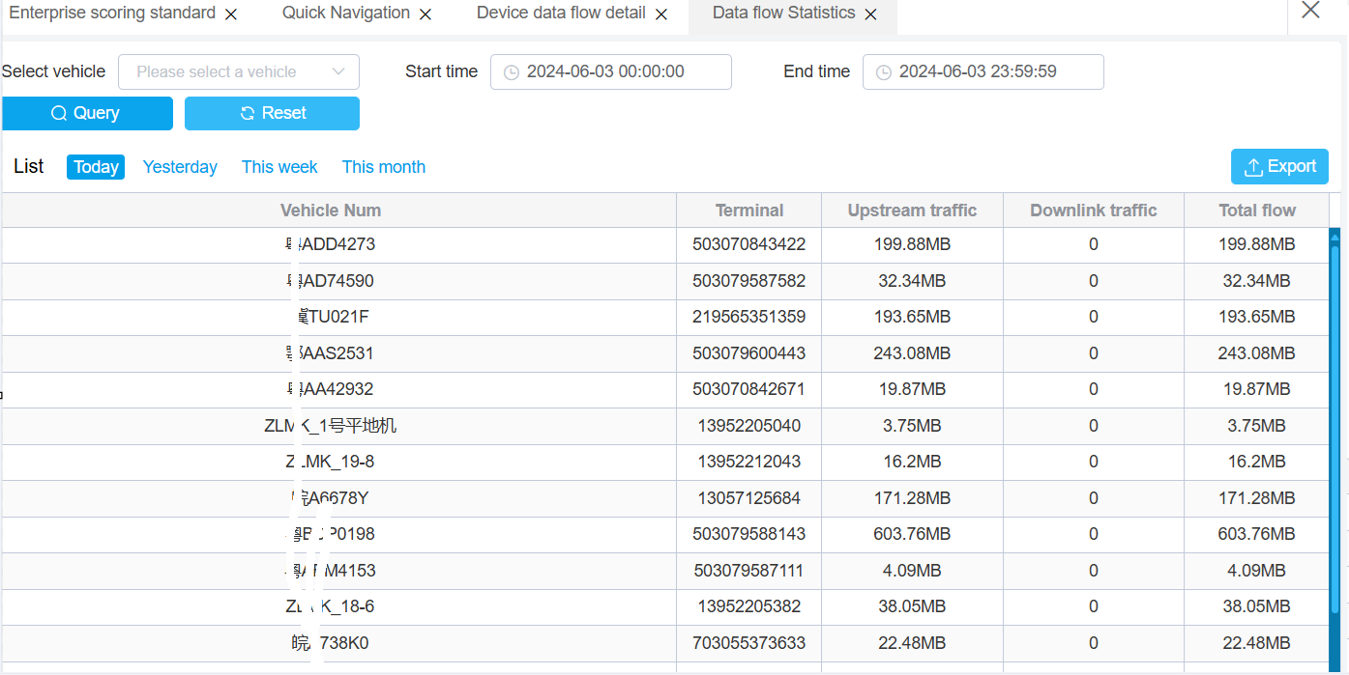

### Cost Statistics

By selecting the expense statistics function of other reports, you can calculate the expense consumption of each vehicle within a specified time.

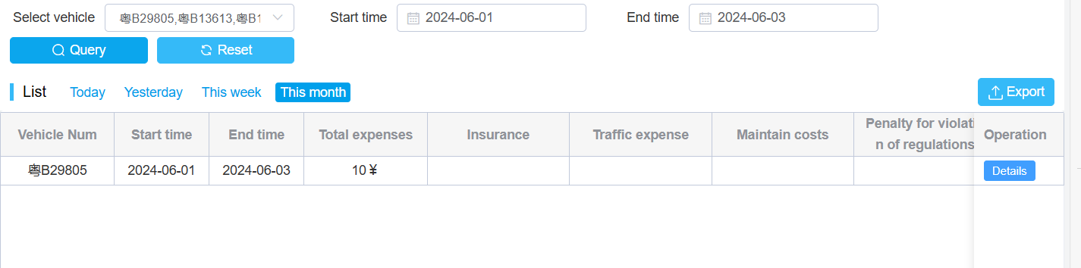

# monitoring screens

## Operation data monitoring large screen

The operation monitoring screen mainly displays the total number and online status of system vehicles, statistics of vehicle operation status, global distribution of vehicles, curves and trends of vehicle online and alarm in the past week, total number and distribution of alarm vehicles, and risk analysis of alarms.

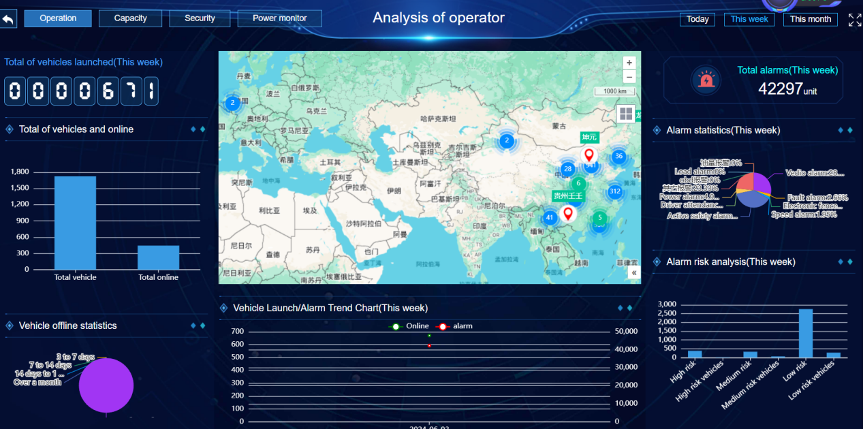

## Capacity monitoring data large screen

The transportation data monitoring screen mainly detects the fuel consumption and load analysis of vehicles. Including heat maps for vehicle refueling and loading and unloading, statistics on abnormal load, ranking of transportation volume, and fuel consumption statistics.

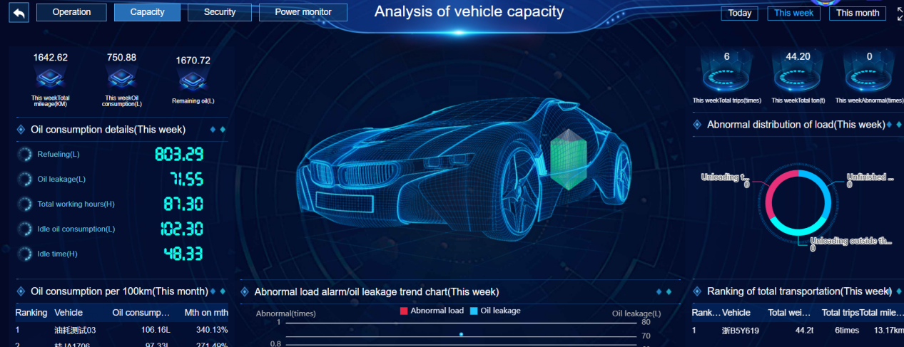

## Security monitoring analysis

Active safety analysis refers to the big data analysis generated after active safety alarms in a system. This includes ADAS and DSM alarm statistics, total number of alarm vehicles, processing status, areas where active safety alarms occur, and alarm trends. Driver rating, distribution of vehicle alarms.

